# JPA In detail

Let’s start with example:

Created spring boot version 3.2.1 project with web, jpa and H2DB dependencies

Create entity class:

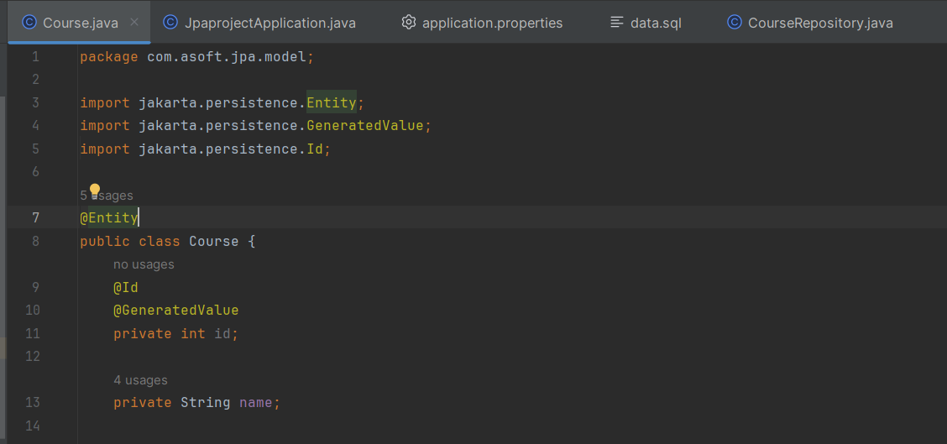

Create repository class:

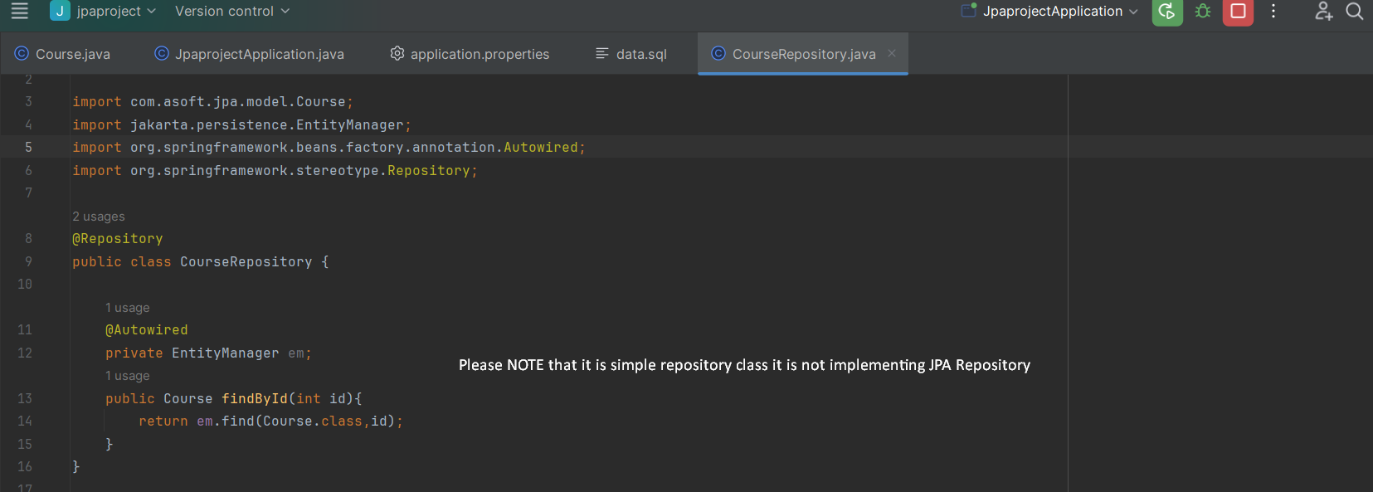

Data.sql: Added because we need data in table after sever startup

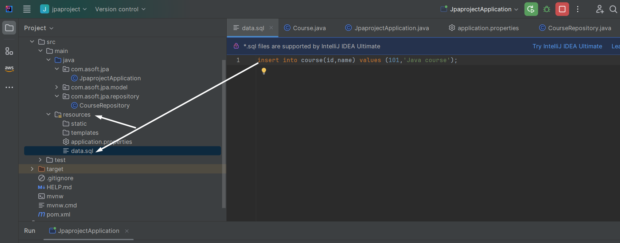

If we want to configure data.sql then we must need to configure bellow property in application.property file

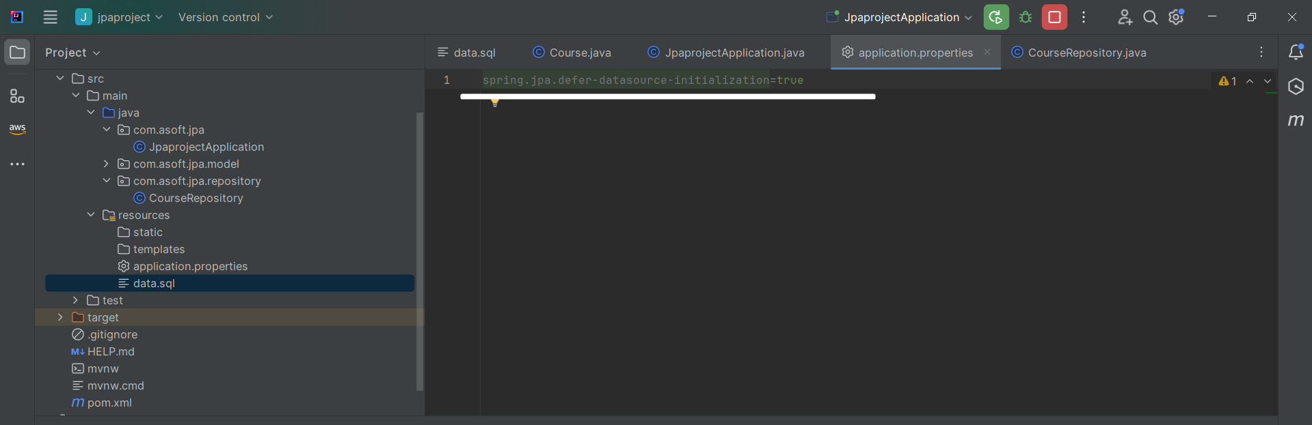

**spring.jpa.defer-datasource-initialization=true**

**The reason is “By default, data.sql scripts get executed before the Hibernate is initialized. We need Hibernate to create our tables before inserting the data into them,** **when we run the project with this file on the classpath, Spring will pick it up and use it to populate the table”.**

Please note that for any script-based initialization, i.e. inserting data via data.sql or creating schema via schema.sql (which we’ll learn next), we need to set the below property:

spring.sql.init.mode=always

For embedded databases such as H2, this is set to always by default.

To access the H2 in memory db console configure below property in application.properties file

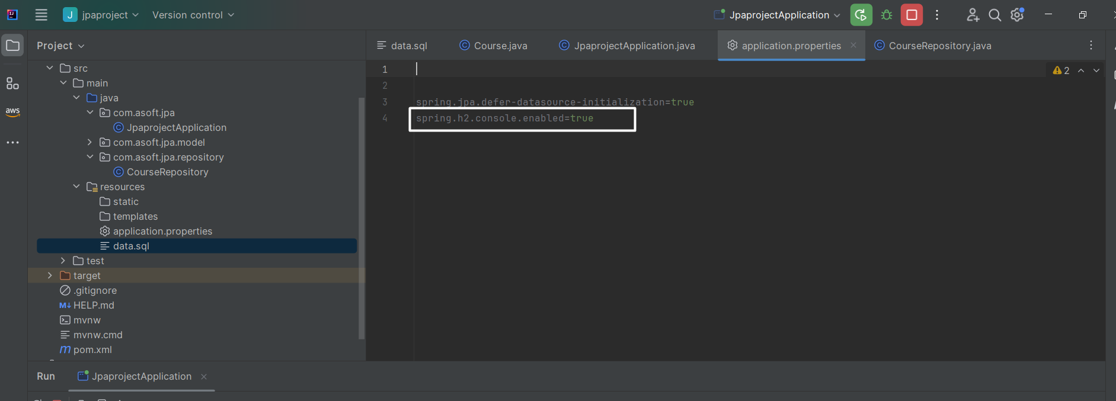

See the logs:

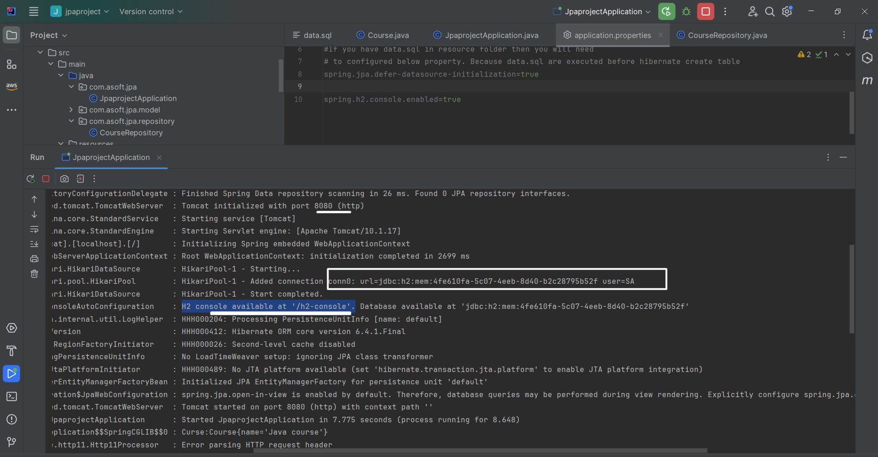

Now using command line running class , try to read the inserted record:

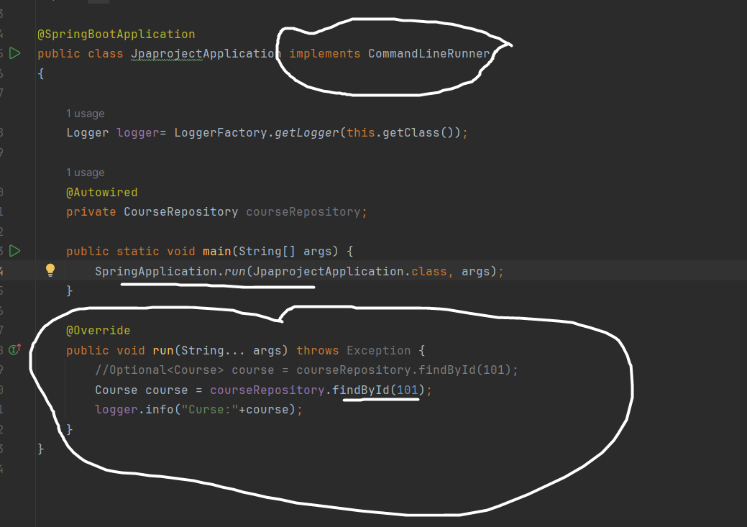

Copied URL from logs and access the console

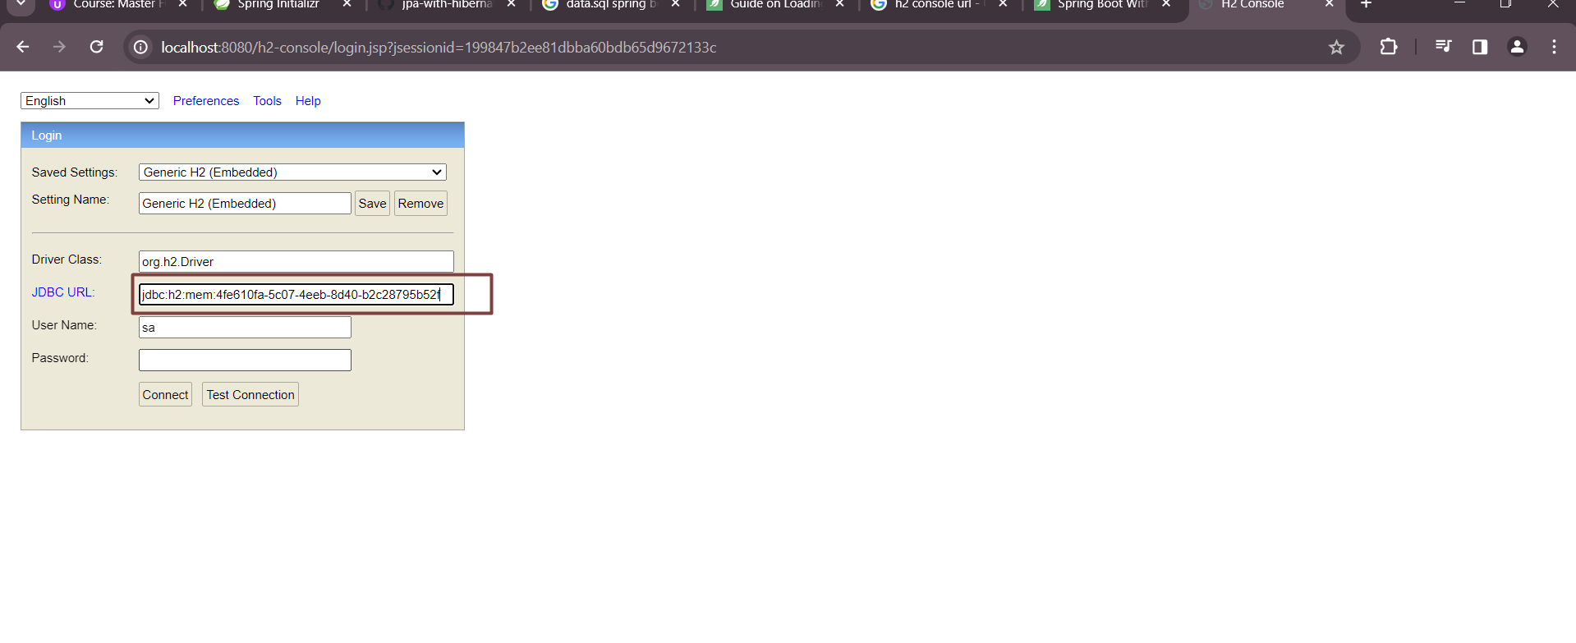

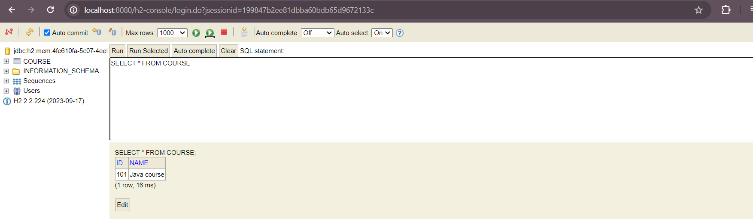

Hibernate properties that helps us for debugging:

Enable statistics:

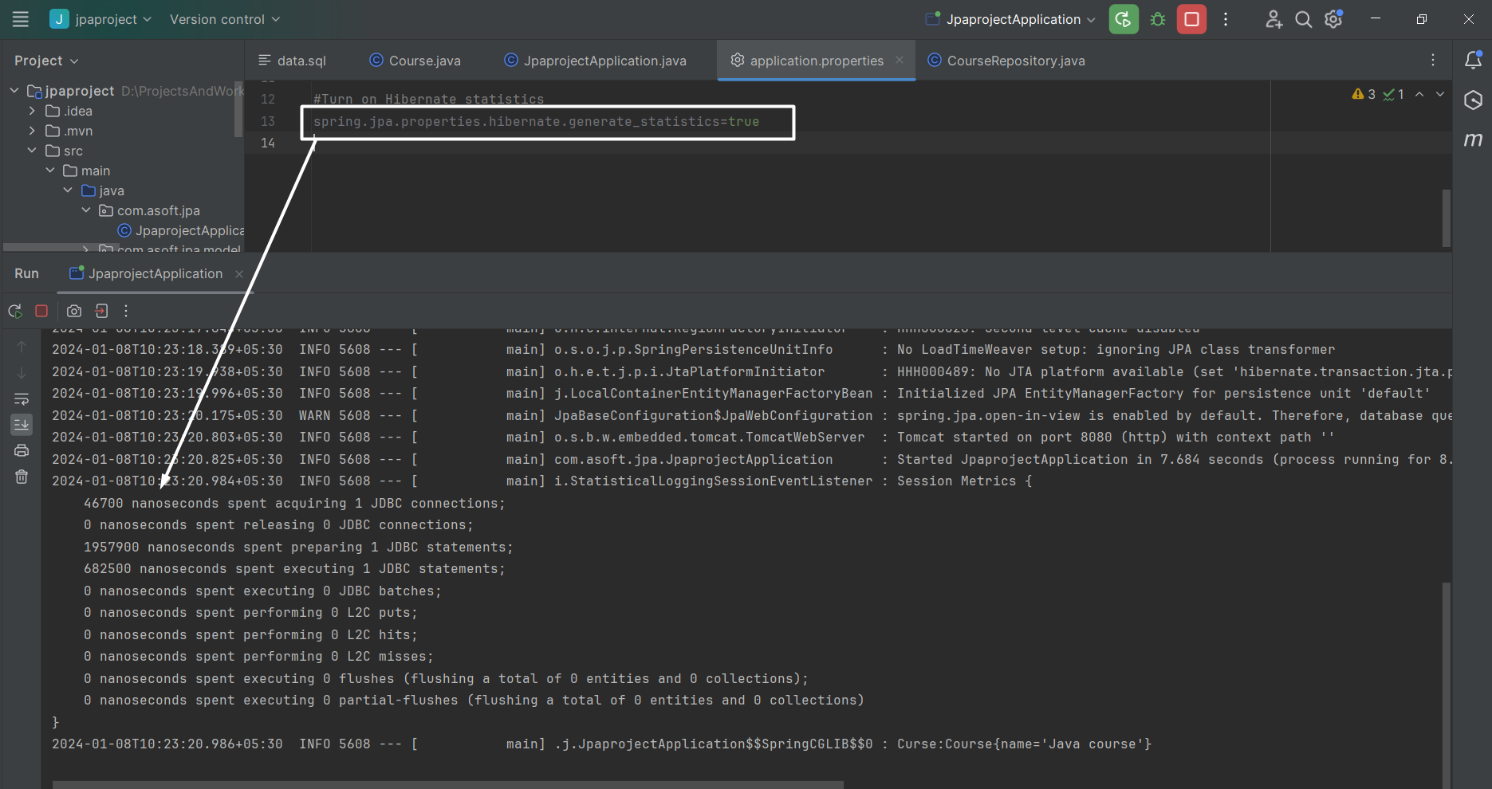

Show sql:

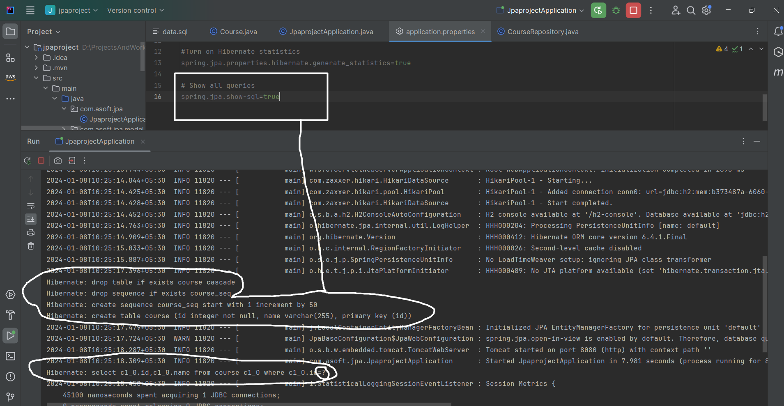

Writing delete method:

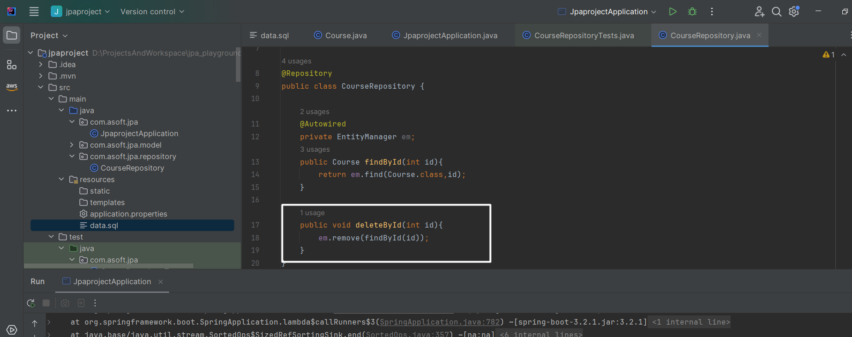

Called it from run method:

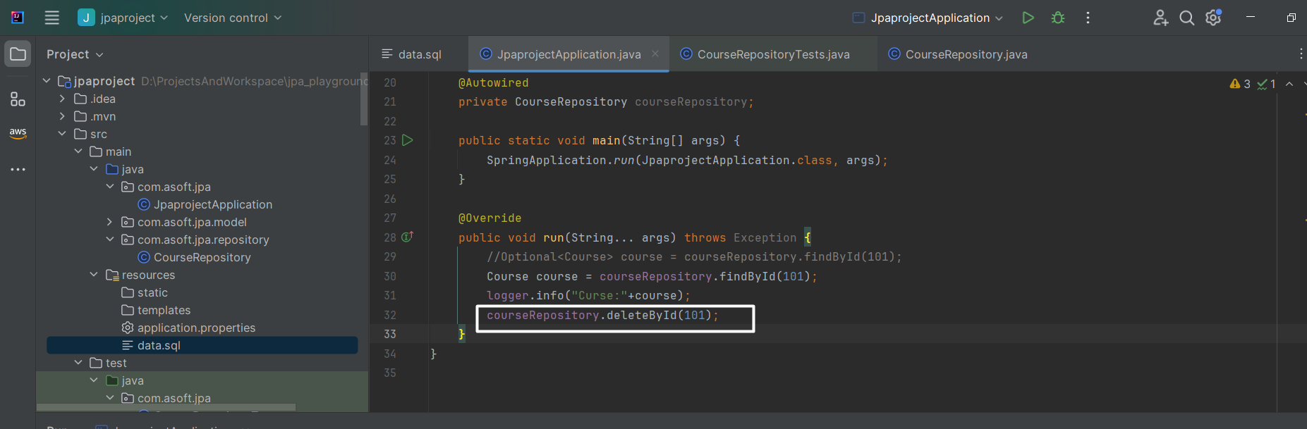

After run the application you will see the below error:

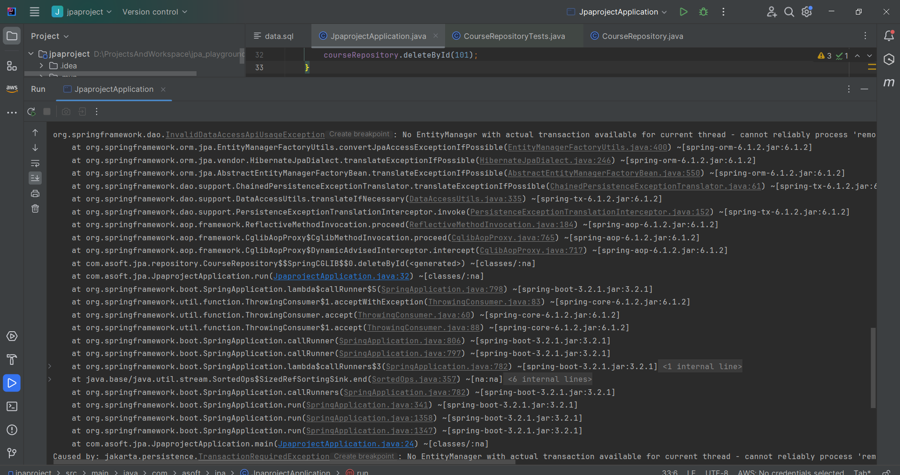

**org.springframework.dao.InvalidDataAccessApiUsageException: No EntityManager with actual transaction available for current thread - cannot reliably process 'remove' call**

**Caused by: jakarta.persistence.TransactionRequiredException: No EntityManager with actual transaction available for current thread - cannot reliably process 'remove' call**

The reason is whenever you manipulate data into DB using EntityManager then it should be in transaction.

So to resolve this issue adding **org.springframework.transaction.annotation**.Transactional annotation

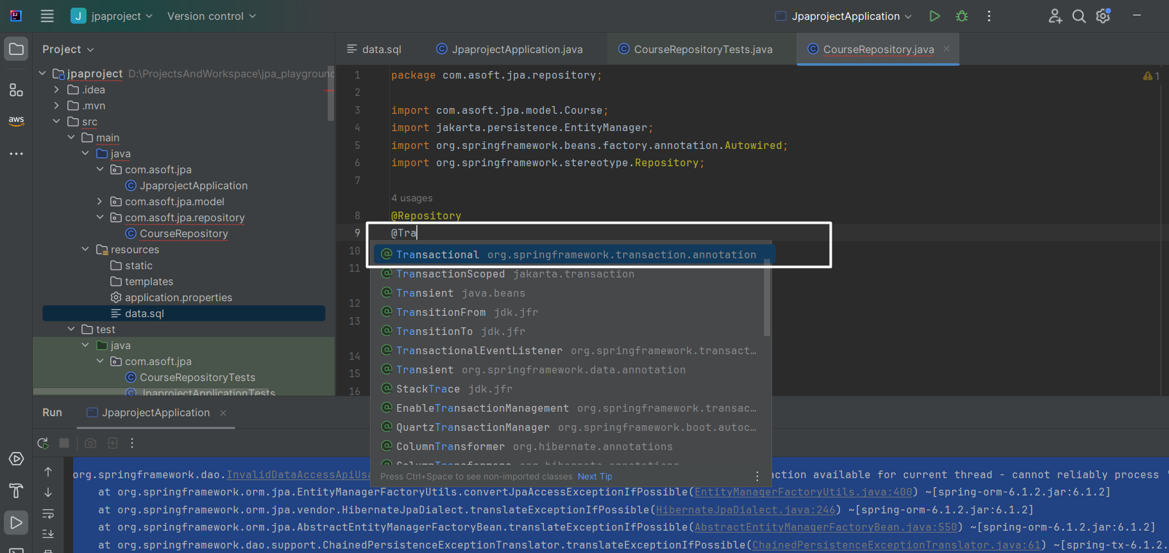

What is @DirtiesContext

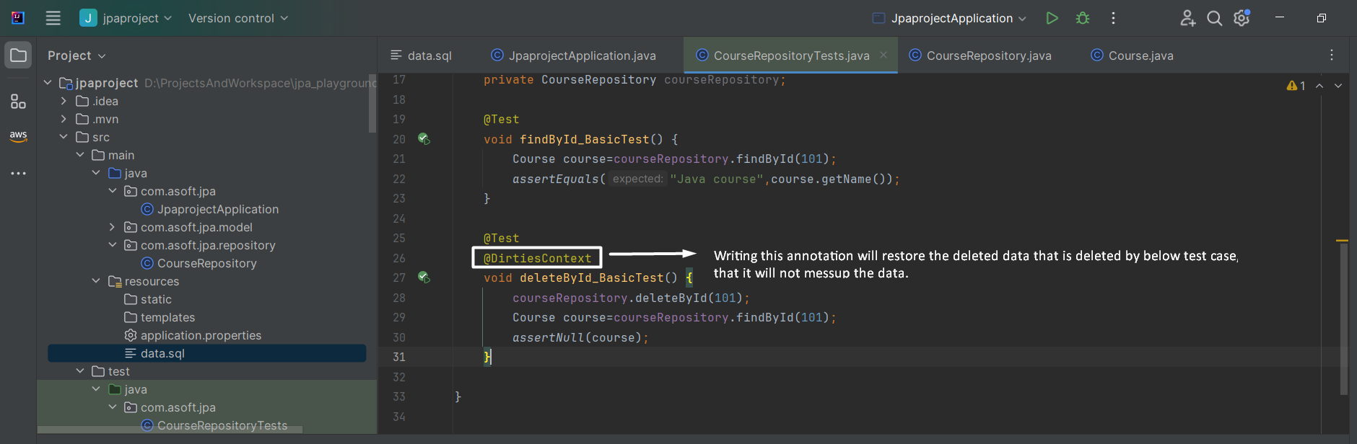

Save and update implementation with EntityManager:

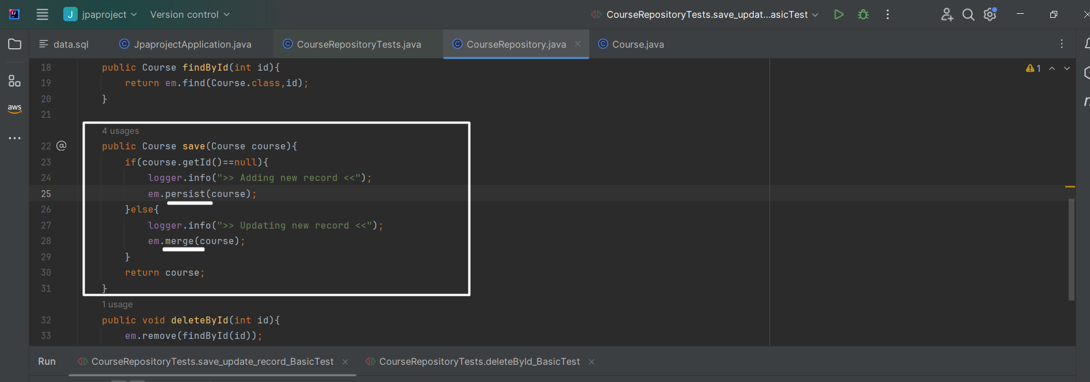

Test case:

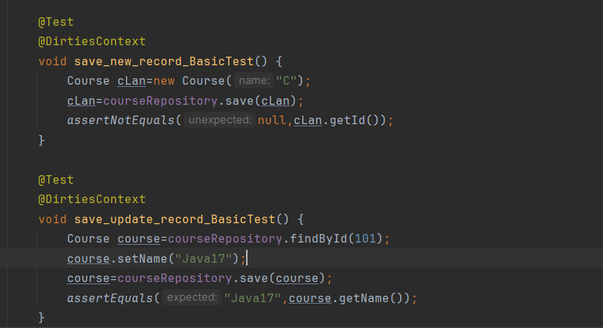

Corner point with entity manager:

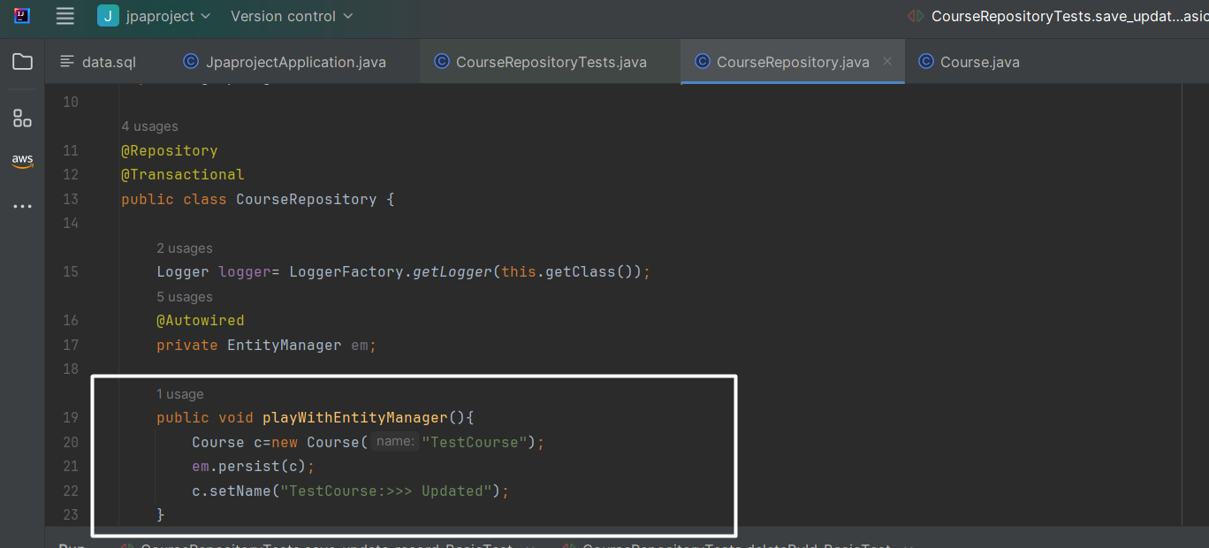

You have playWithEntityManager method that is creating new Course record into database using persists method. So when we execute/invoke playWithEntityManager method it is expected that in database I would see one row with “TestCourse” name. Ok enough talk, let’s execute and see the database:

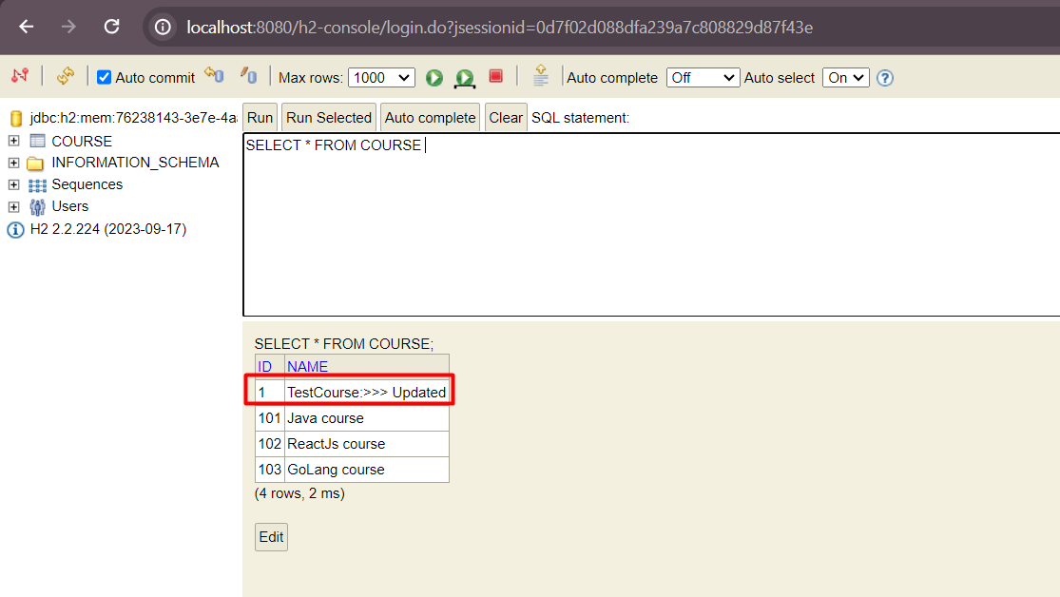

Ohh, it is expected that record should create with TestCourse but some entity manager creating it with TestCourse:>> Updated. But why?

The reason is @Transactional annotation is enabled on your class & after persist method you are setting name again with new value. The at line no 20 the transaction has been begin & transaction will track all changes to attached entity i.e from line no 21 to 23 and reflect those changes to the database. So bottom line is line no 20 to 23 is the transaction area.

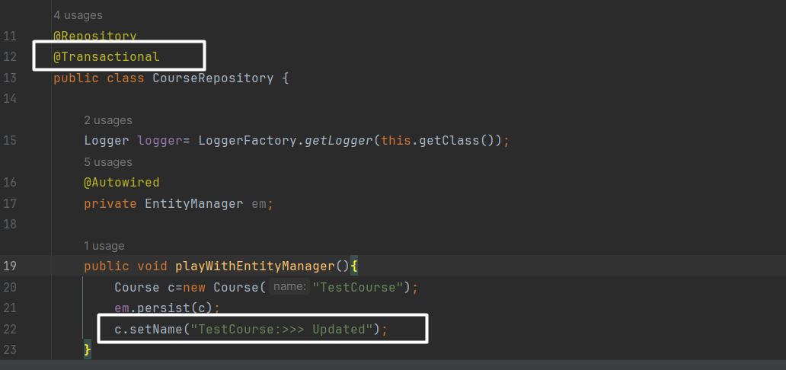

Detach() and flush():

So, let say you don’t want this kind of behavior how you gone achieve it?

* Yeah, you can simply detach the entity from entity manager after you persist using em.detach(course) or em.clear() method but before that you will need to flush it.
* NOTE that without invoking flush method detach won’t work. Because flush it kind of commit statement in database term.

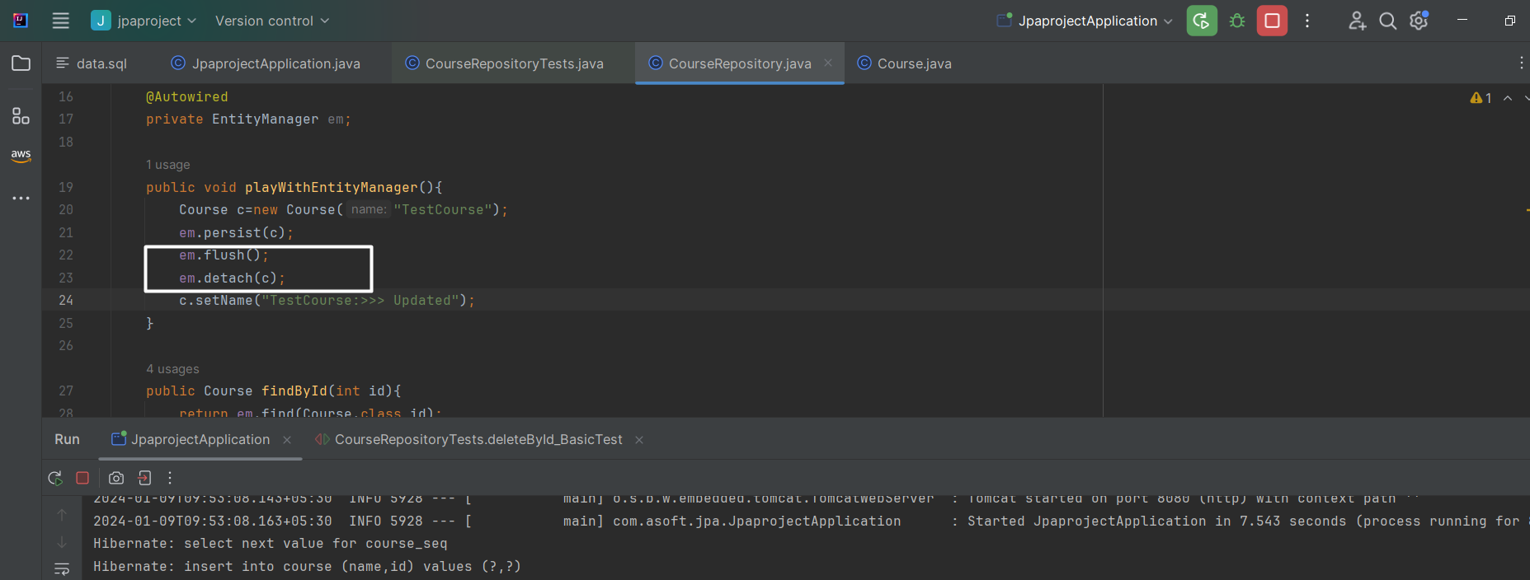

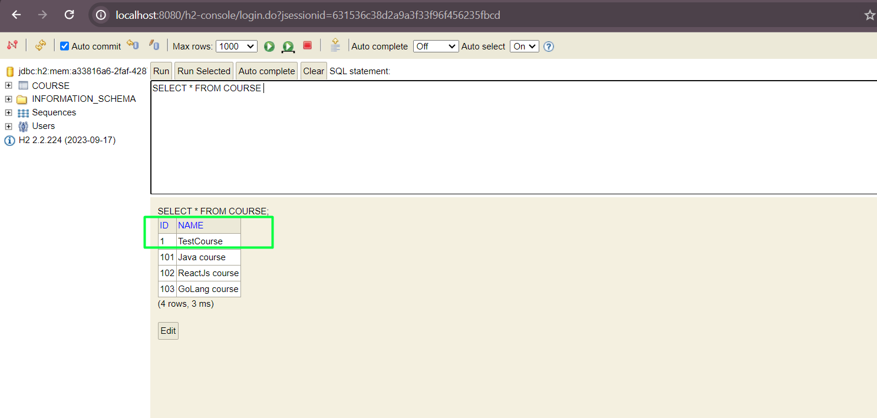

# JPQL basic- Java persistence query language

* See the comments in screenshot

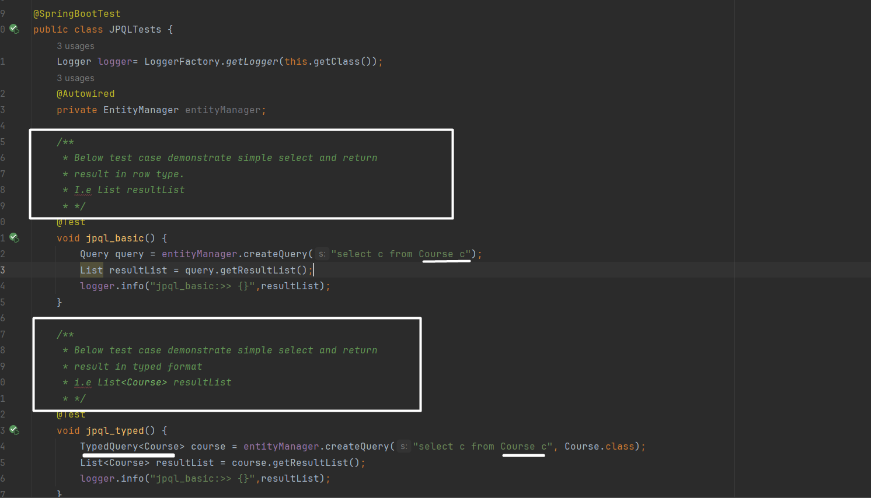

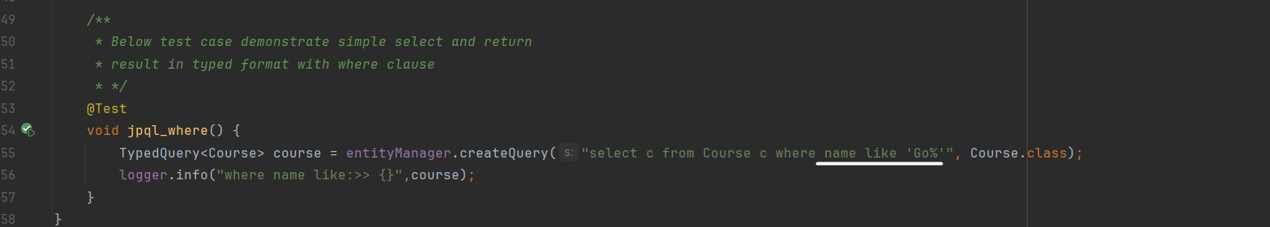

# Named Query:

-Main intension of named query is reusability, it means define once and reuse multiple time.

Example:

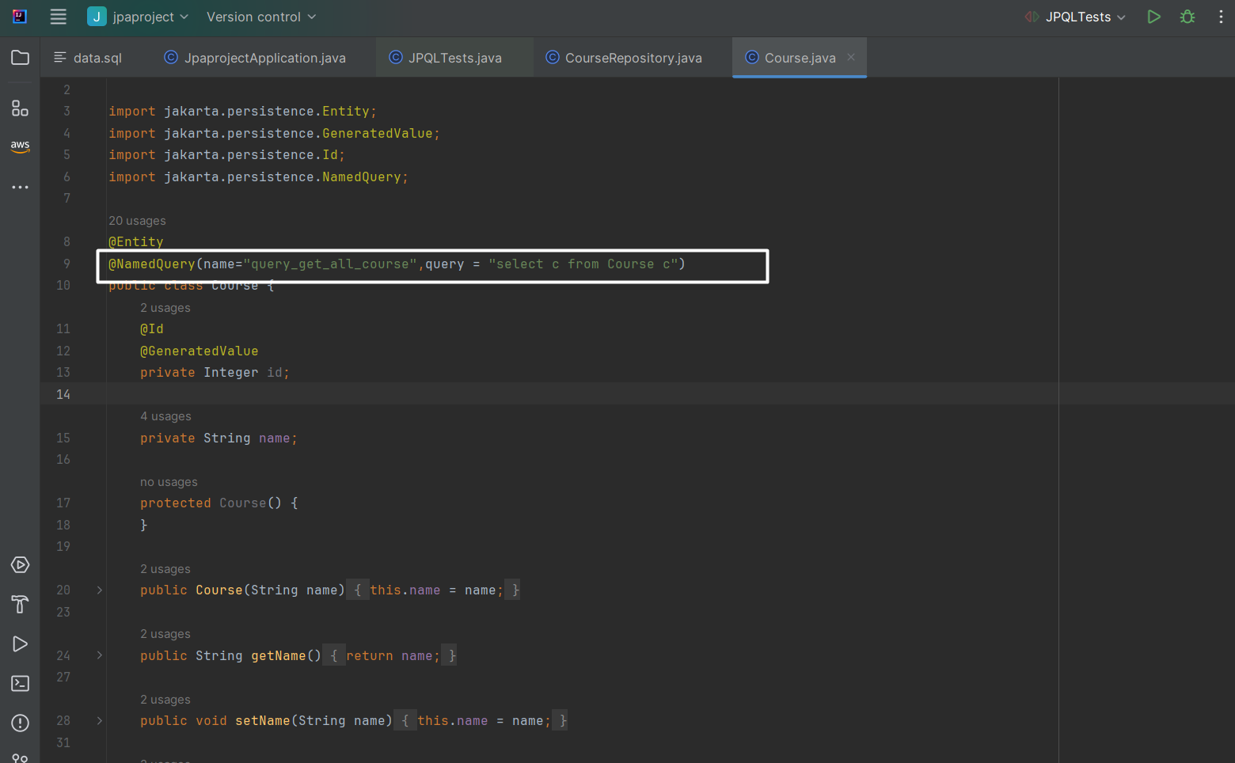

Now use this query in caller: using createNamedQuery method we can call the query

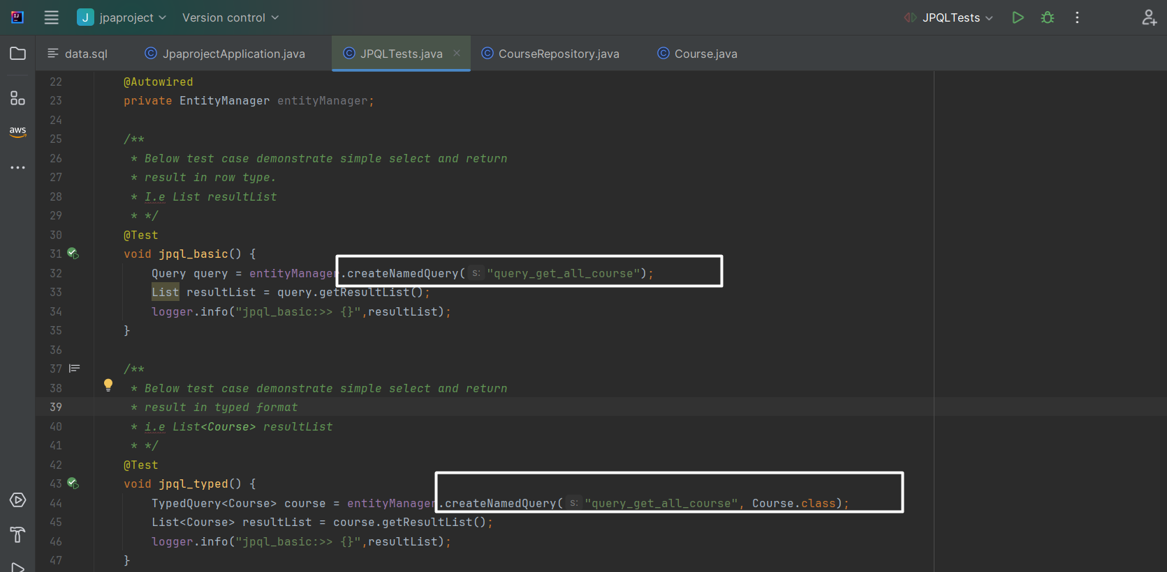

What if you want to define multiple named Query?

There is two way:

First define namedquery like this

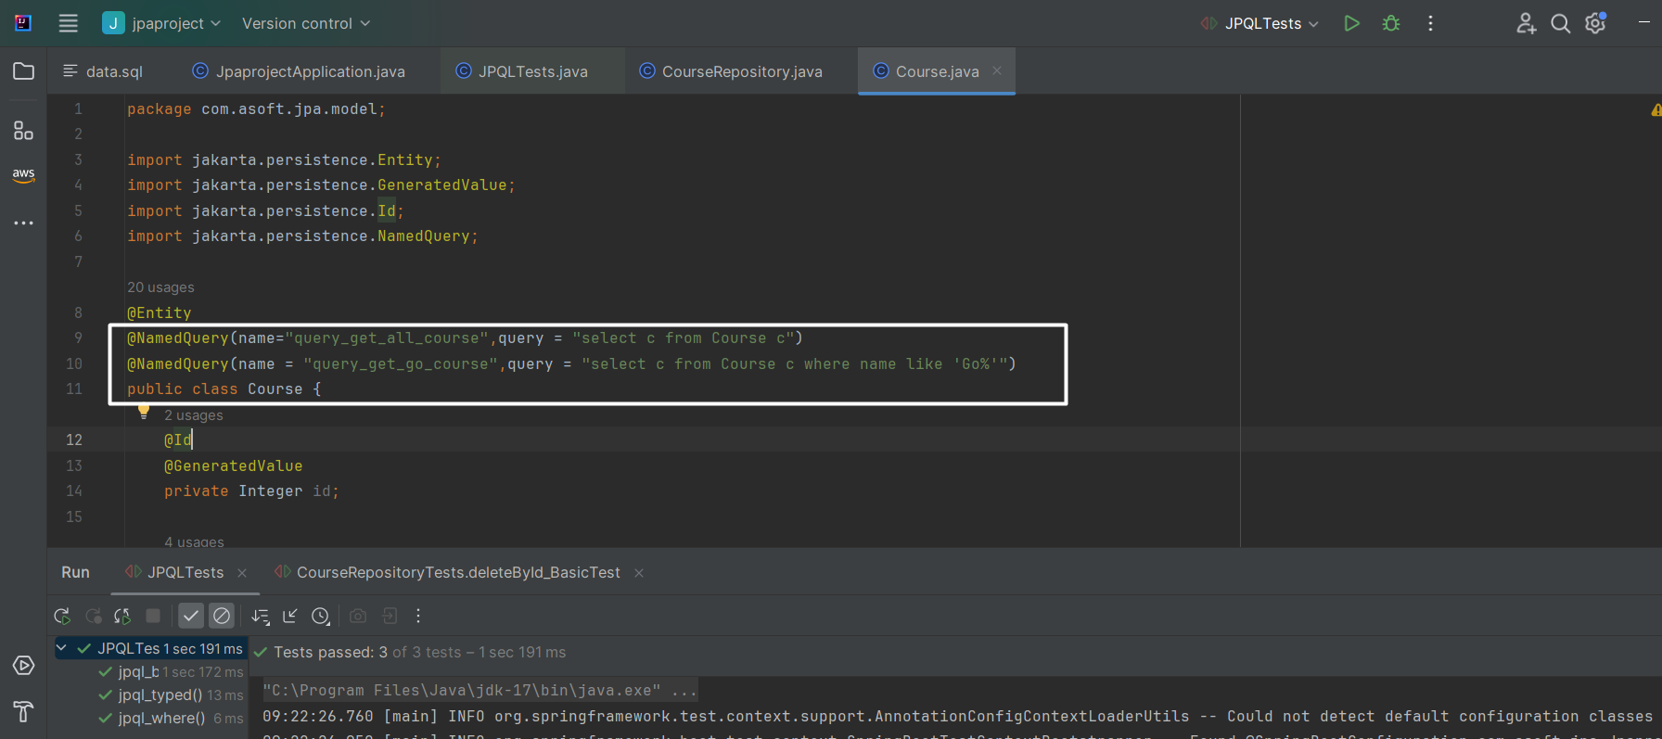

And invoke like this:

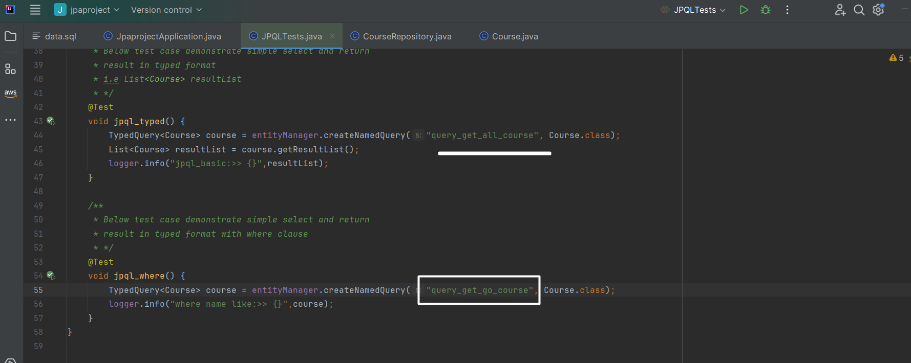

Second: Define named query using @NamedQuer**ies** annotation, so that all queries are grouped

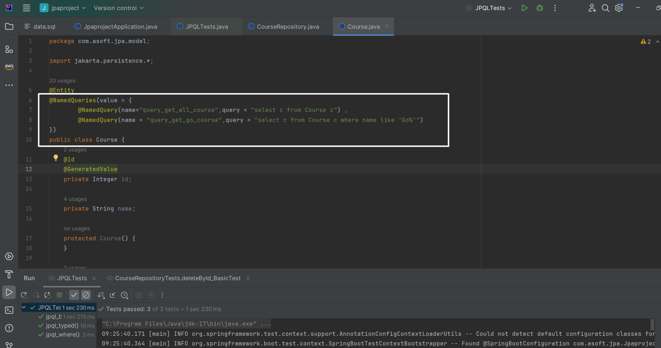

Invoke as like previously invoke.

# Native Queries:

Native query is nothing but sending a raw sql out database.

PLEASE COMMENTS TO UNDERSTAND THE PURPOSE:

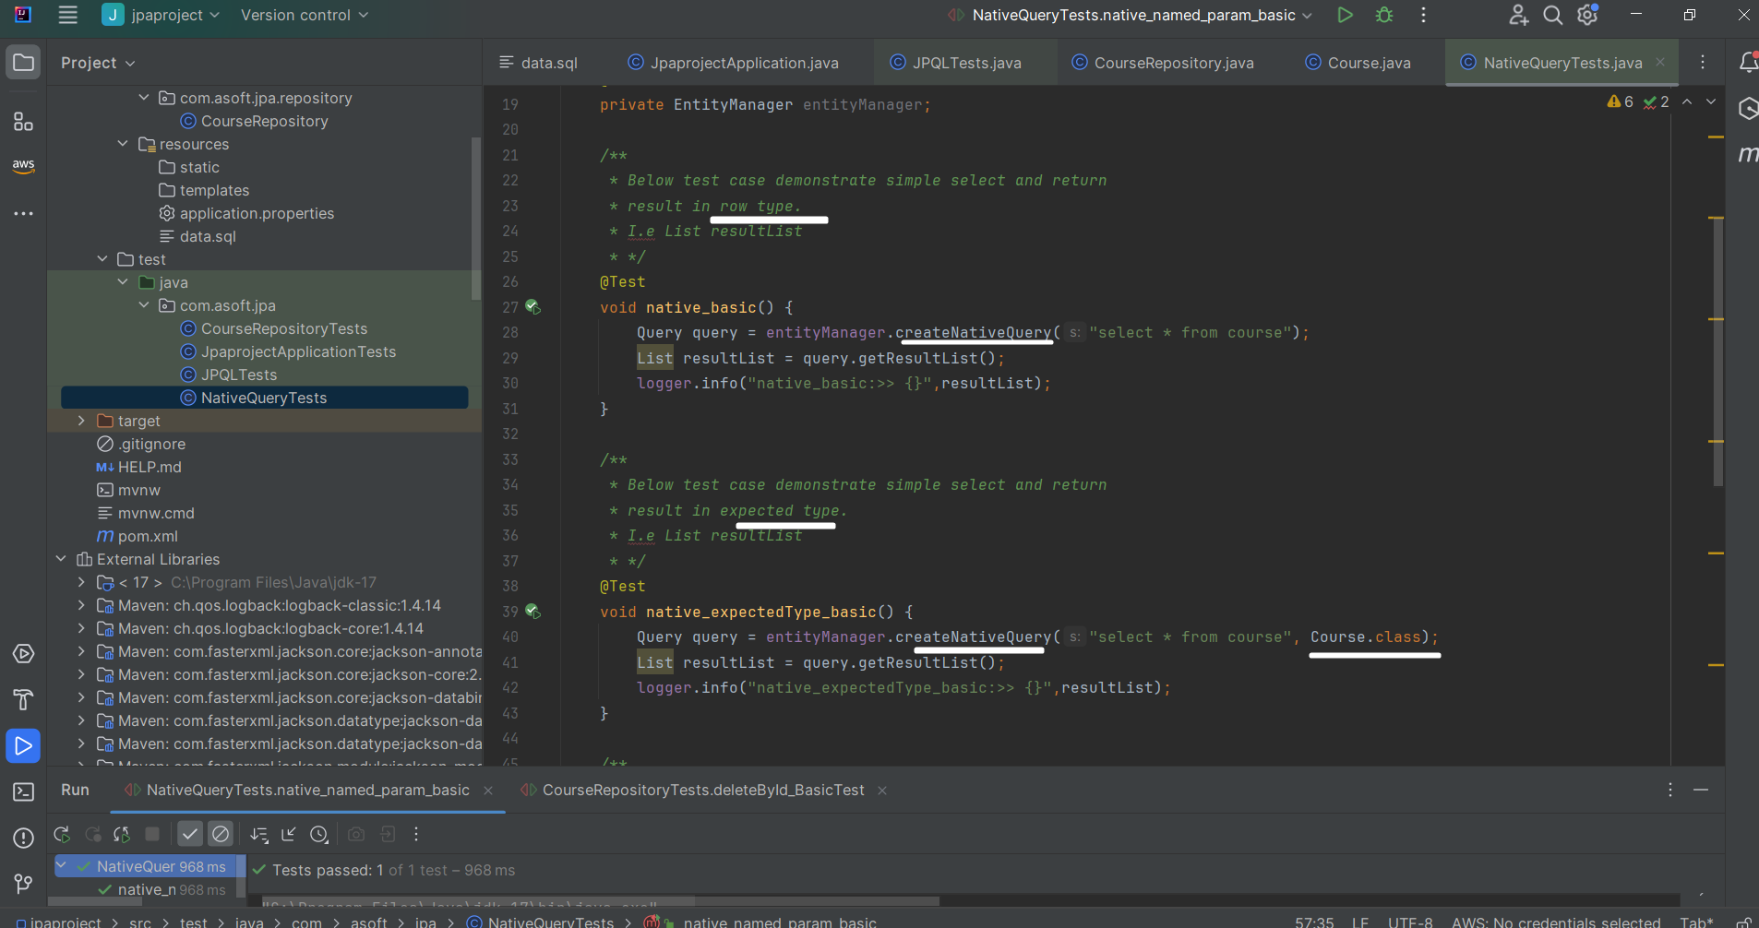

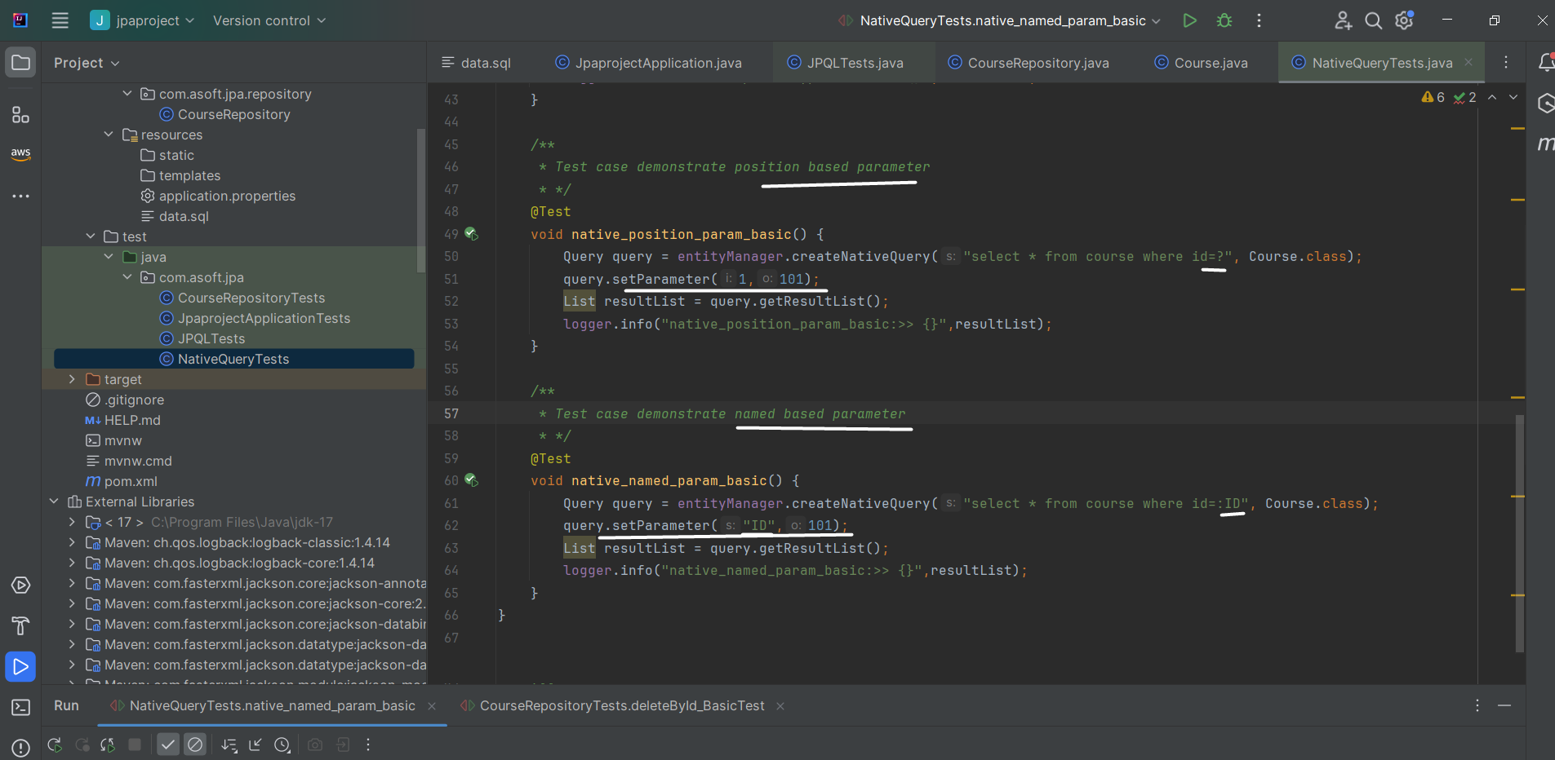

Best use case when to use native queries:

* When you want to use database specific features
* Mas update
  + If you want to update n number of rows of particular table then it is best, because using JPA to update the row we need to first read it and then update it.

Ex:

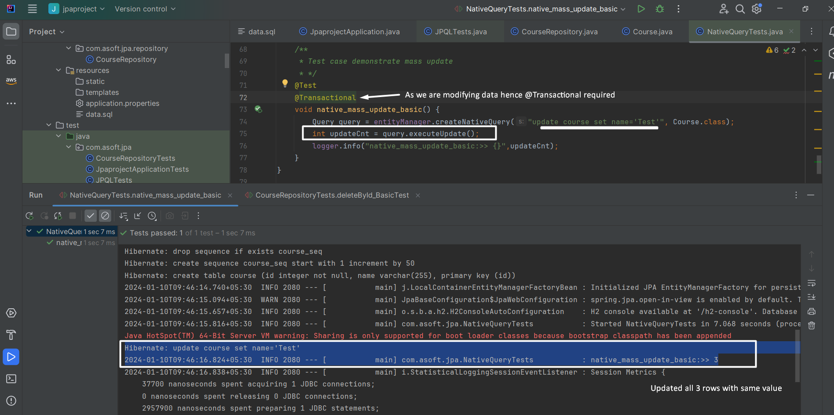

# Entity Relationship

## One to one:

Entity involved: Student and Passport

Before any relationship define the code and table structure

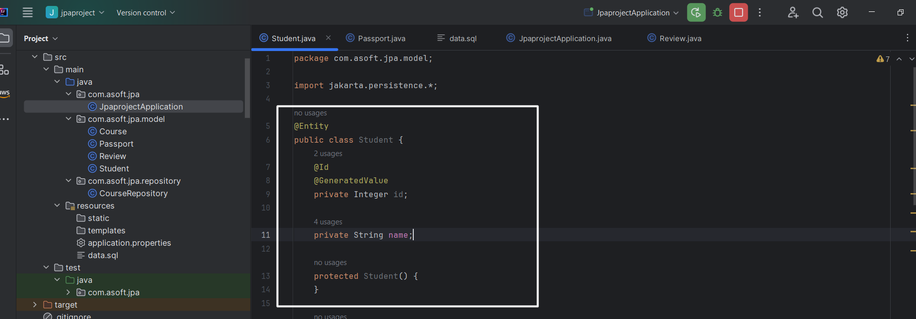

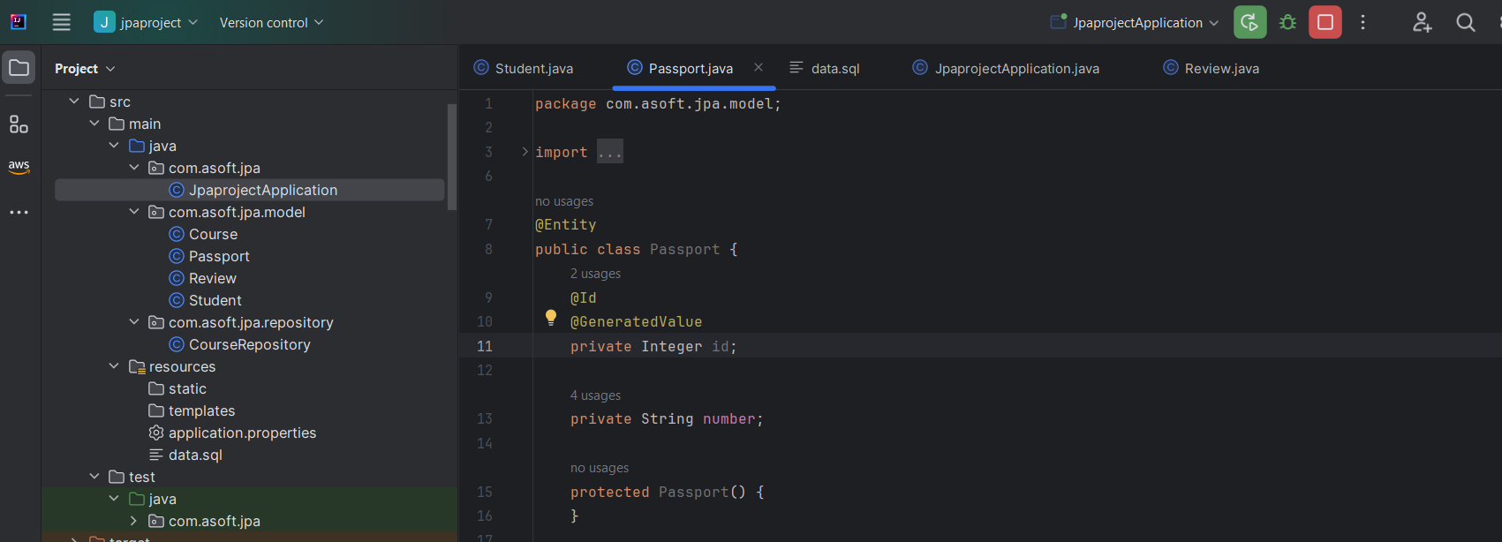

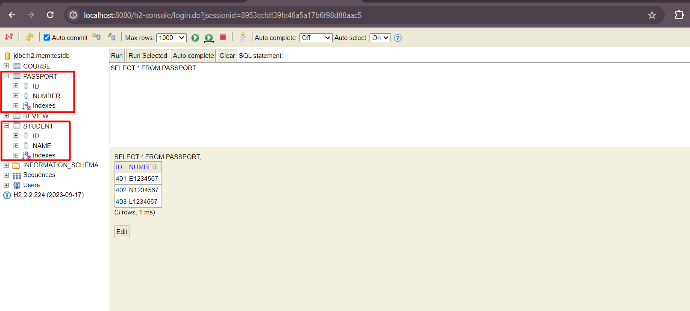

To establish the relationship between Passport and Student entity we either create passport id column into student table (in this case Student will be owning entity) or we can create student id column into Passport table (in this case passport will be owning entity).

Student as owning entity:

Code:

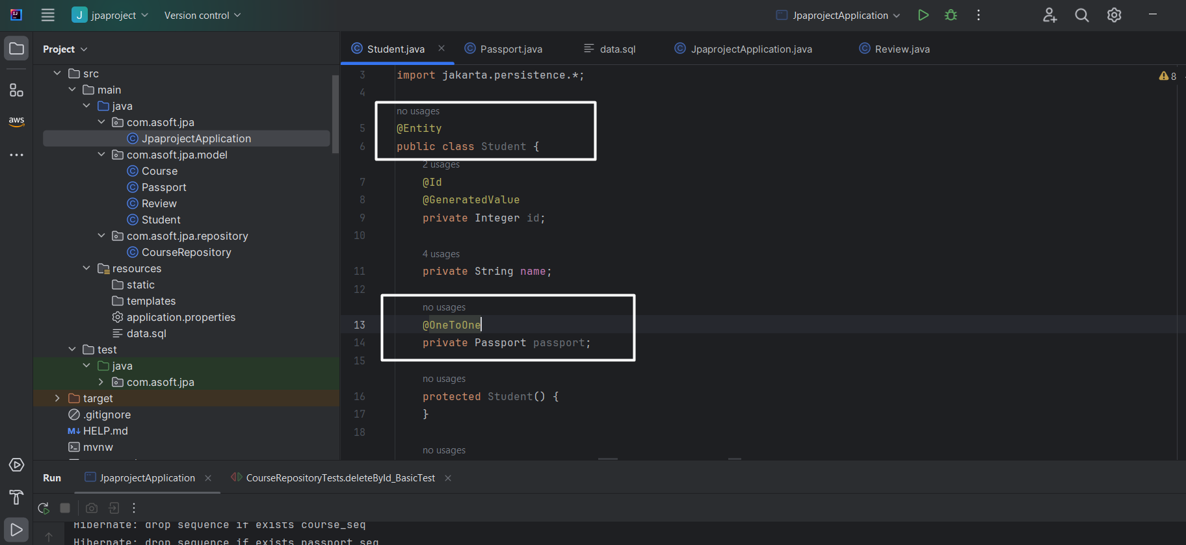

Restart the server and see the table

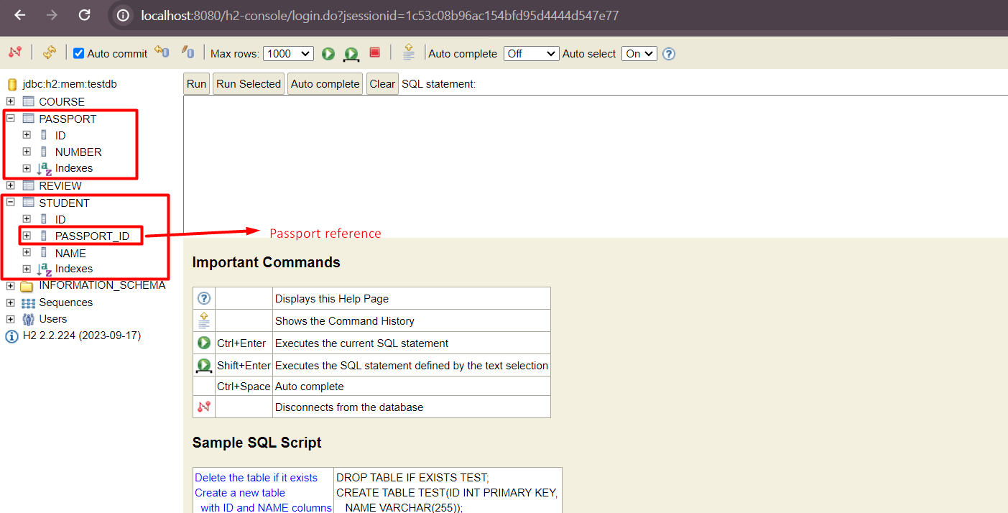

Let’s add passport id ref to data while data load:

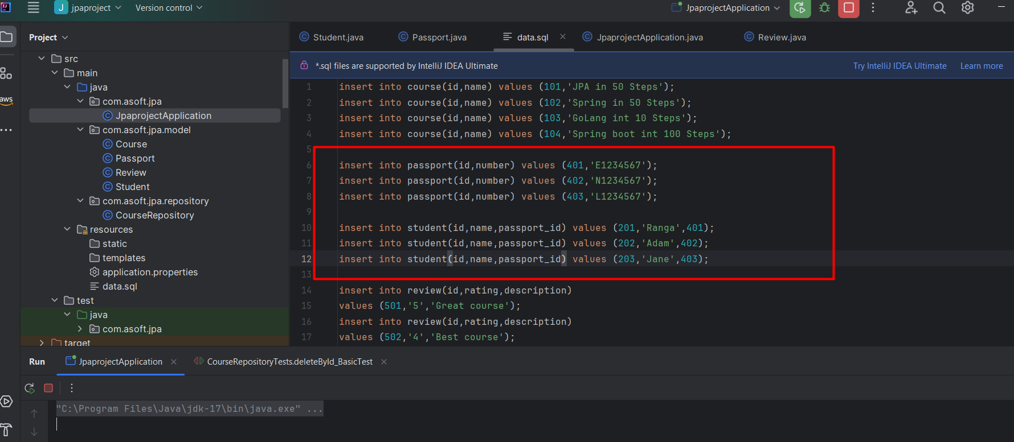

Restart the server and see the table

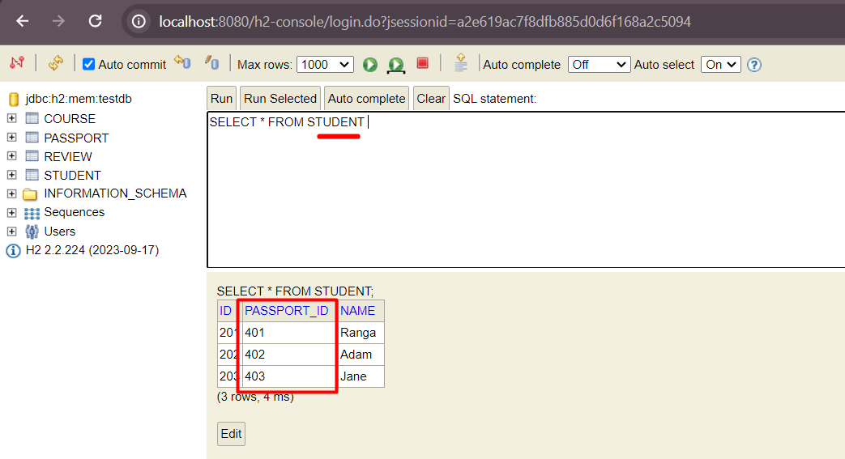

Add Student and passport record using Repository

Code:

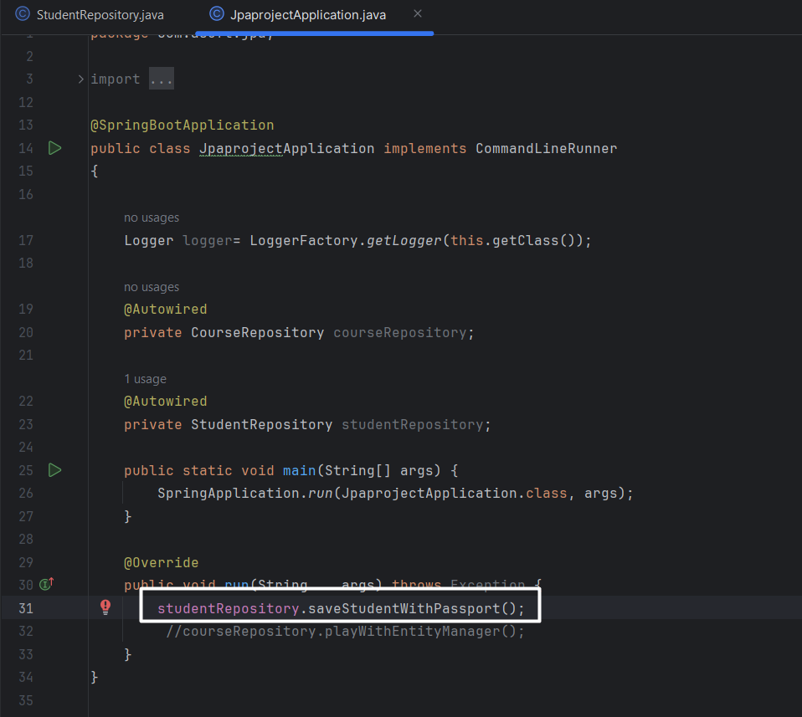’

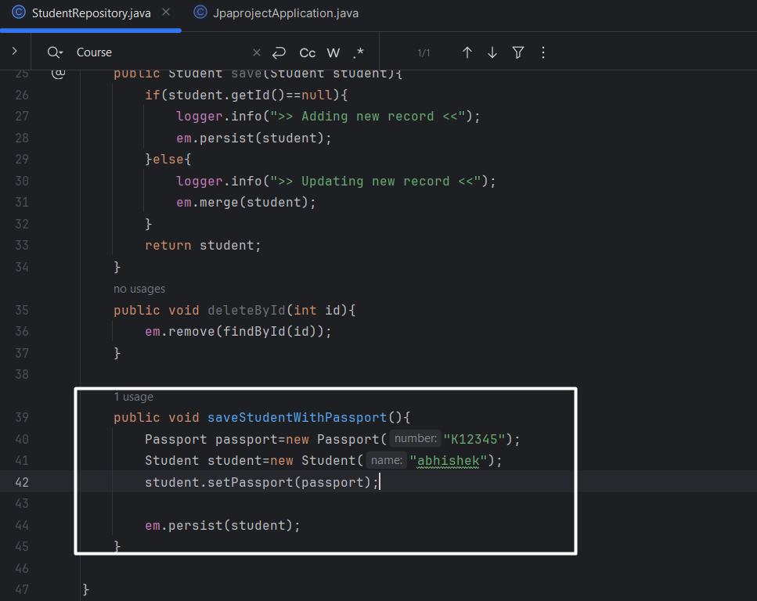

Start the server:

Failed with

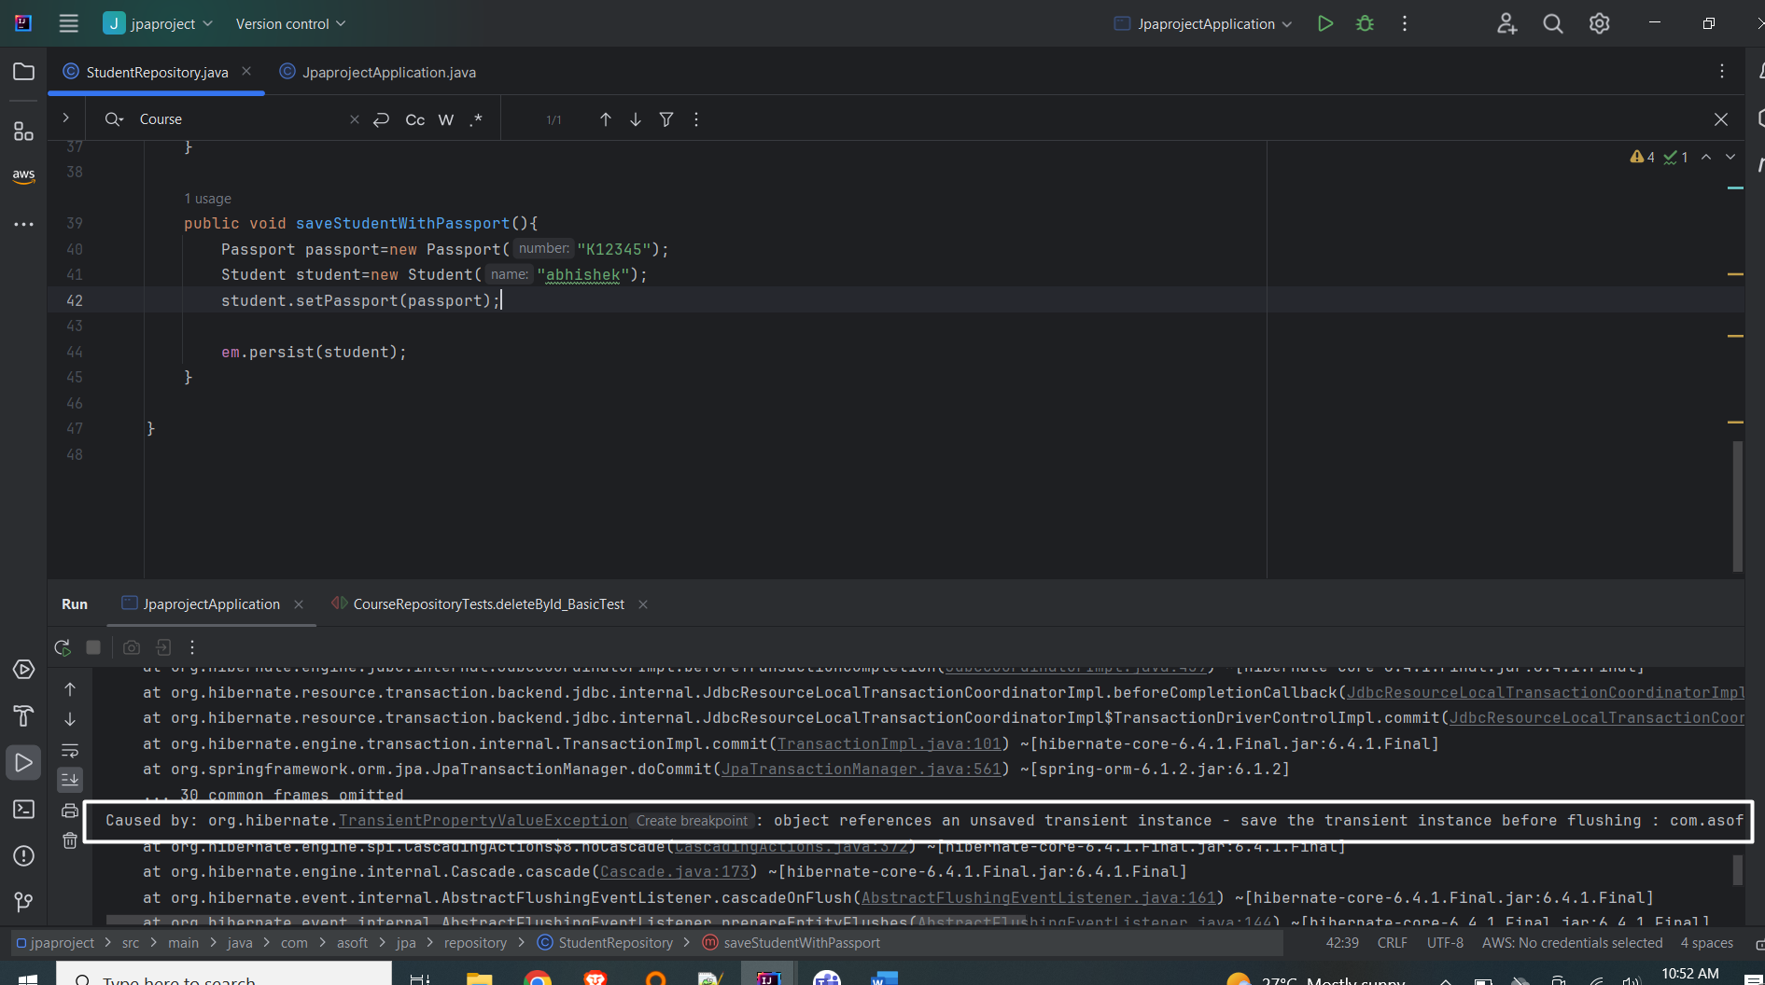

Caused by: org.hibernate.TransientPropertyValueException: object references an unsaved transient instance - save the transient instance before flushing : com.asoft.jpa.model.Student.passport -> com.asoft.jpa.model.Passport

Because you our passport entity record is not yet saved in database still you trying to use it for relationship. The solution is first save the passport entity and use it int student entity for persistence

Change code & restart the server:

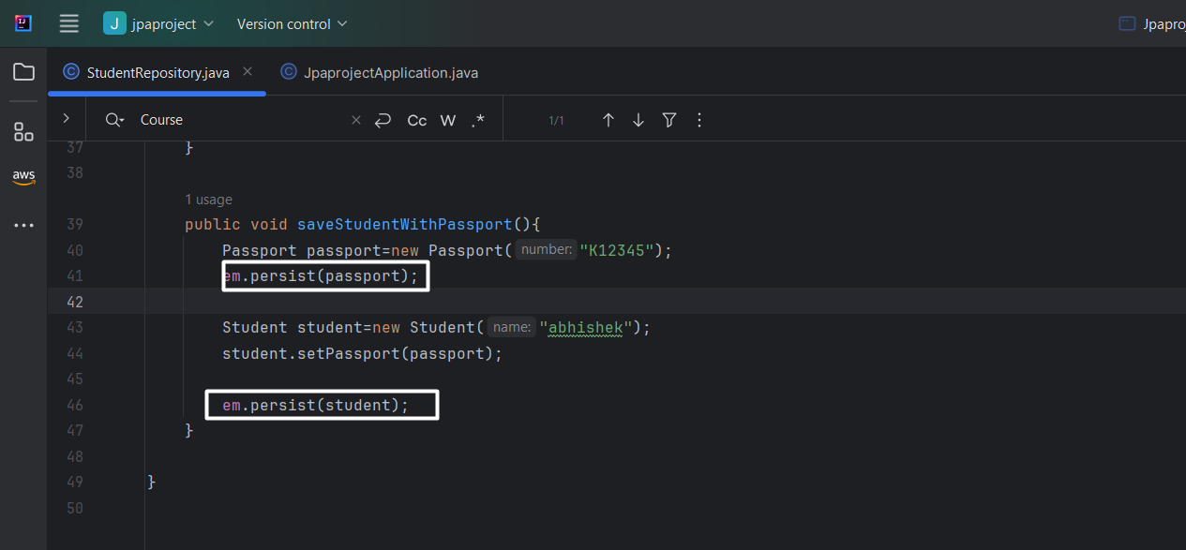

No error, see the records in table

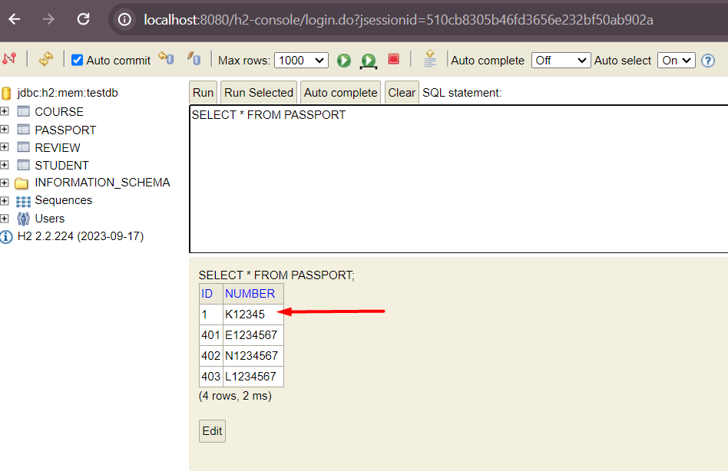

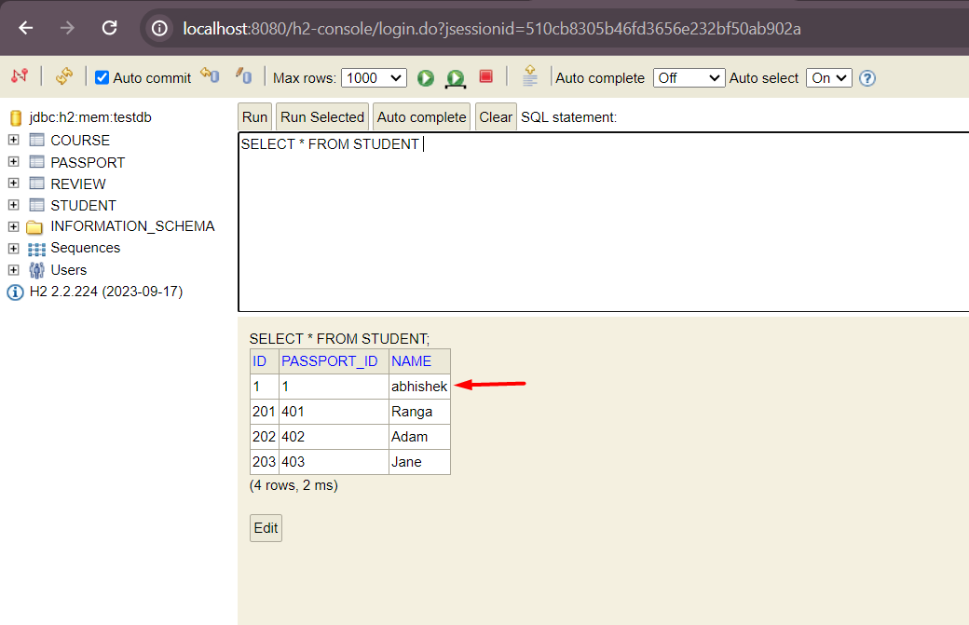

Eager loading and lazy loading

To understand this let’s write a test case that will fetch record.

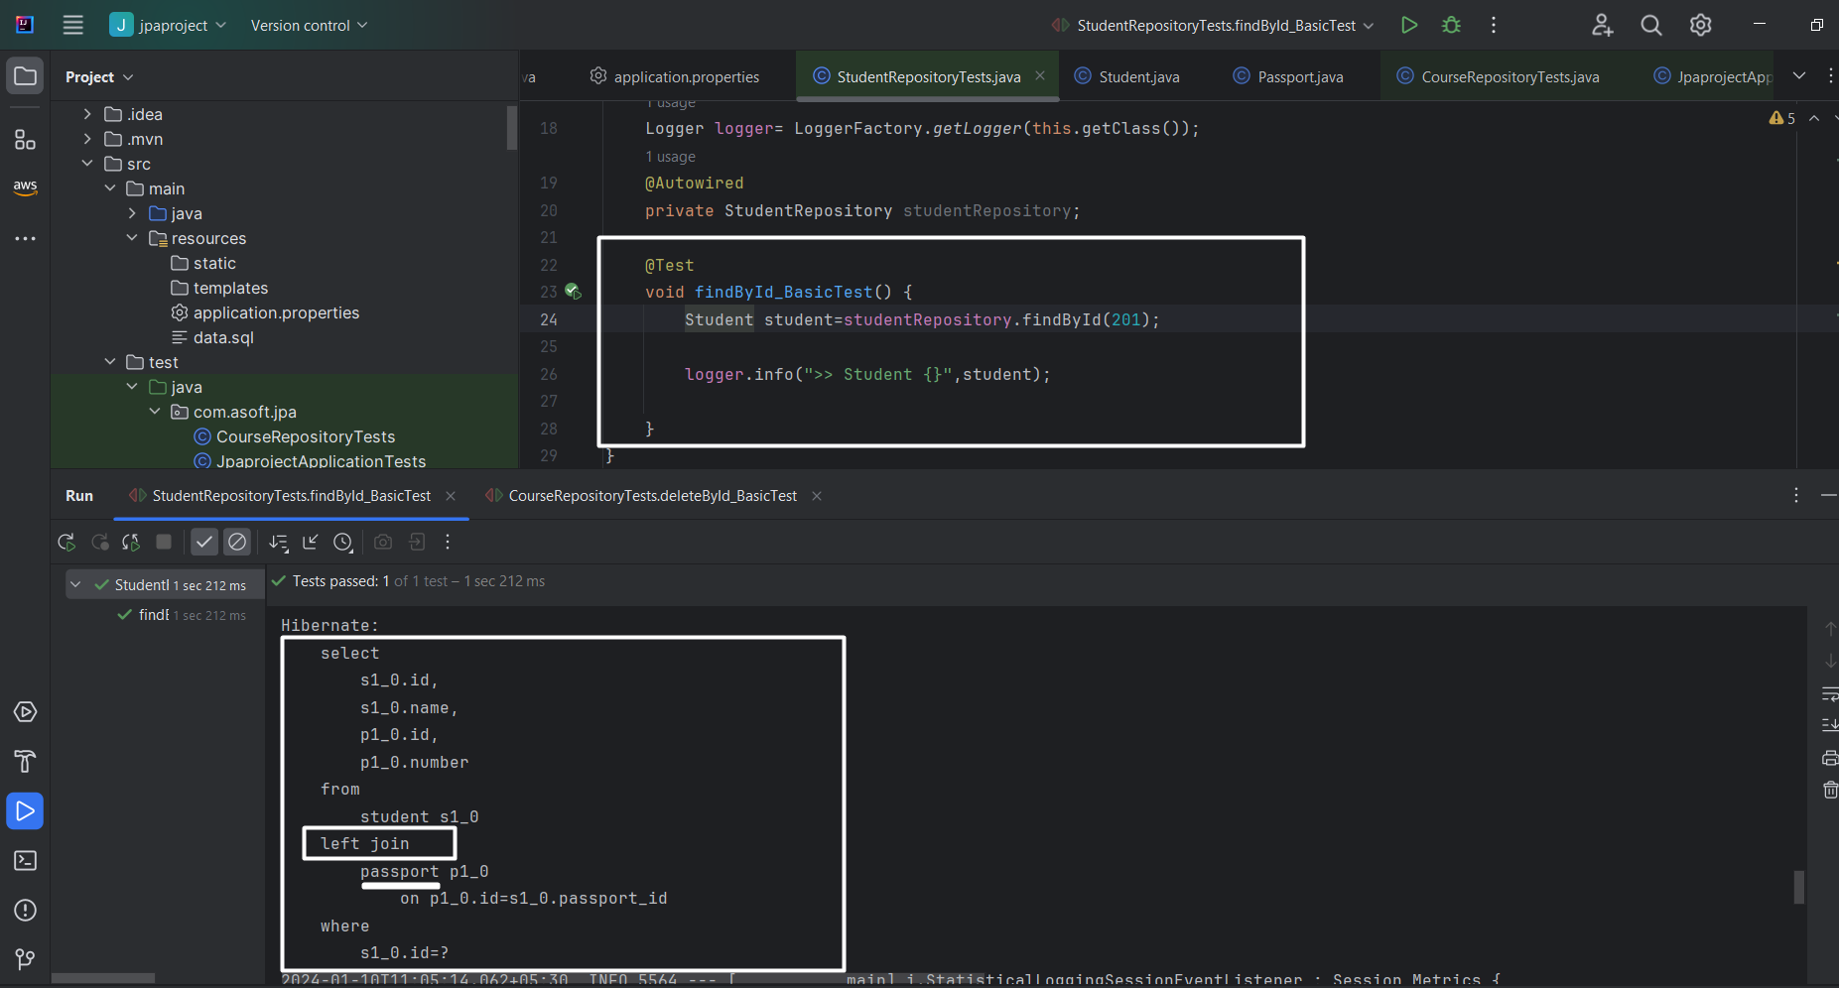

Here entity manager fetches the associated passport record as well while retrieving student. See the generated SQL it is doing left join on passport table. It surely causes performance issue in large data volume. This is called **Eagerly fetch**.

Data:

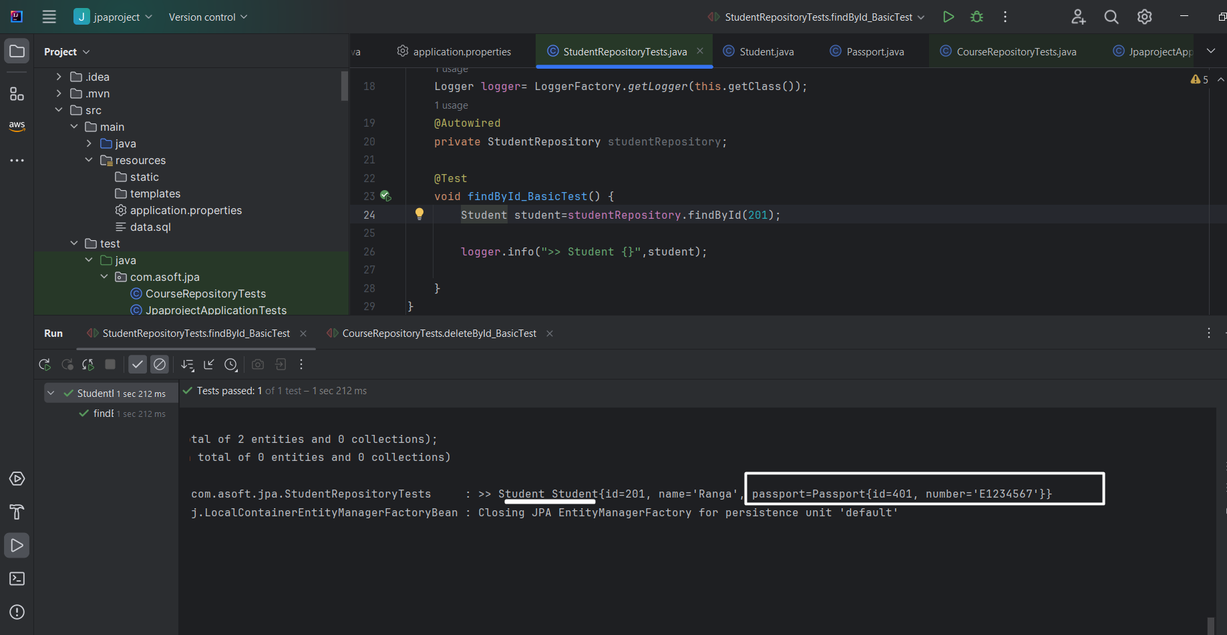

So how we can solve this issue:

We can solve by changing

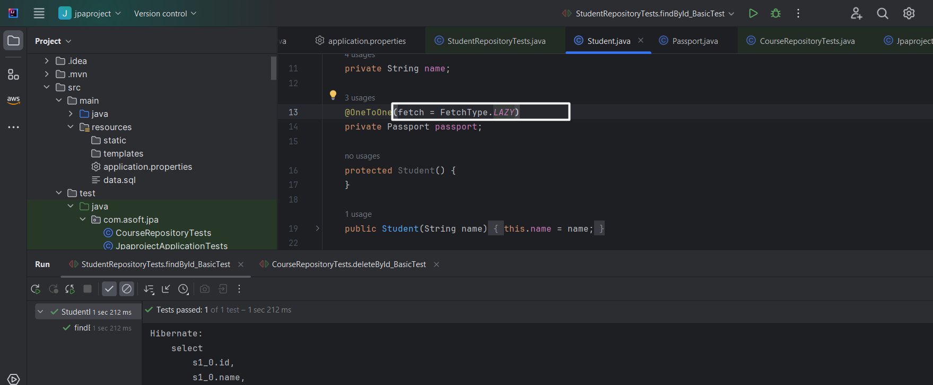

Now re-run the test case and see the logs:

Now select query prepared without left join

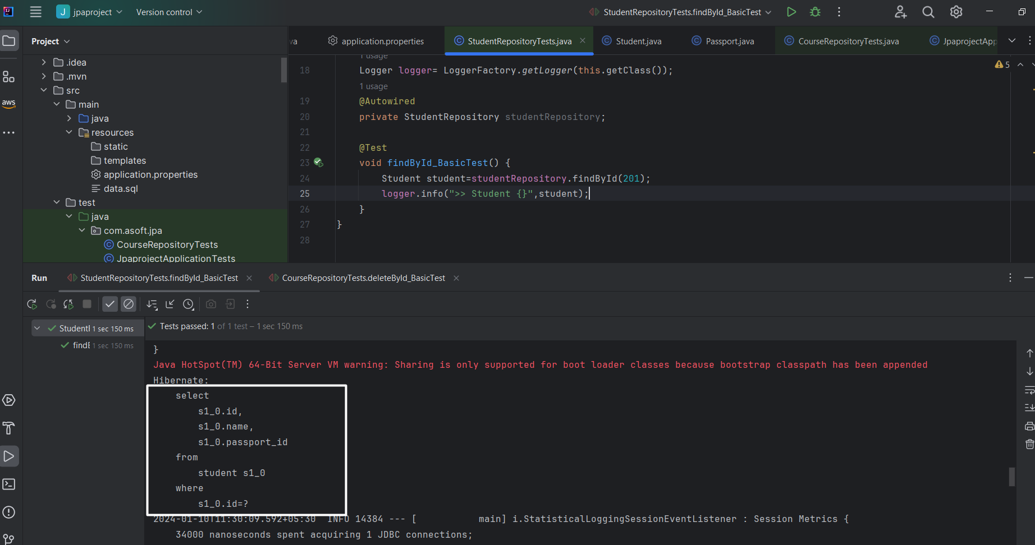

Now make code change & try to get Passport record

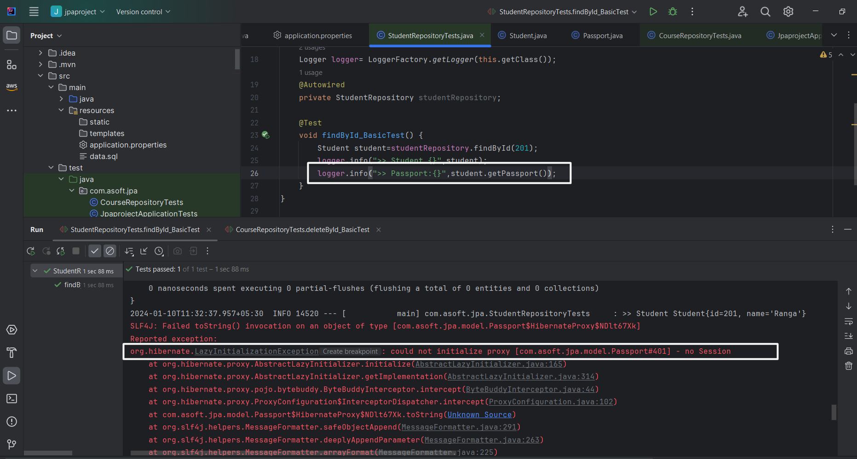

You can see the exception, the reason is in studentReporsitory. findById does not have @Transactional annotation hence after executing em.fetchById() the session is closed, and when try to invoke passport object that time jpa try to make separate query and while executing that query he got to know that session is closed hence throwing the error

StudentRepository:

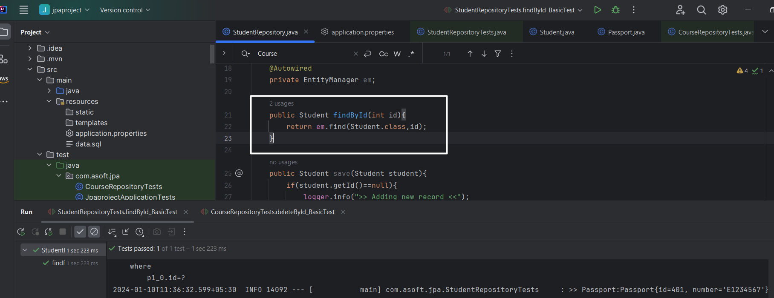

To solve this issue I am writing @Transactinal on findById_BasicTest

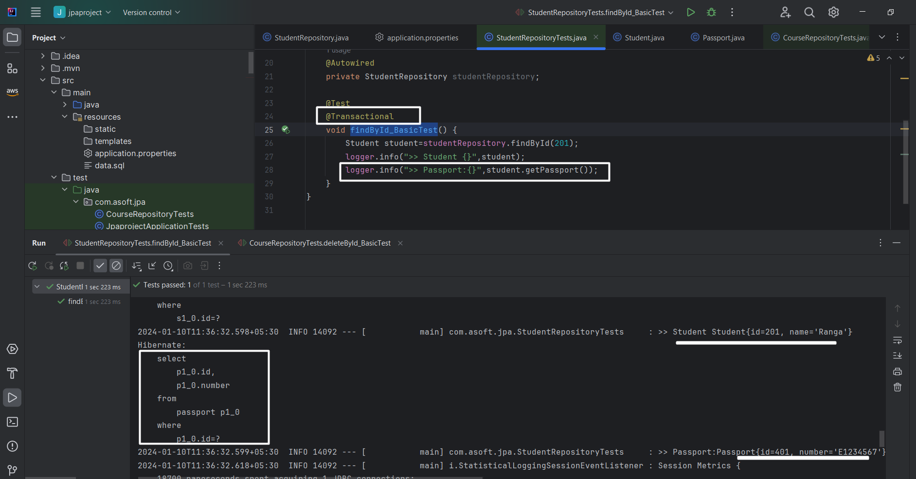

## One to one bidirectional

Till now we have define owning entity as Student, it means Passport id column will be created into Student table. So that we can get the respective passport object by using student object ref. (ex: student.getPassport()).

Now what if we want to get student information using passport object ref. Ex: passport.getStudent(); ? How we gone achieve this?

* To achieve this first we need to add student ref into passport entity like below

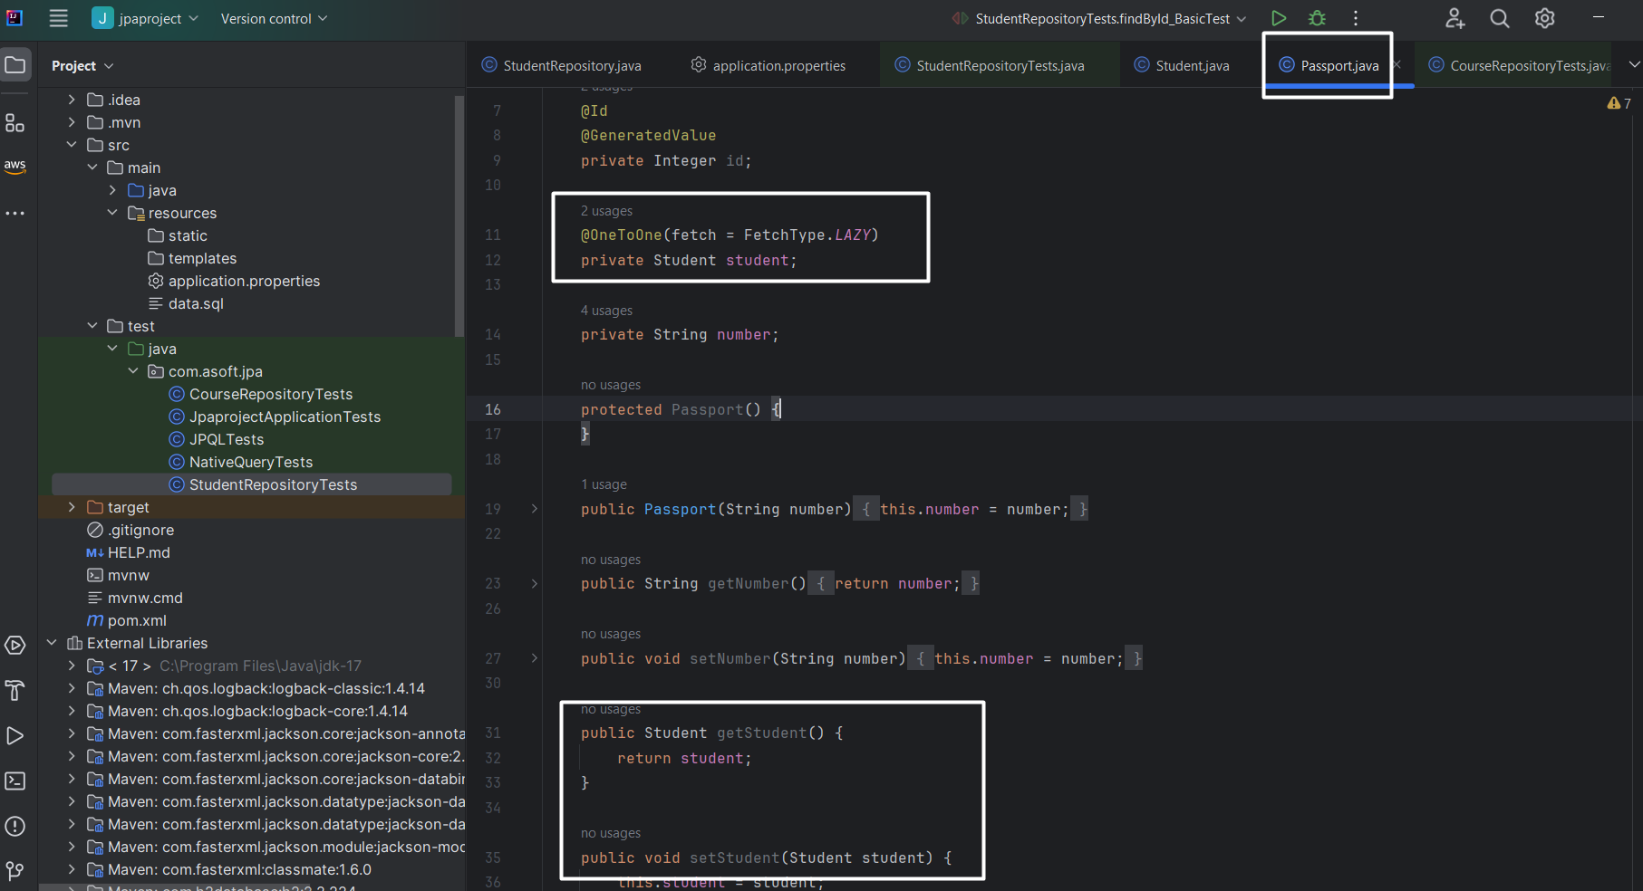

Restart the server and see the table structure

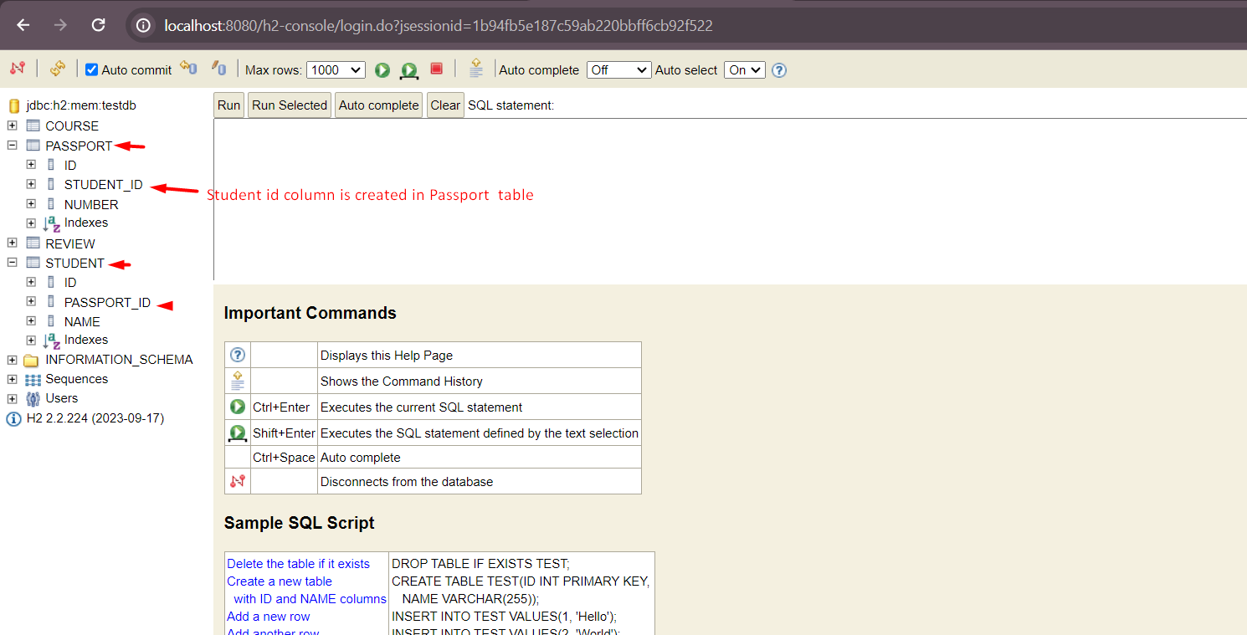

Now we have passport id column ref in student table and student id column ref in passport table. The main issue here is we are duplicating data. And according to DB design rule this invalid. So how do you gone resolve this issue.

* We can resolve this issue using **mappedBy** , let’s make small change in Passport entity and restart the server and see the table

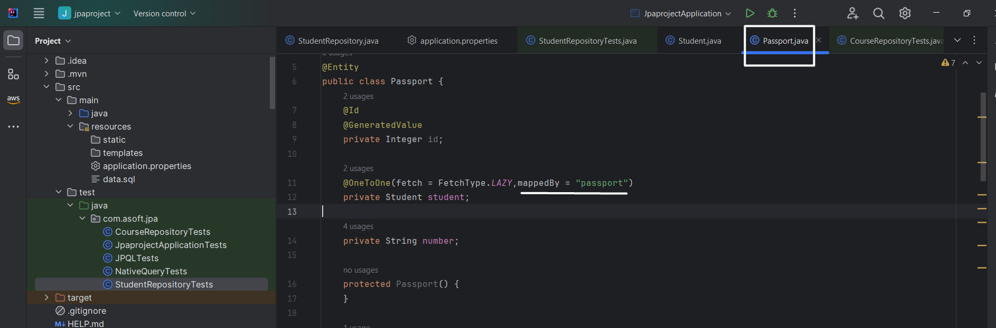

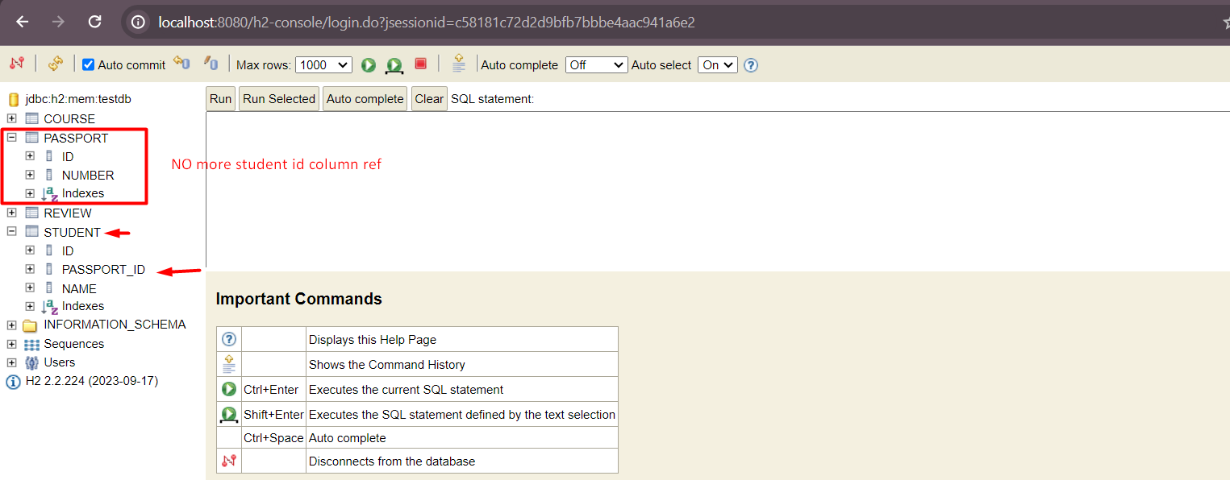

Now retrieve the Student by Passport. (in short navigate student from passport)

Write a test case and execute

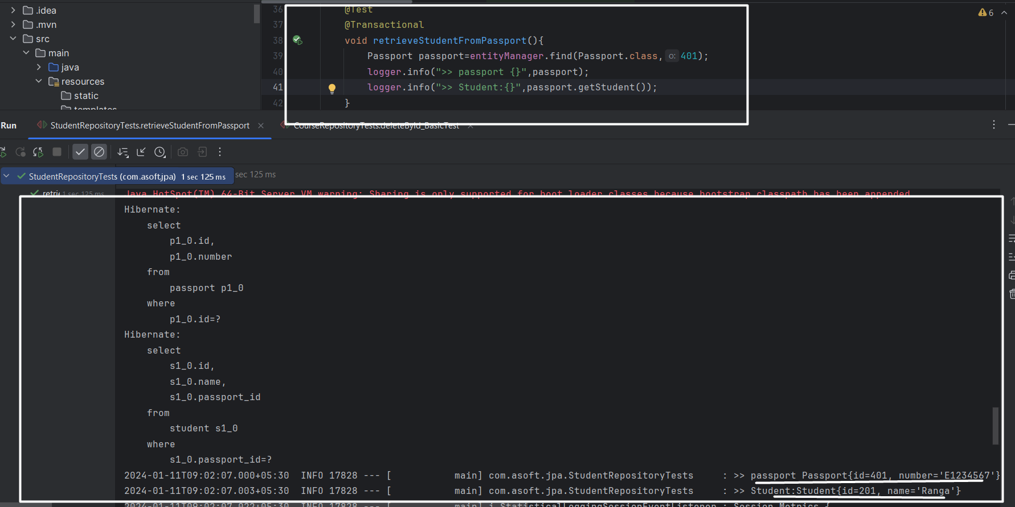

## One to many relationships:

Let’s start with example, we have two table called course and their review like below

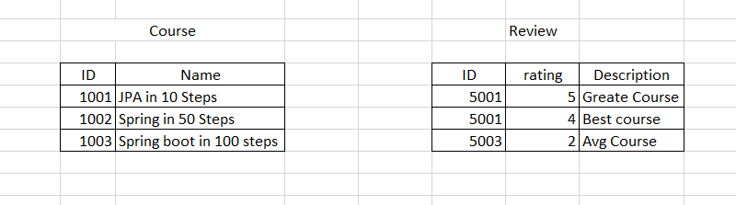

So one course have 0 or multiple reviews. For example

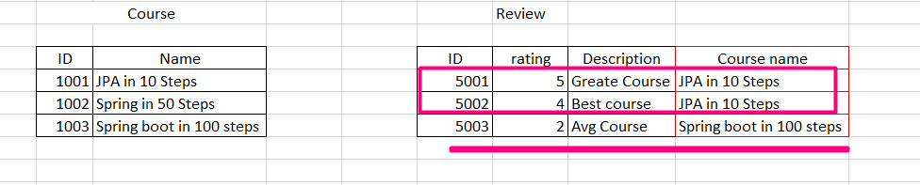

As you can see review table, the JPA in 10 steps course have two review i.e 5001,5002 and Spring boot in 100 steps course have one review i.e 5003 and course Spring in 50 steps does not have any review yet.

So how do I establish the relationship between Course and Review table.? Can we add review_id column into course table.? Let’s try this..

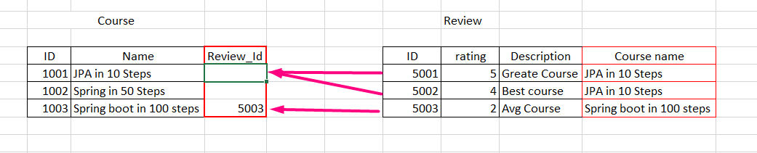

Ohh, can you see the problem? The Course 1001 have two review so it is not possible create one more row in course table with same course name just to represent another review, what if we have 100 of review for course 1001? Can we store review id like 5001,5002 ? Answer is no. It is bad design.

So how to solve this problem?

* We can simple add course_id column ref to Review table. I.e by making review entity as owning side of relationship.

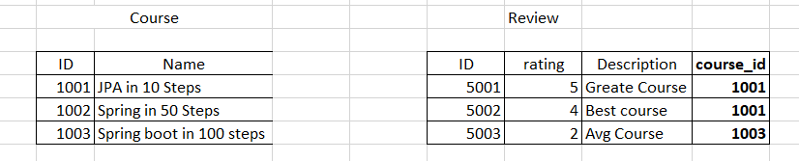

Now start coding:

Define Review entity one to many relationships in Course entity like below and restart the server.

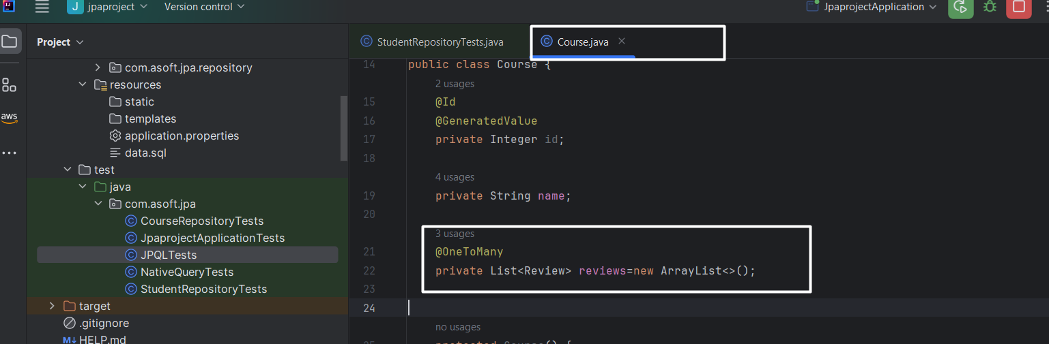

**NOTE: Nothing is yet defined in Review entity**

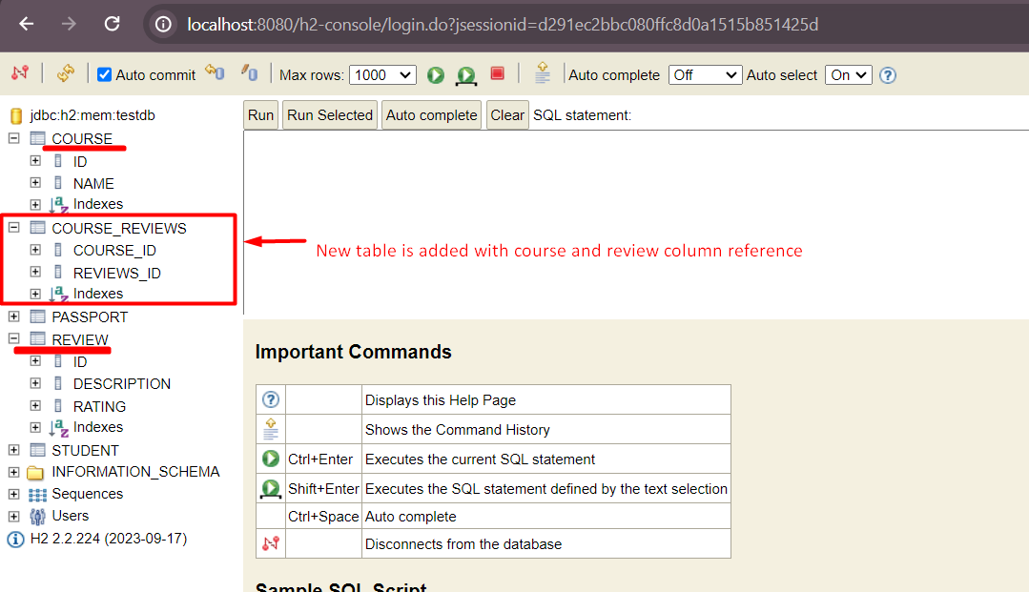

Ohh, but this is not we want, we want course_id column to be in review table, i.e we need review entity should be owning side of relationship. How do we do that?

Ok, let’s below code changes and restart the server and see the table structure

Review entity:

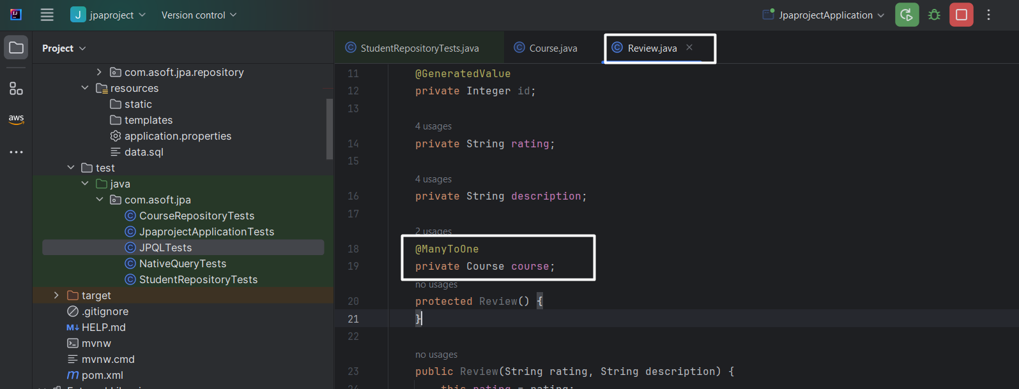

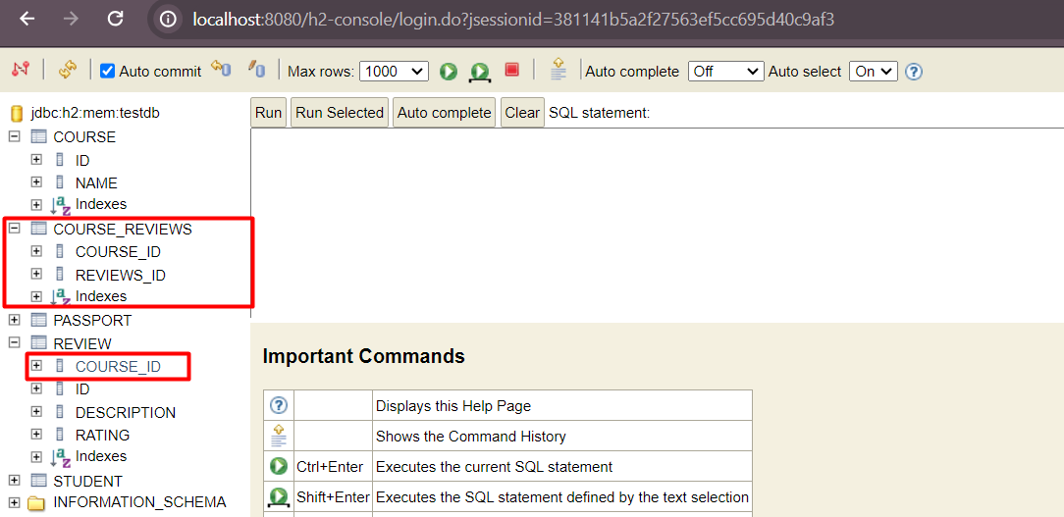

Ohh, still course_reviews table is there , but you can see the course_id ref in review table. But how do you get rid of course_reviews table?

* By adding mappedBy in Course entity

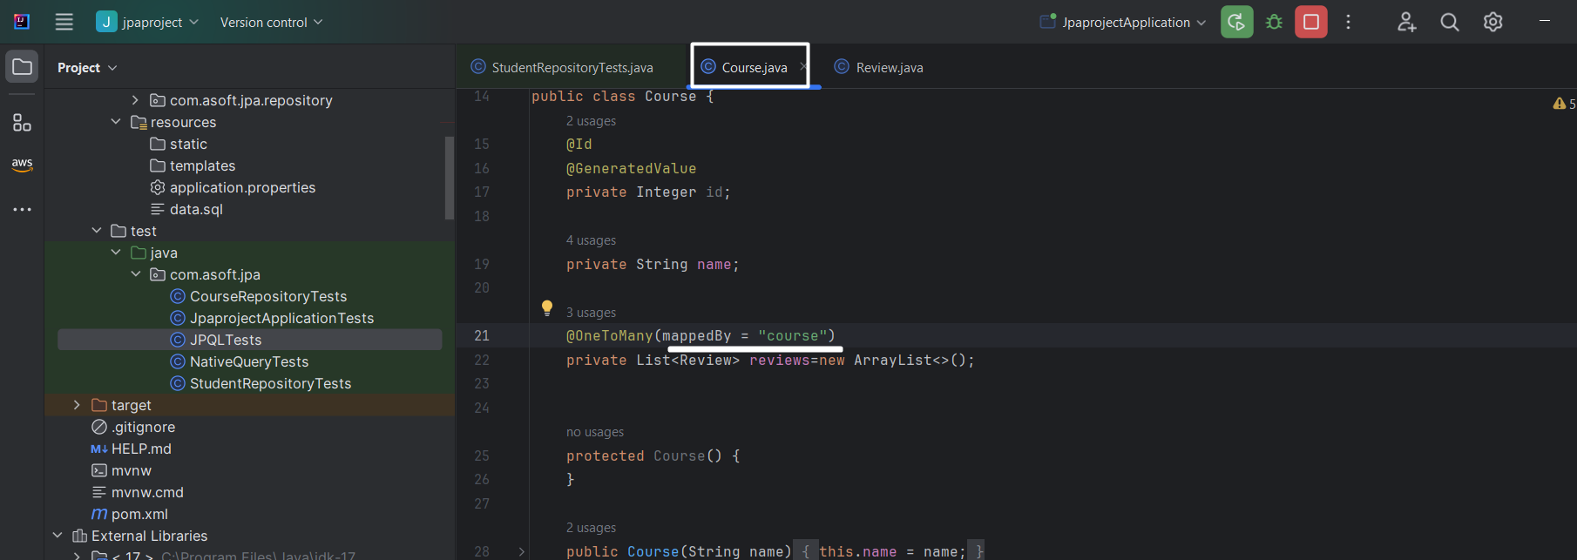

NOTE: mappedBy always comes at non owning side of relationship.

Restart the server and see the table structure

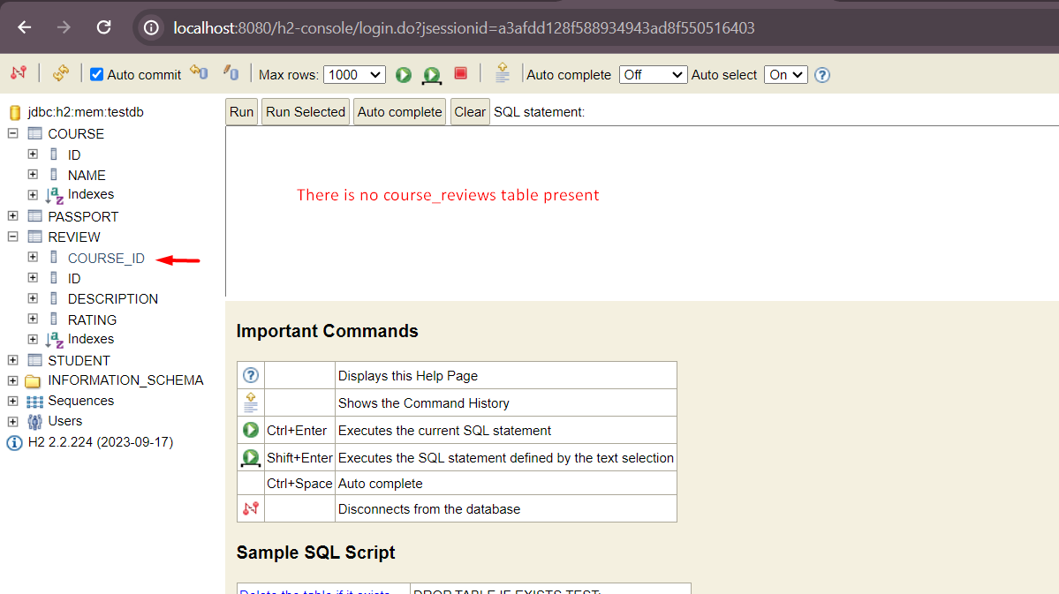

Ewww, there no course_review table now.

Inserting new Review for course 102.

Before inserting

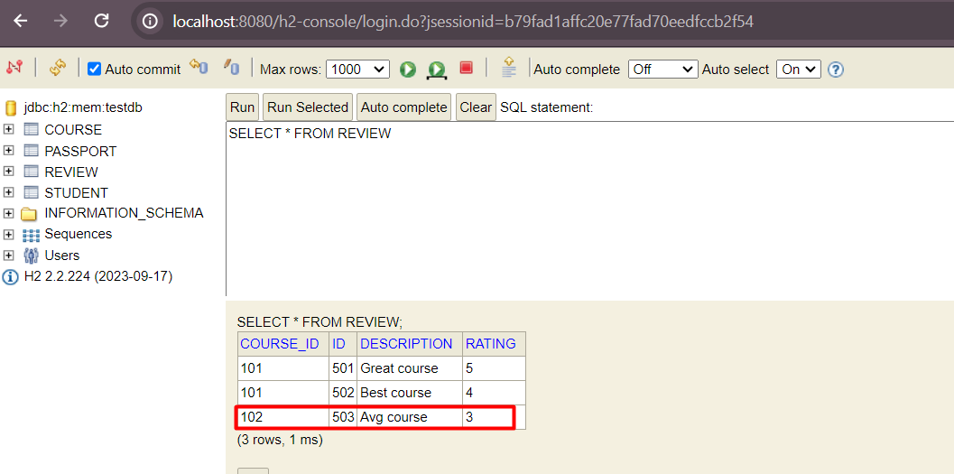

Code

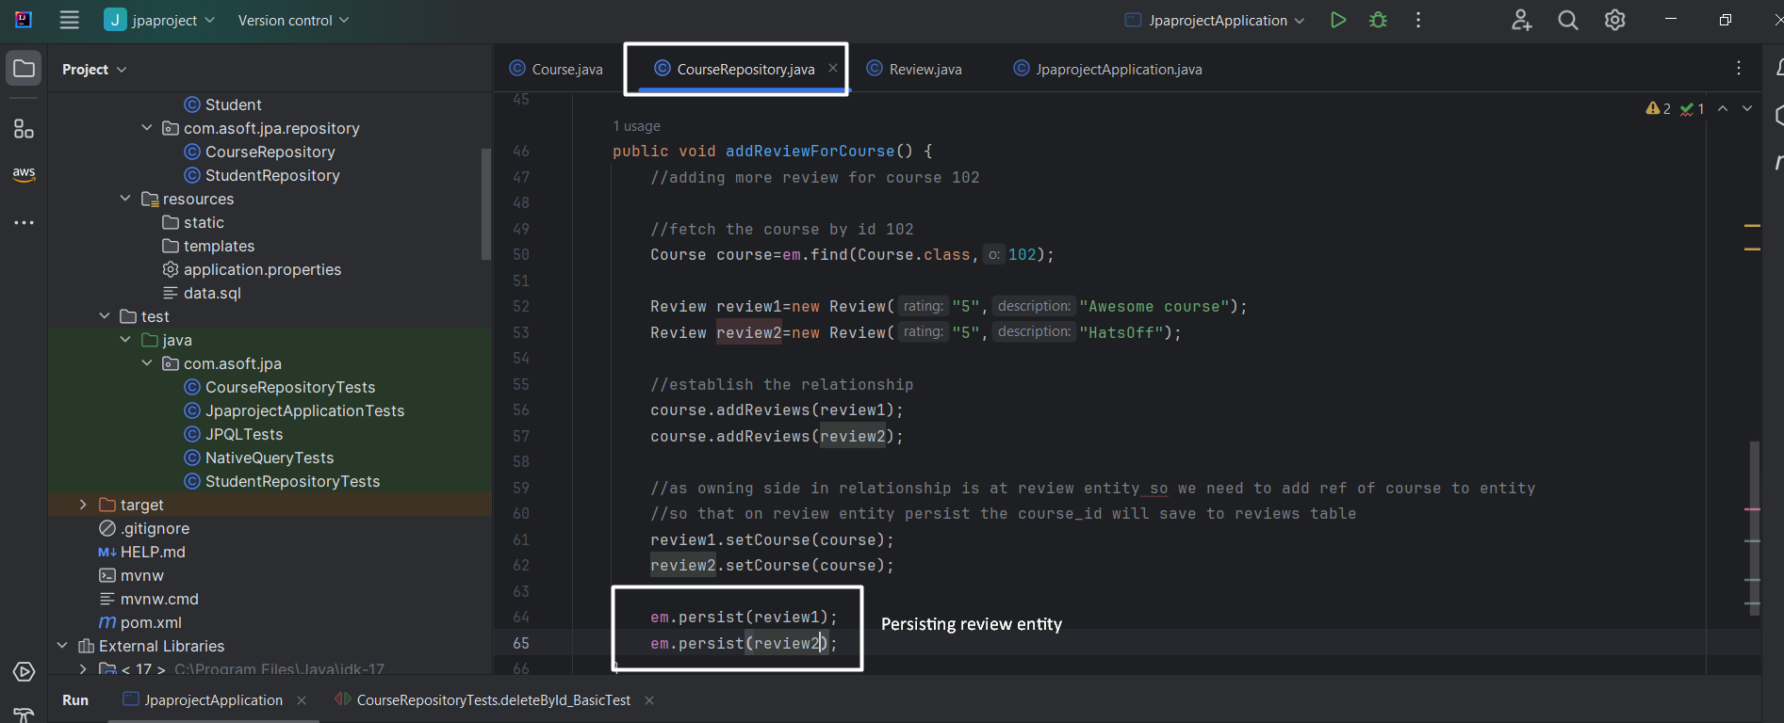

Restart server and see the review table

NOTE: this method is invoked from command line running on spring boot starter class.

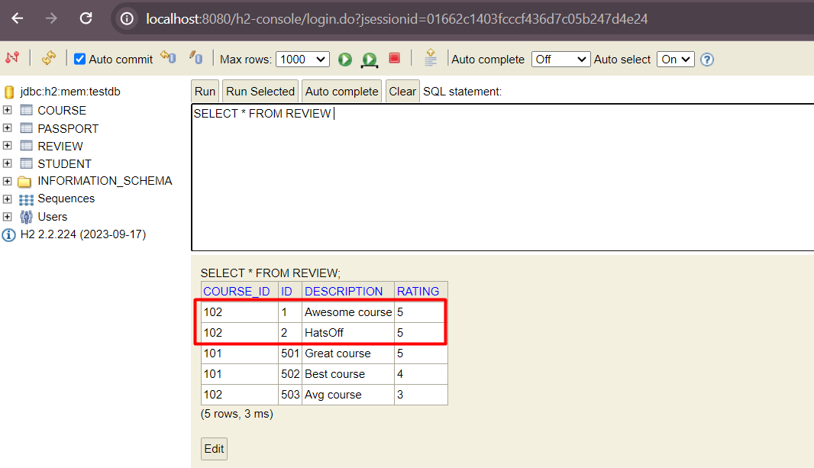

NOTE: By default, in oneToMany relationship the fetch strategy is Lazy loading is applied. Example.

Course course=courseRepo.findCourse(103);

Course.getReviews(); // When this invoked only that time select query get fired on review table otherwise not.

## Many to many relationship

Let’s understand it with example, we have student and course table like below. The many students can enroll to one course or one student can have many course or vice-versa.

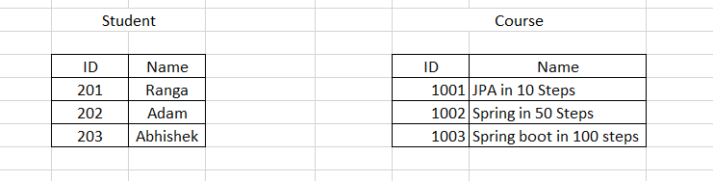

How do you define the relationship?

Take scenario: One student into many course

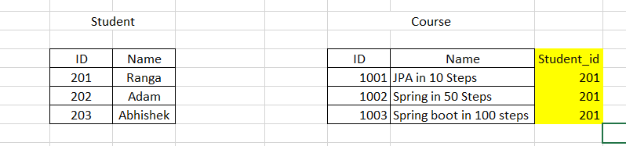

Ok, this issue is solve,

Take a scenario: Many student want to enroll many course

Ex: what if Adam i.e ID 202 want to enroll into same course. i.e many student want to enroll many course. Can we do it like below

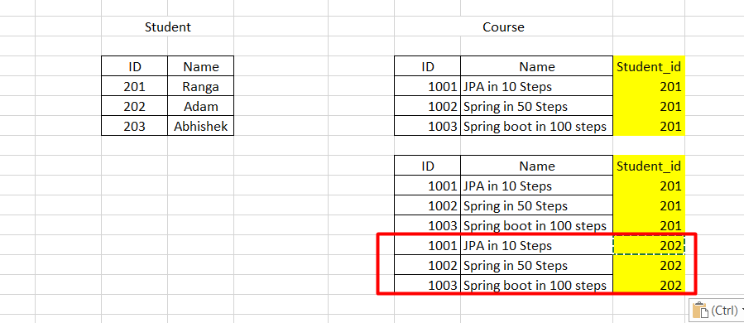

Repeating all three course rows again in course table just for Adam enrollment is not good an idea. If break the database rule.

Can we add course_id column to student table.?

* No, it does not solve the problem, the same problem that you face above will face again here as well.

So how do we solve this issue?

* By introducing join table. The table that have two columns to represent course_id and student_id like below

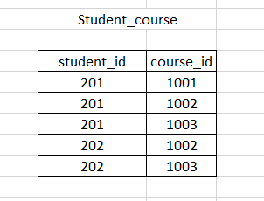

Let’s code:

Establish the relationship in entity classes:

Many course have many student: (Course to Student)

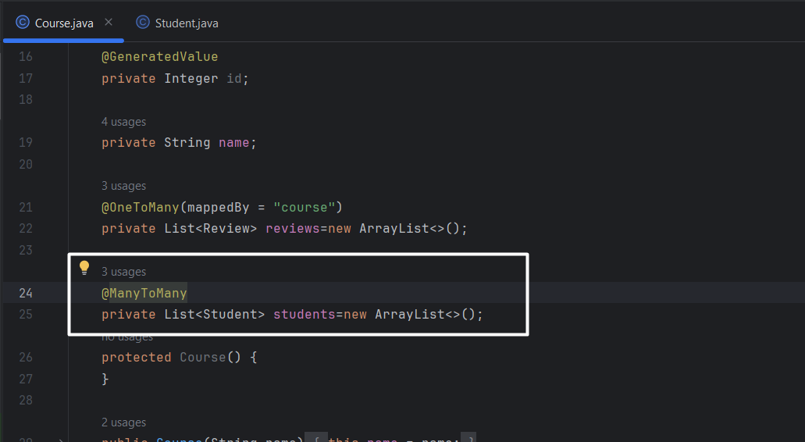

Many student have many course: (Student to course)

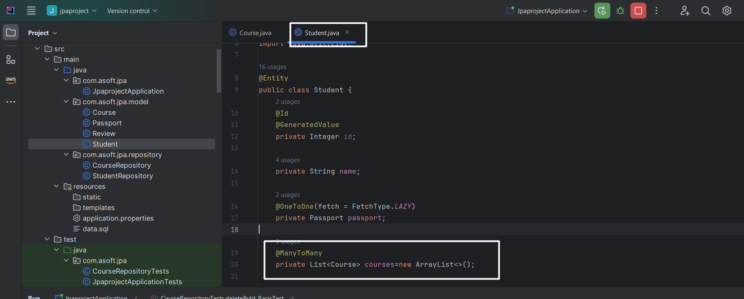

Ok, Now starts the server and see the table structure:

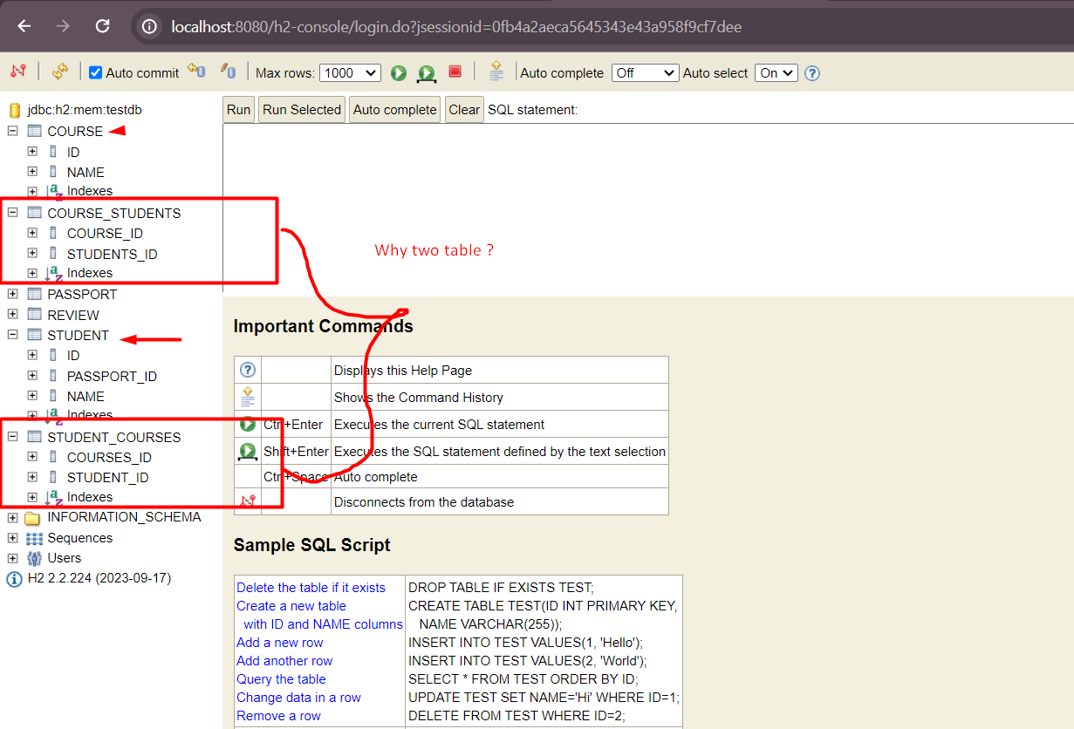

Ohh, noticed ? It is expected that only one intermediate or join table should get create but here two table got created. But why?

* As we define maytomany relationship in both entities hence two separate table got created.

How to solve this?

* To solve this we need to make one of the entity to be owning entity, and using mappedBy we can get rid the that extra table.

Let’s consider student as owning entity and write mappedBy at course entity like below and restart the server and see the tables

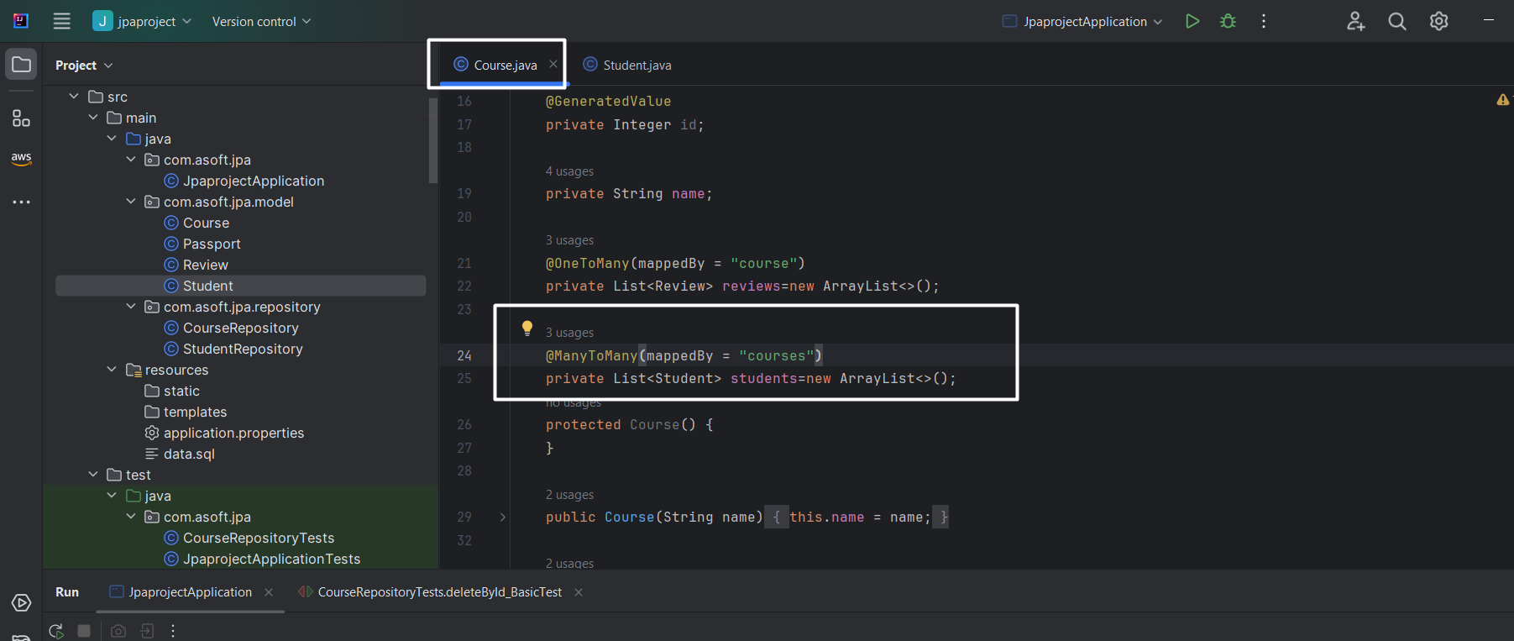

NOTE that in manytomany relationship owning entity is play the role as like onetomay or onetoone relationship. In onetomay or onetoone relationship the owning entity actually have reference column of other entity. In case of manytomany relationship we are defining owning entity just to get rid of extra table.

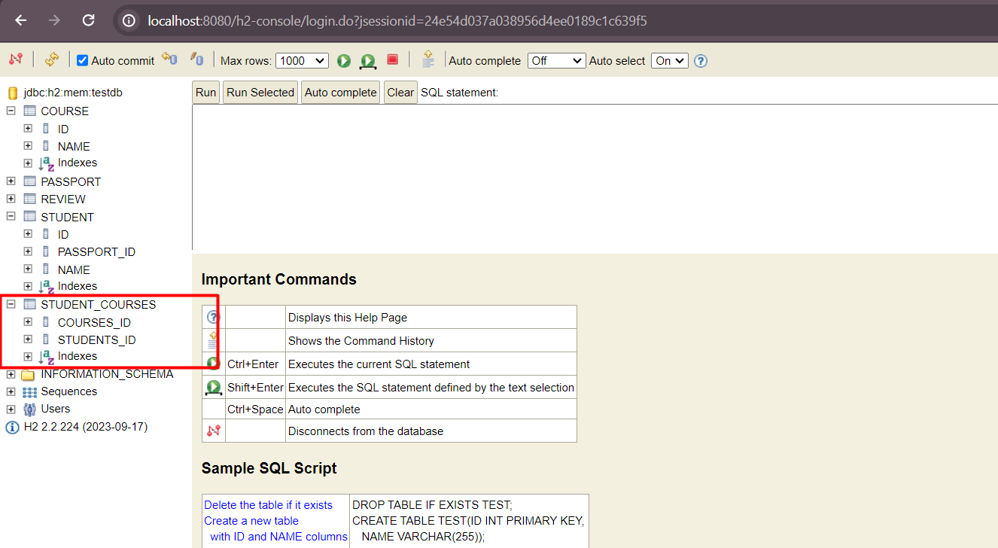

Yes, now we have only one join table.

There is small issue here, as you can see in the above screenshot the column names of Student_course**s** table are cours**e_**id and student**s**_id. Which is not quite as per industry standard. So how to fix it?

* To fix this, we need to write @JoinTable annotation at owning side of entity, i.e in our case it is Student.

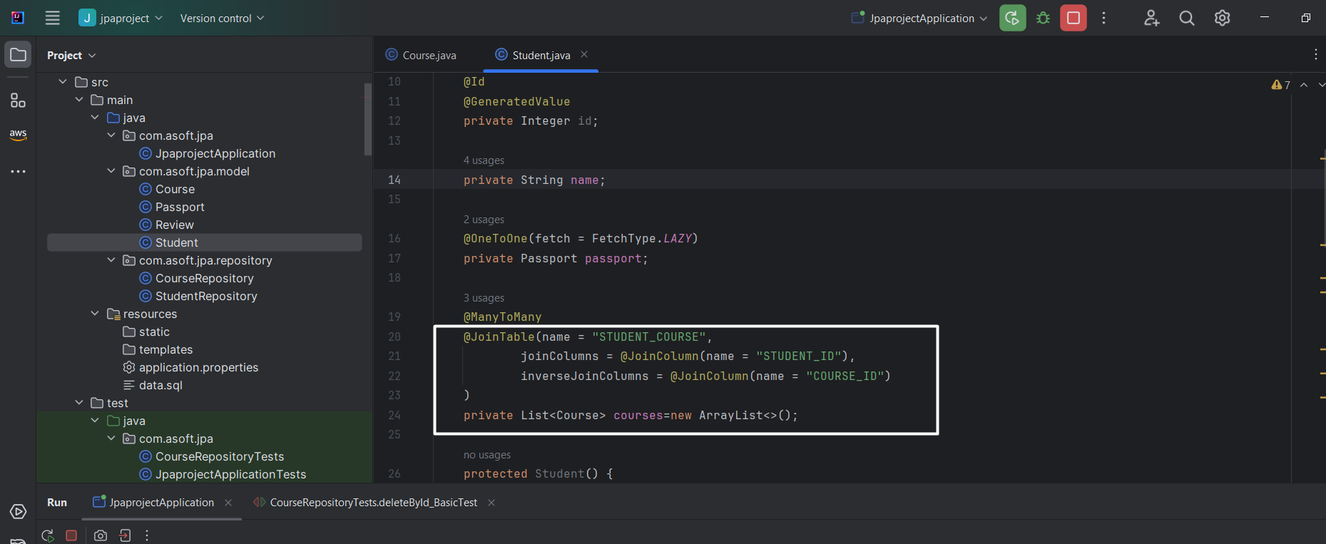

Table:

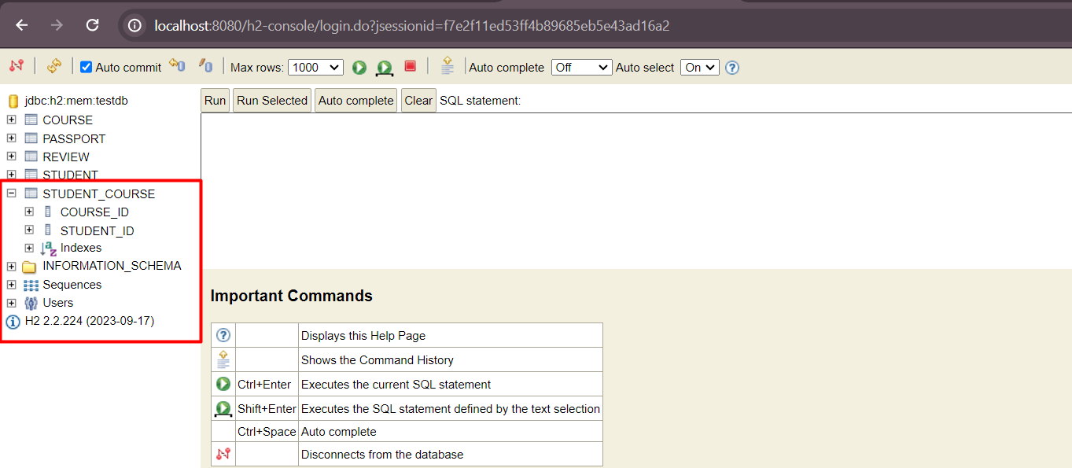

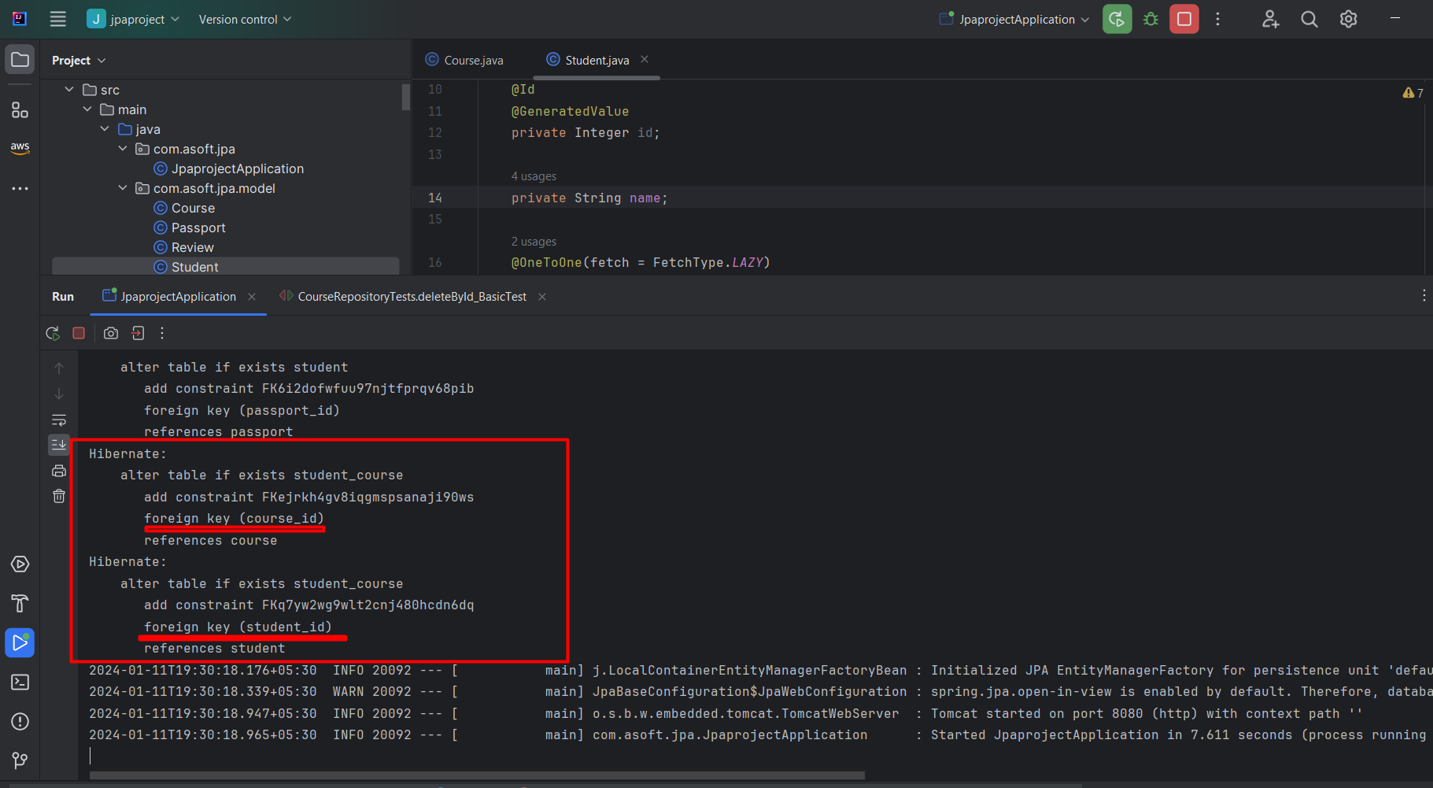

Enough theory, let’s insert data into this entity using data.sql

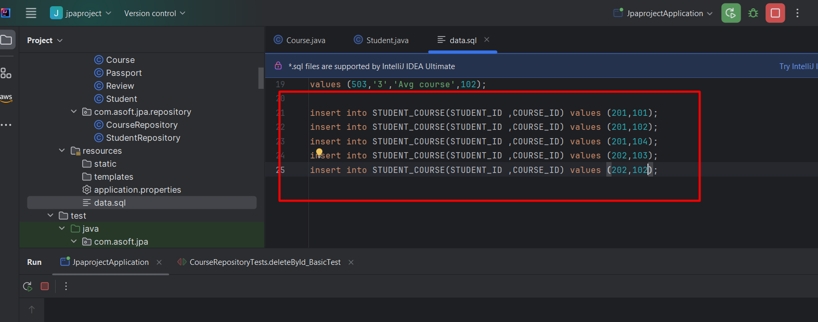

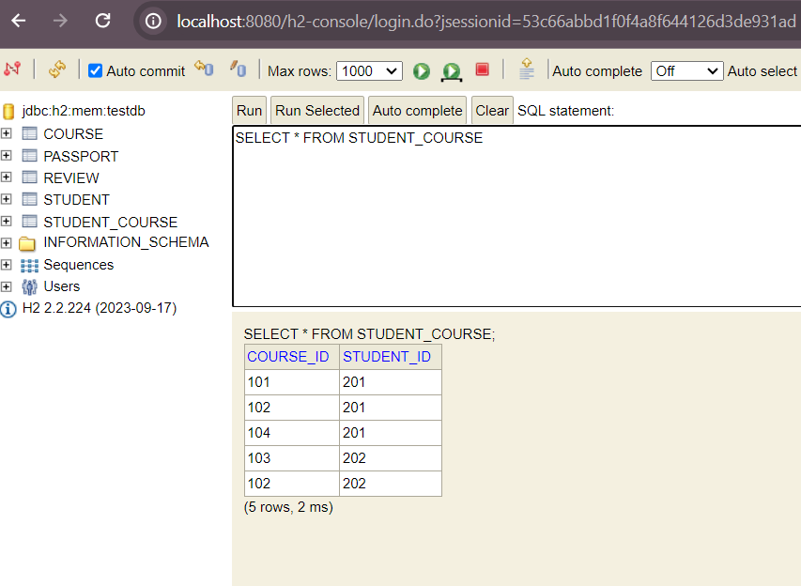

### ManyToMany Mapping - Retrieve Data using JPA Relationships

***ALWAYS REMEMBER THE IN ***ToMany RELATIONSHIP FETCH TYPE LAZY APPLIED BY DEFAULT.***

Code:

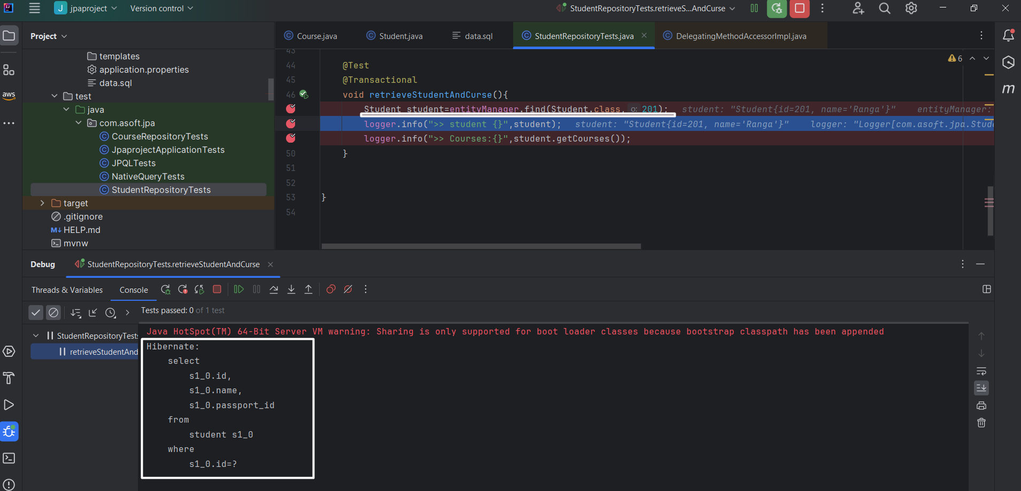

Only select of student but not on course

Let’s move the control to student.getCourse() and see the query

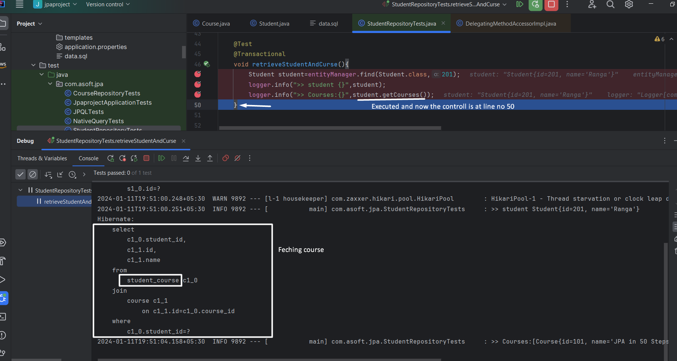

Let’s see how to insert using jpa.

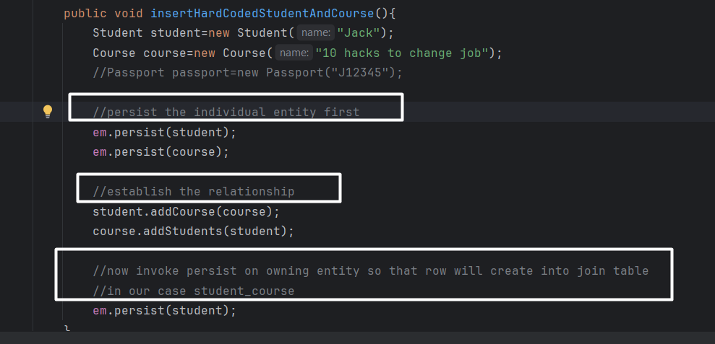

Called it from command line runner and see the tables

Student_course:

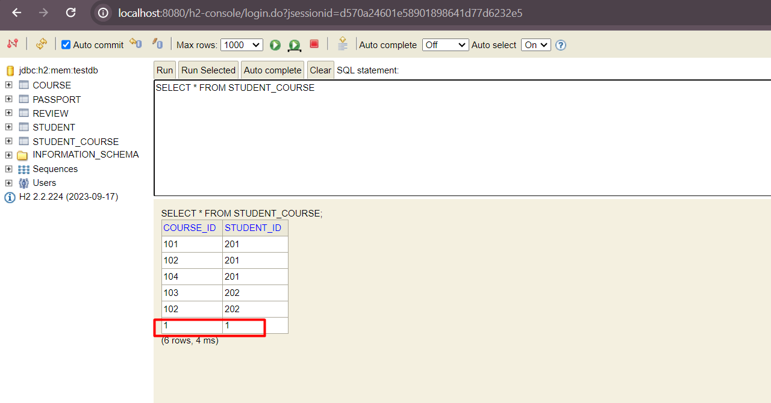

Course

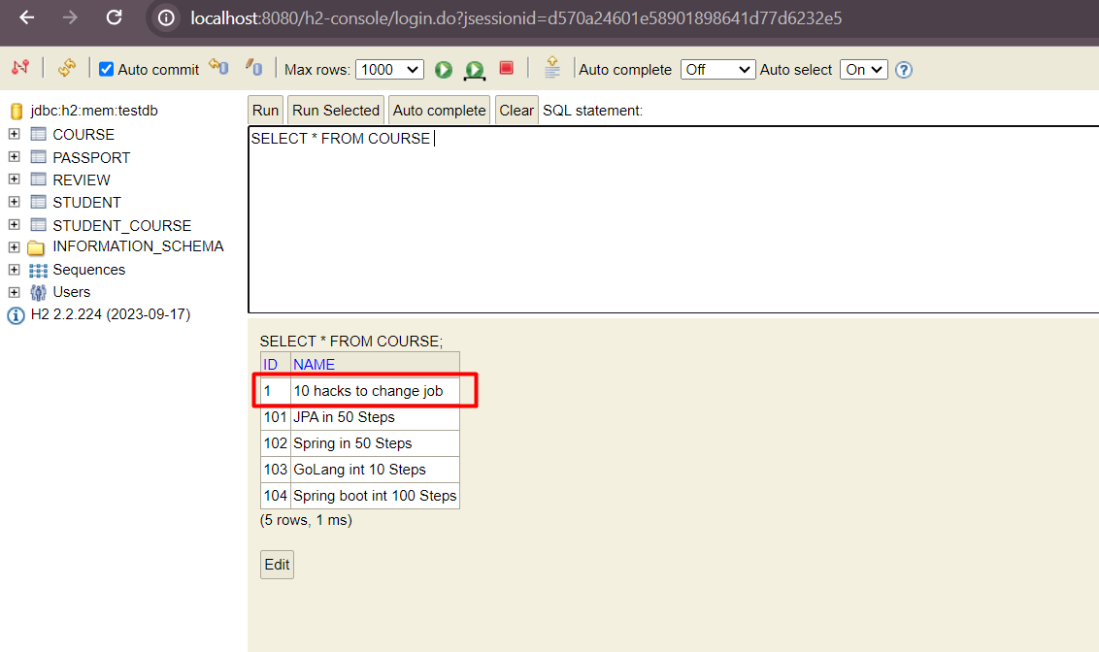

Student

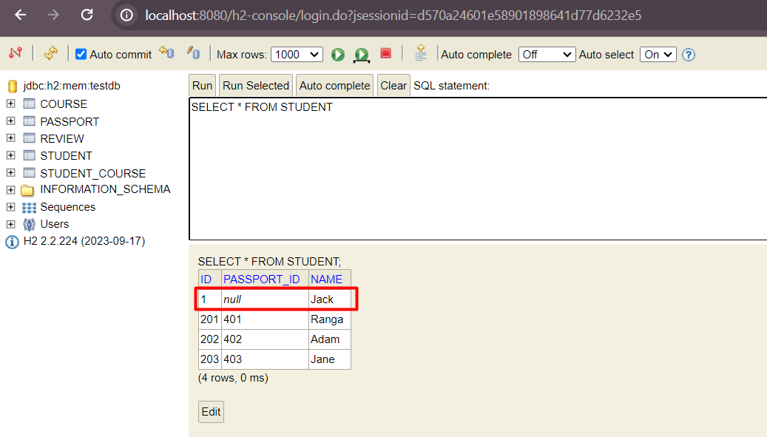

## Introduction to Inheritance Hierarchies and Mappings

Let say you have below tables

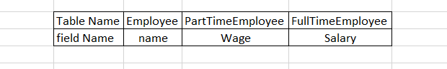

How do you gone establish the relationship

SINGLE_TABLE strategy:

Base class, i.e Employee

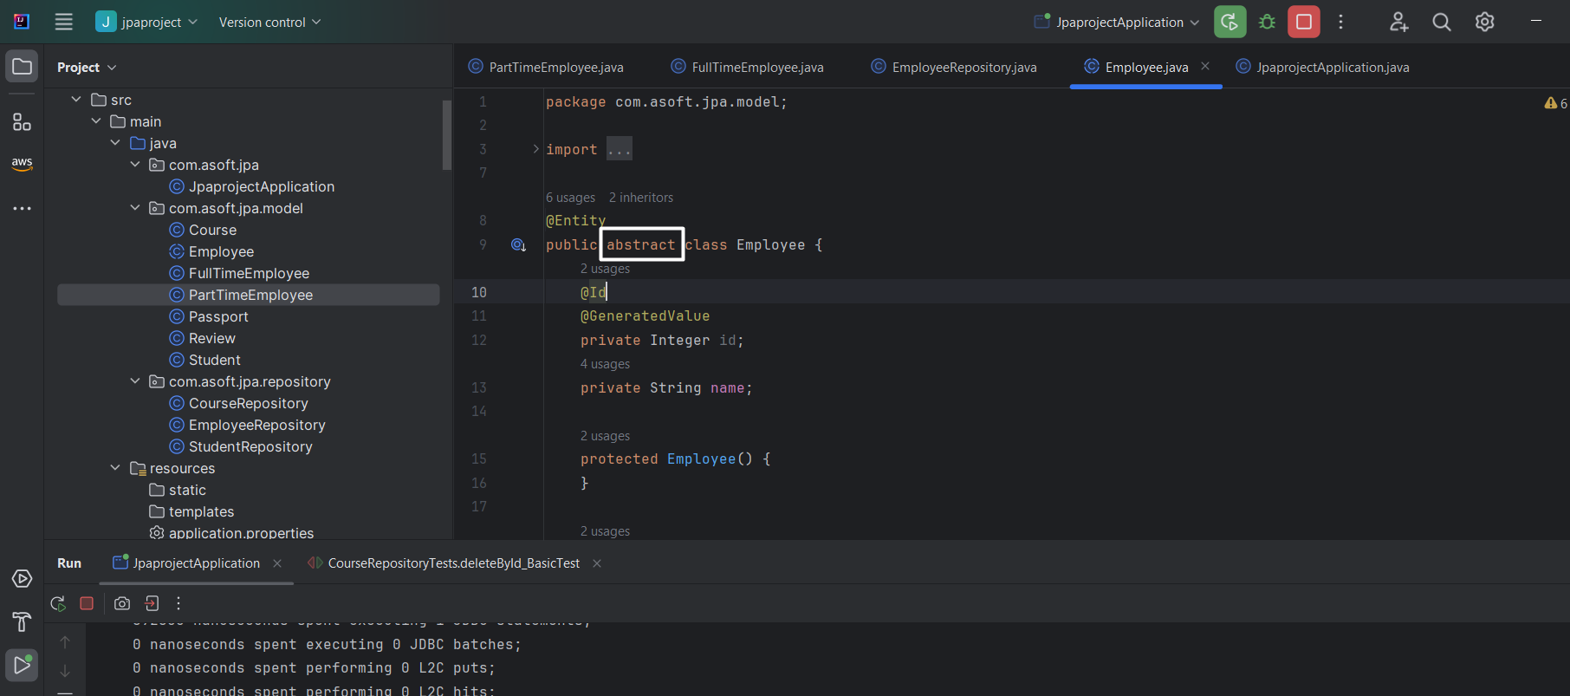

First sub-class

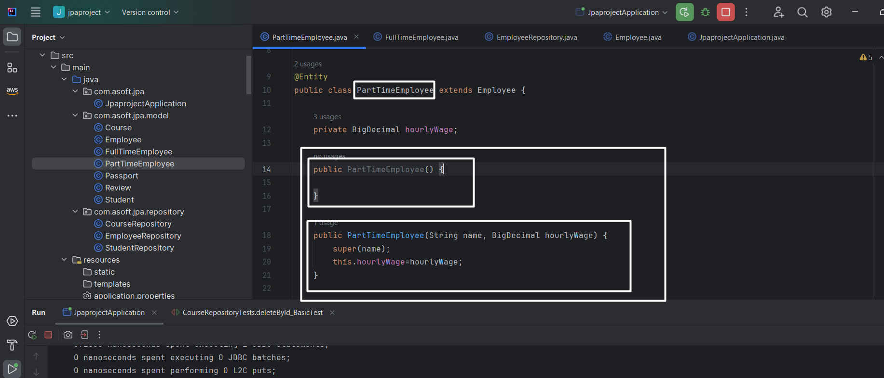

0 param constructor is must

Second sub-class

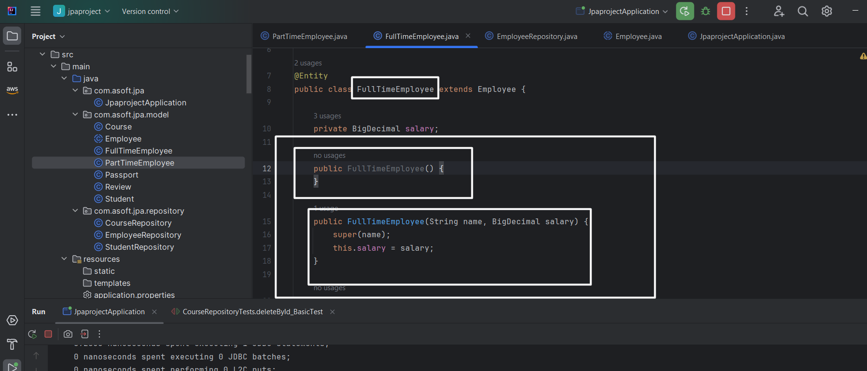

**0 param constructor is must**

Start the server and see the table structure

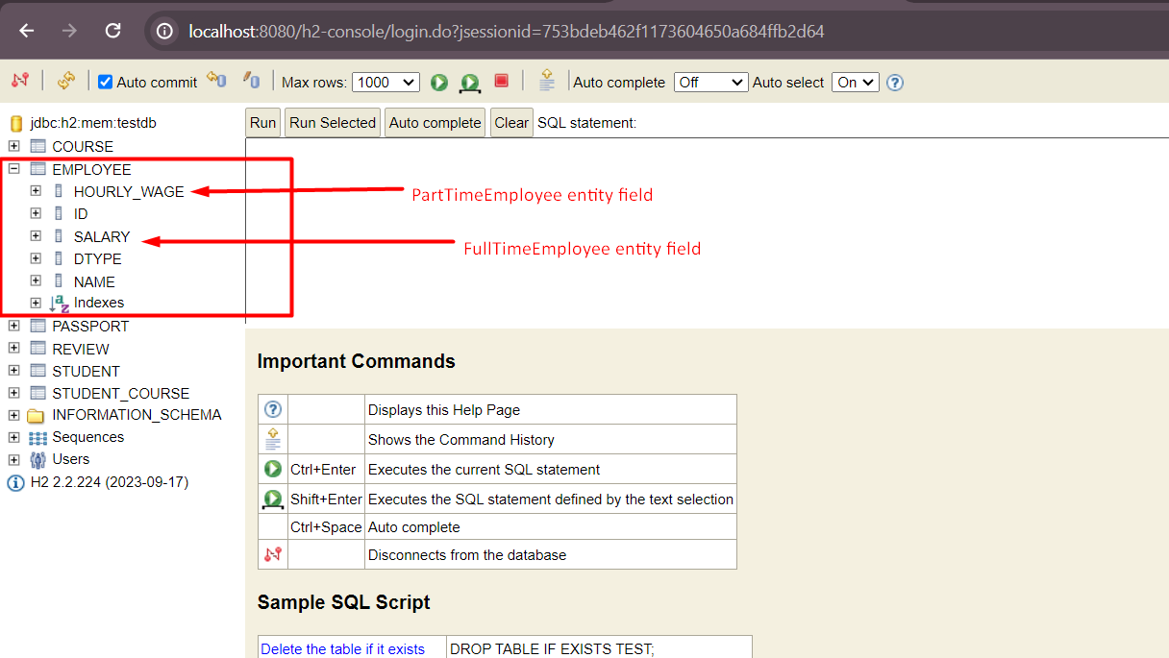

Single table got created.

Let’s insert data using jpa

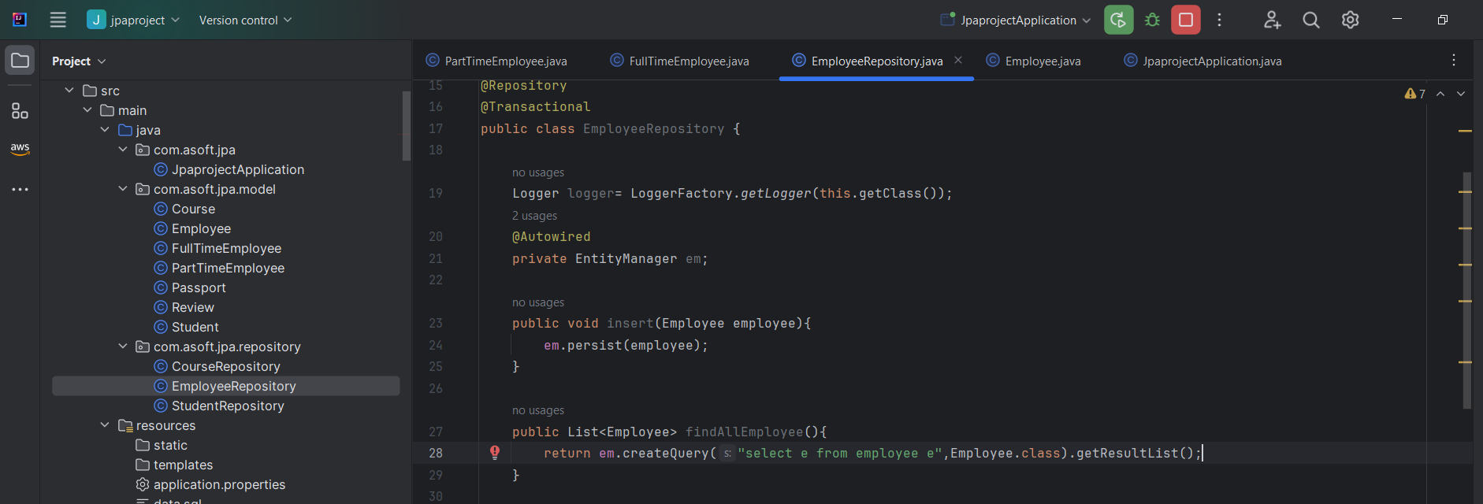

Invoke both insert and find method from command line runner and see the o/p in the logs:

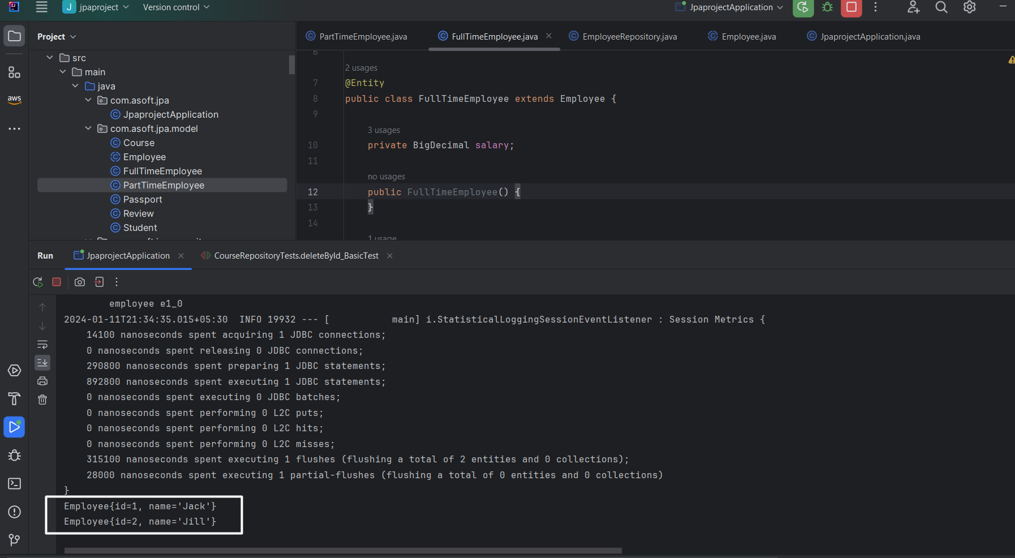

Table:

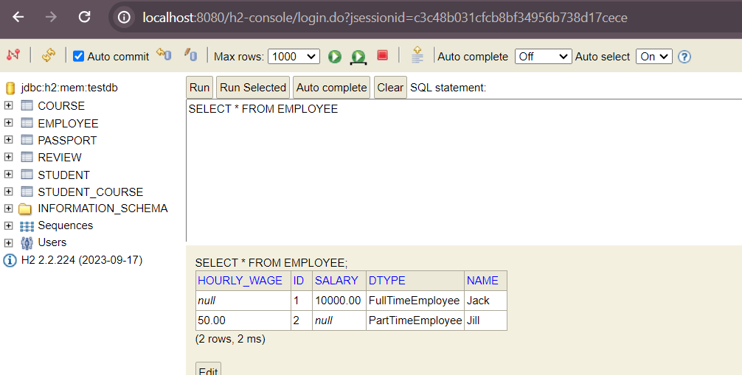

The one employee table is created is called SINGLE table strategy which is default enabled.

The Employee entity is like

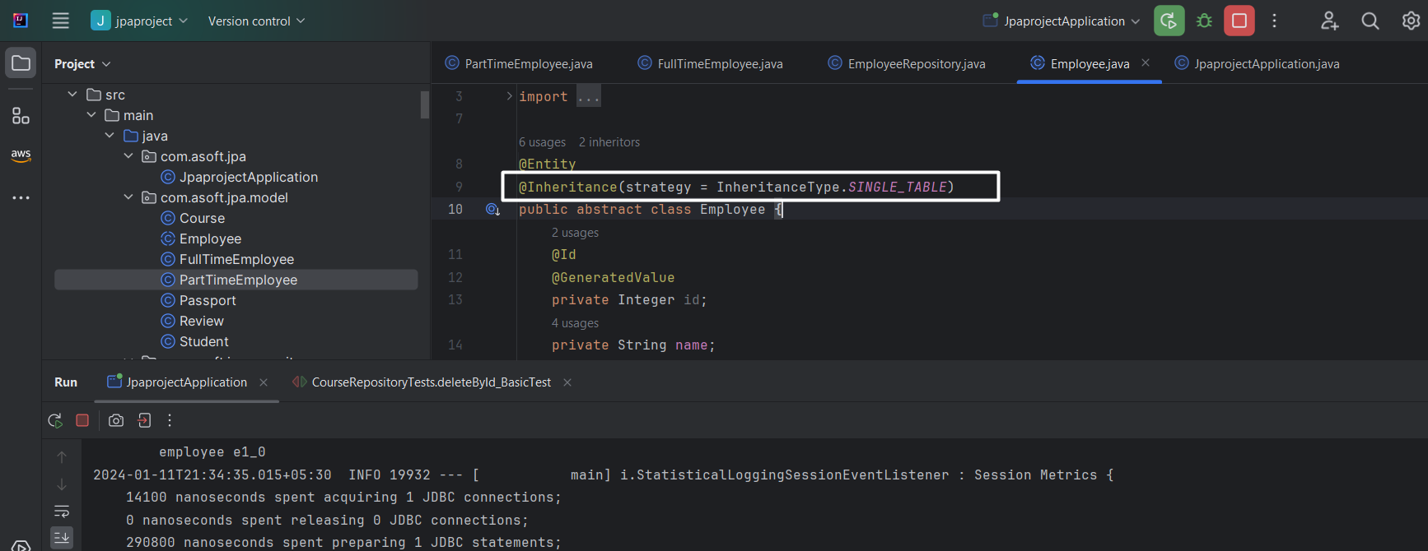

@Inheritance(strategy = InheritanceType.SINGLE_TABLE) >> Is default in this case.

Disadvantage: null data in table, please see the above screenshot

Table per class:

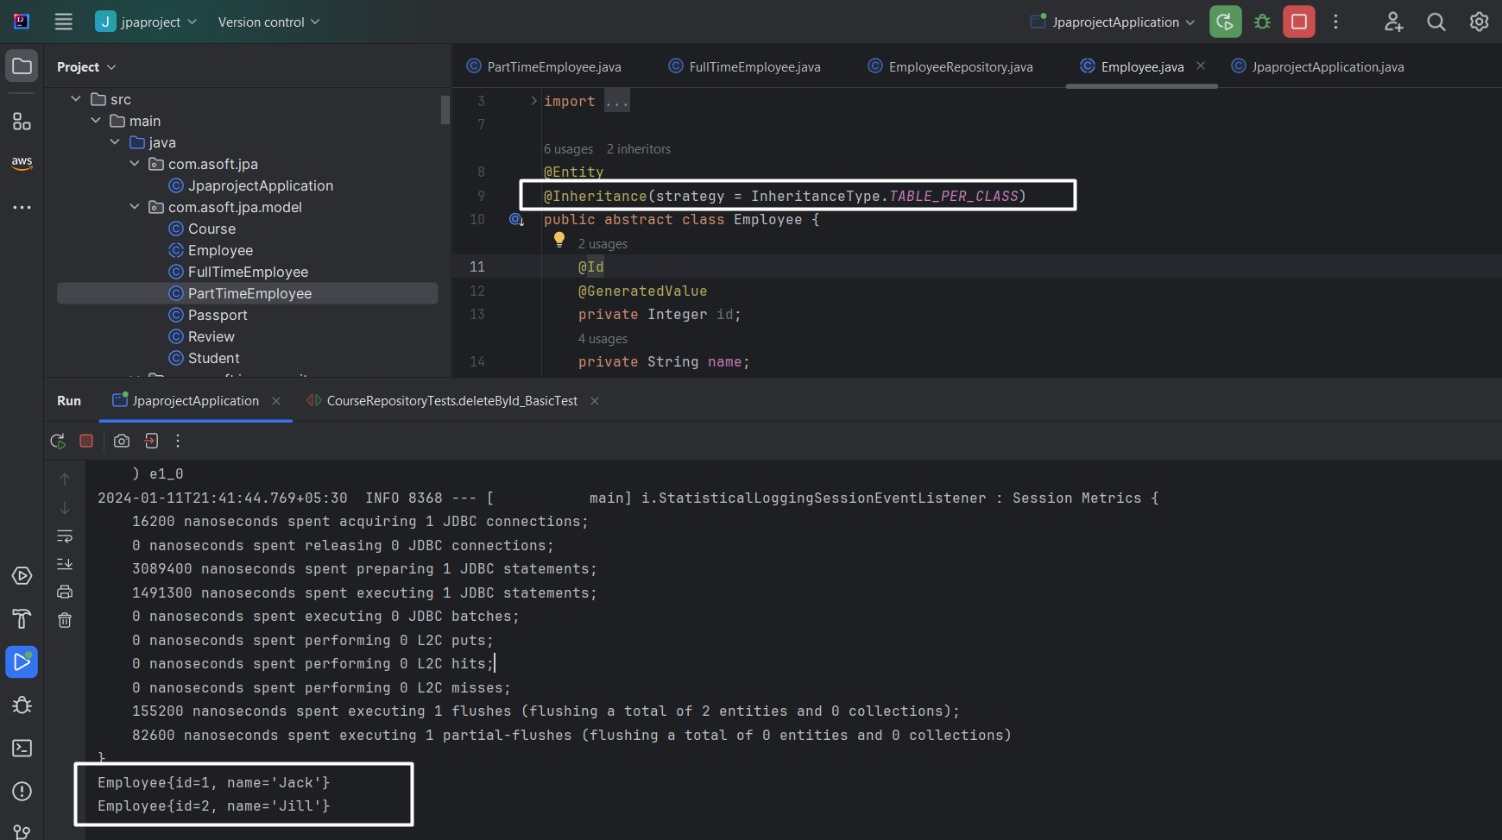

Tables:

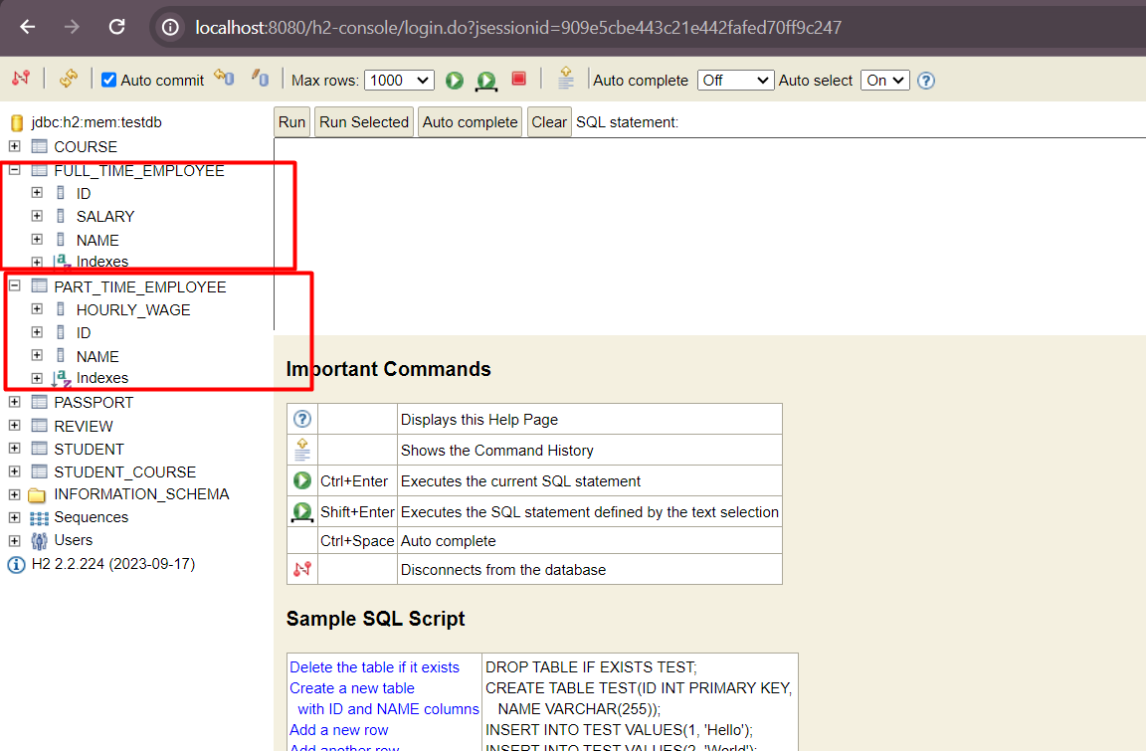

Two separate tables, No employee table got created.

Joined strategy:

Will create table for employee, fulltimeexmployee, partimeemployee

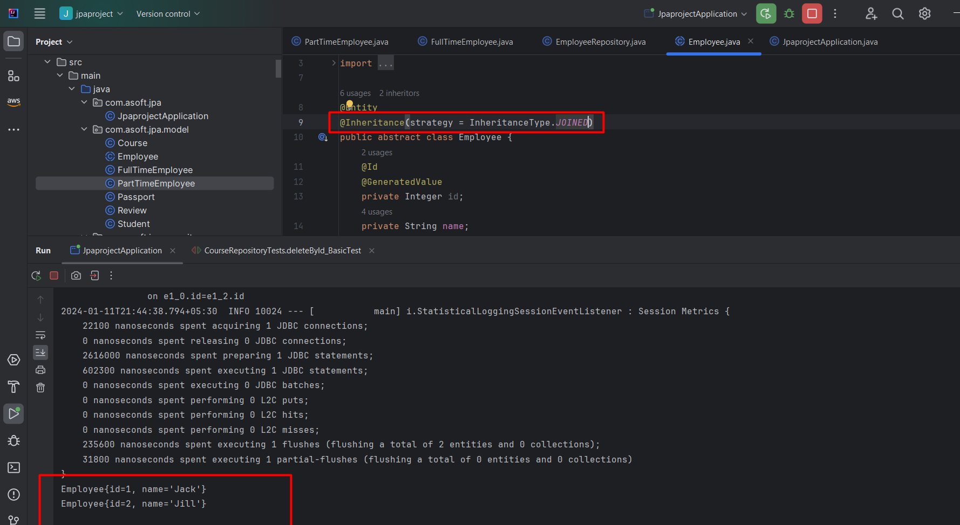

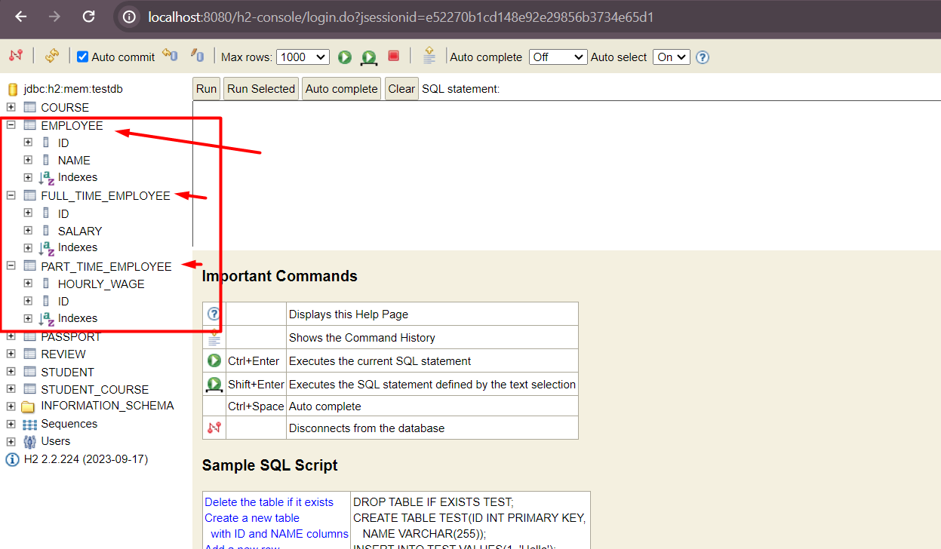

Advantage: All common info is stored in Employee table and specific info is stored into their respective table.

**Mapped Super Class: It says there is no inheritance relationship. It is just simple abstract class that acts as parent of all.**

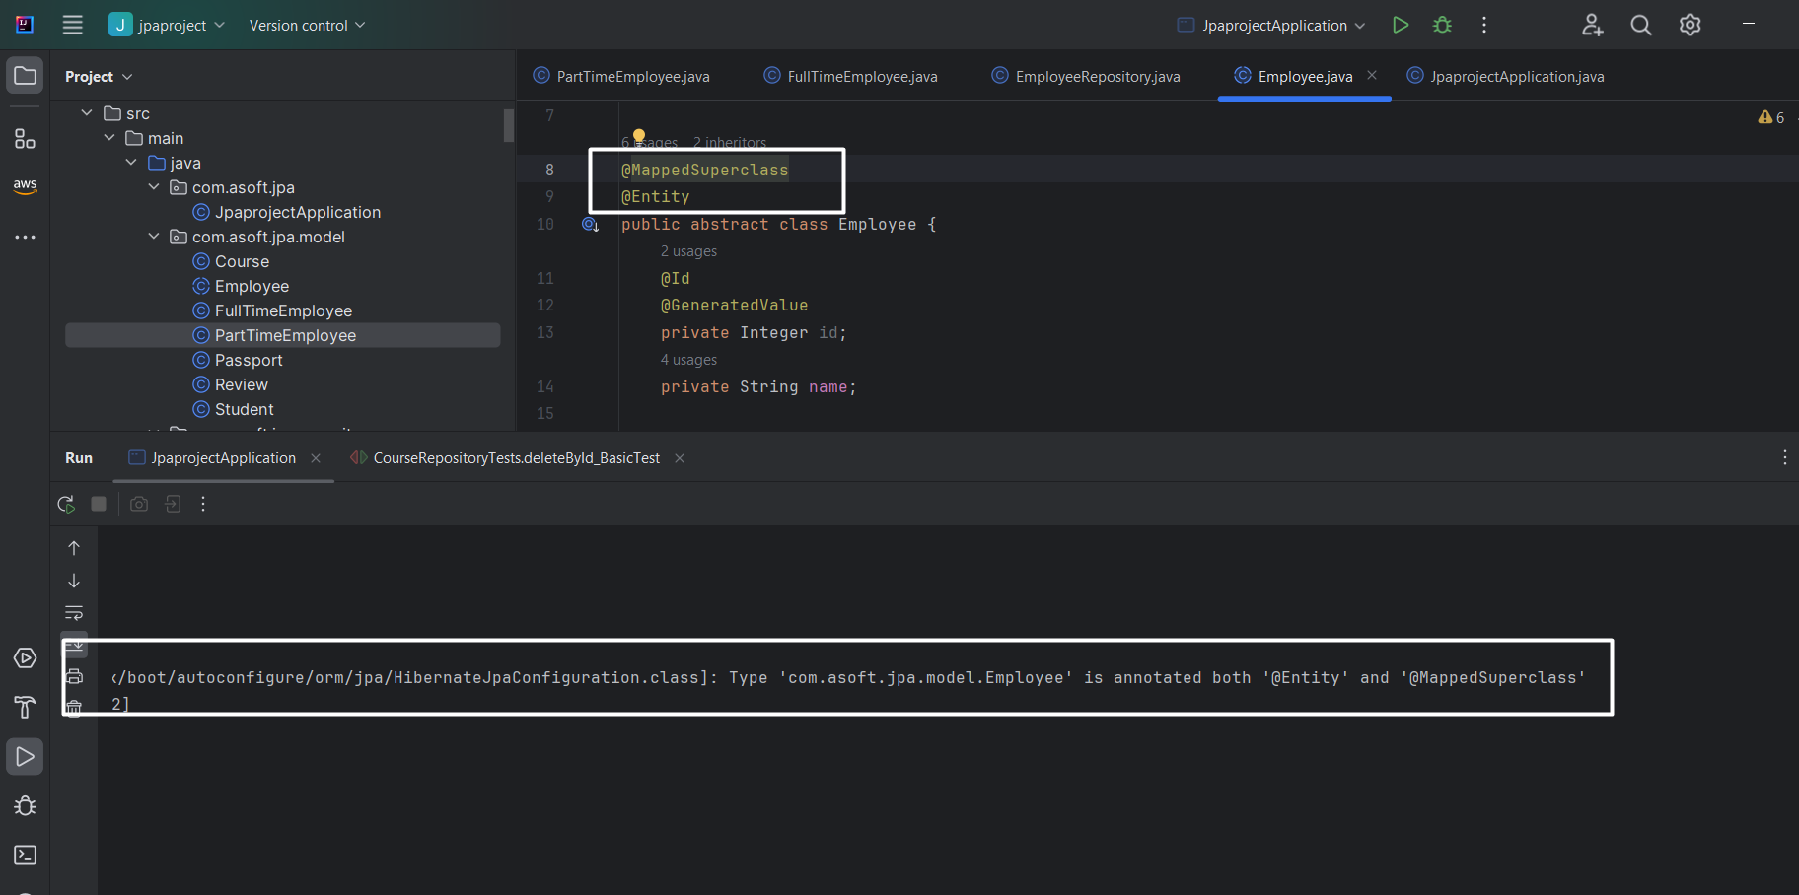

Server failed to start, because we annotate our class with @Entity and @MappedSuperClass. If any class is annotated with @MappedSuperClass then it should not be annotate with @Entity. Hence removing @Entity and restart the server and see the table structure

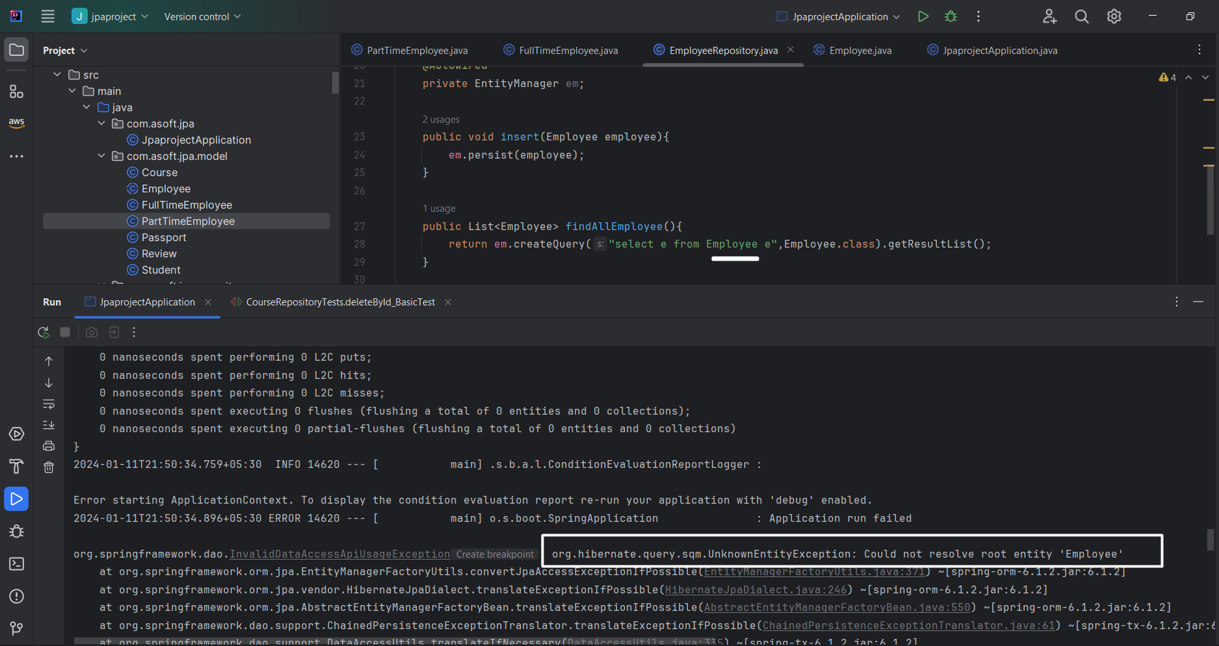

Ohh, again server fail to start with above exception, what does it mean?

* As you can see in the above screenshot at line no 28 we are executing query “select e from Employee e”, where JPA doesn’t understand Employee because we already removed the @Entity annotation from it. So, we are no longer able to execute queries on it.

What is solution then?

* Write two method to pull PartTime & FullTime exmployee details

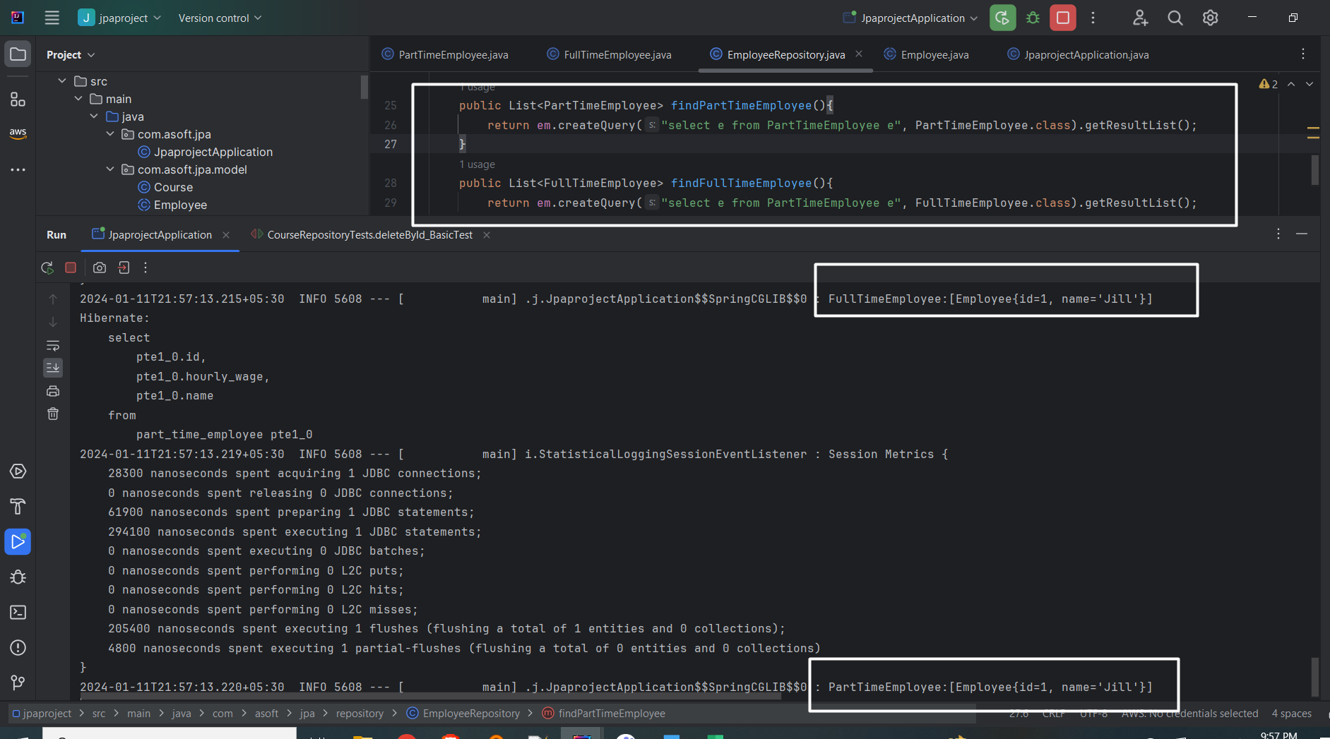

Finally tables:

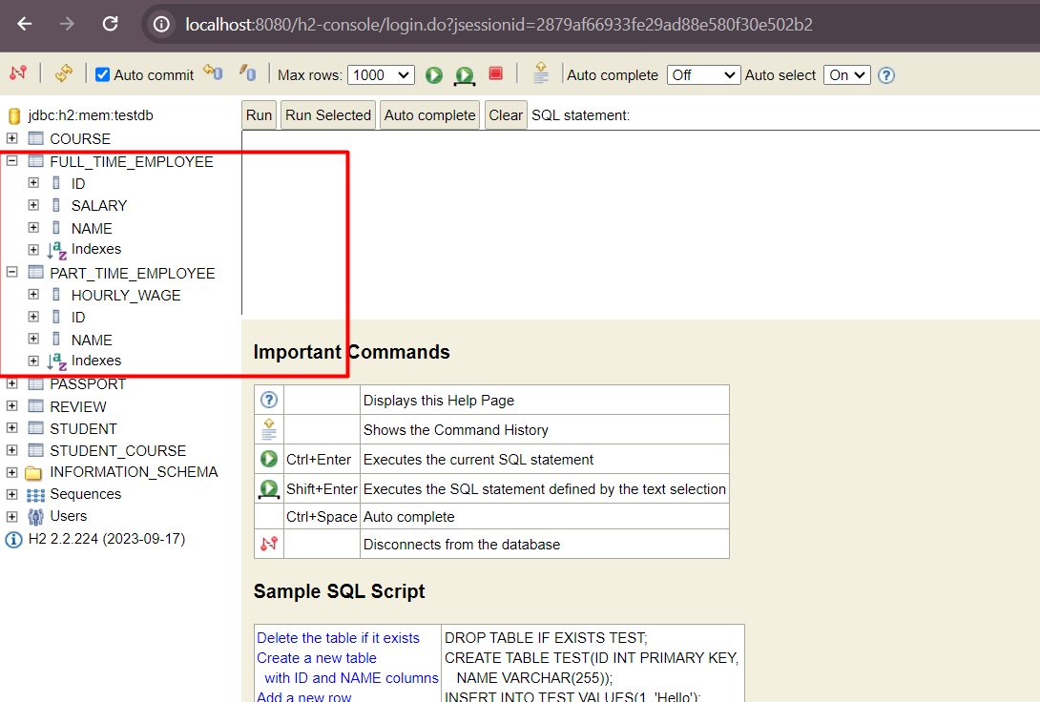

## Queries with entity using JPQL

Write a query to get course without any student?

Normal sql:

Select * from course where course_id **not in (select distinct course_id from STUDENT_COURSE) ;**

JPQL:

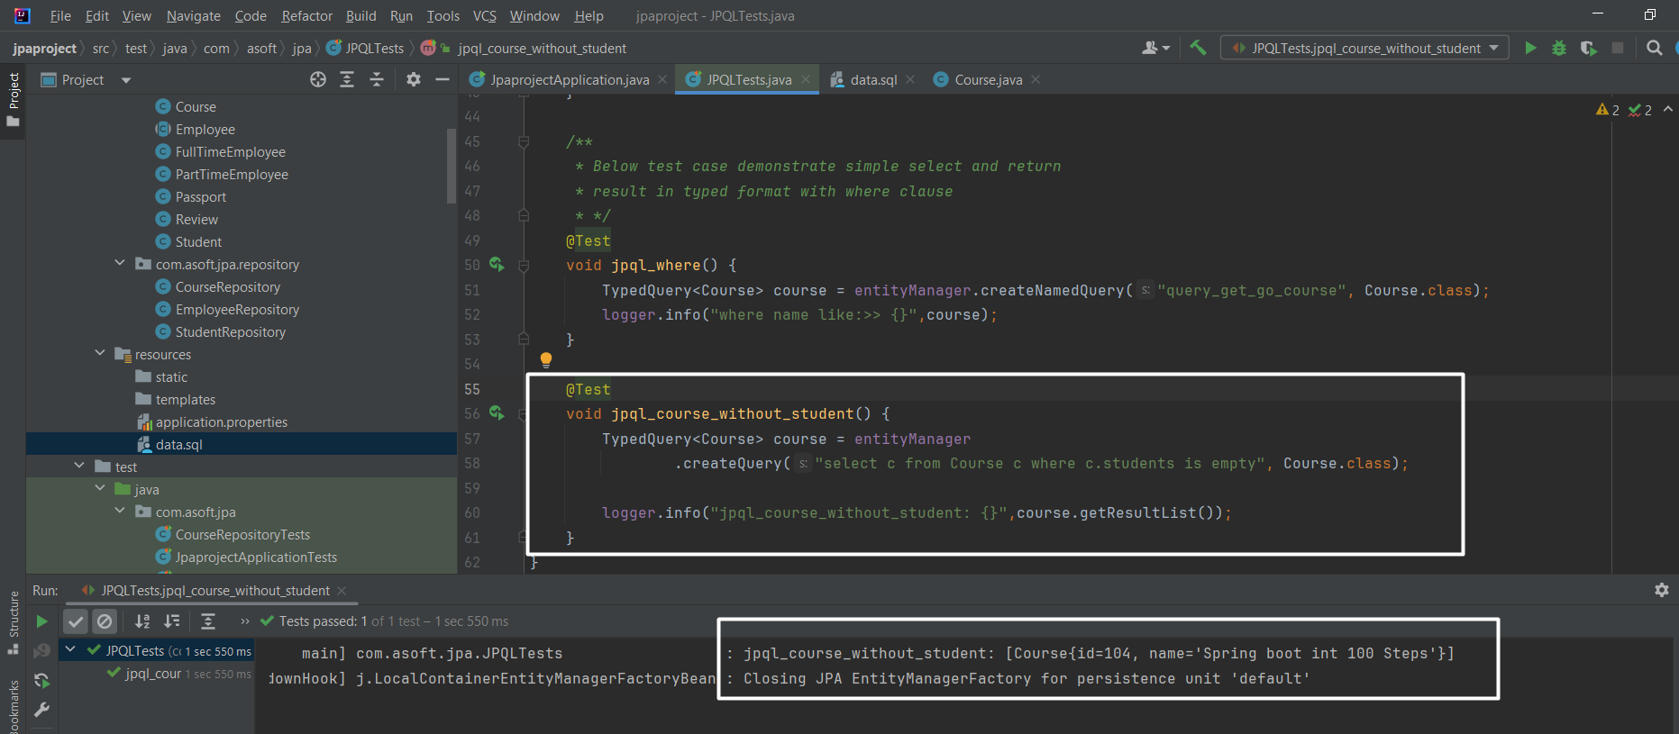

Write a query to find Courses with at least 2 Students?

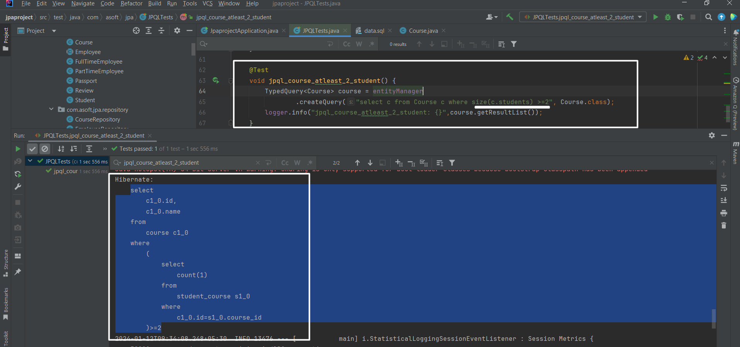

Write a query to find such student whose passport number contains 1234?

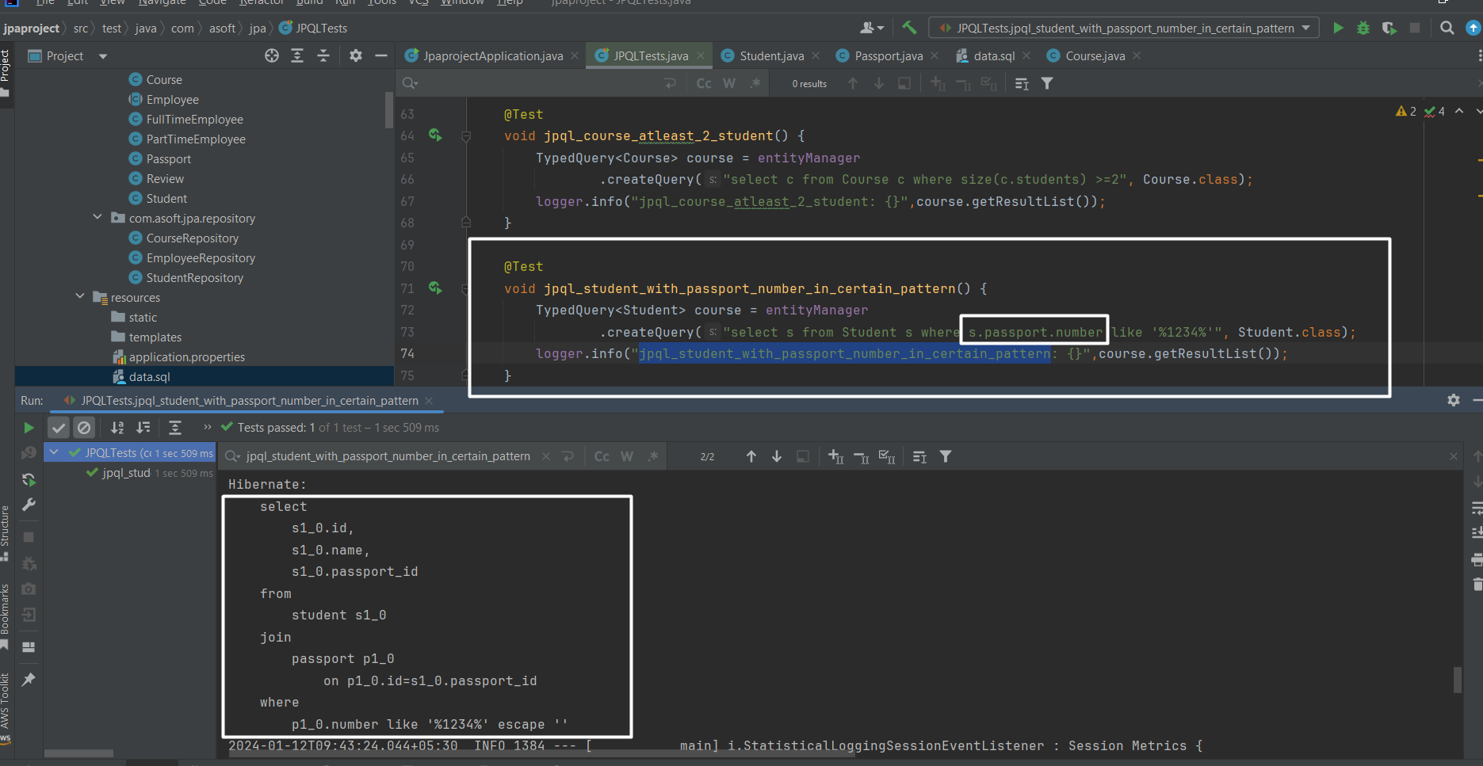

JOINS with JPQL

Inne join:

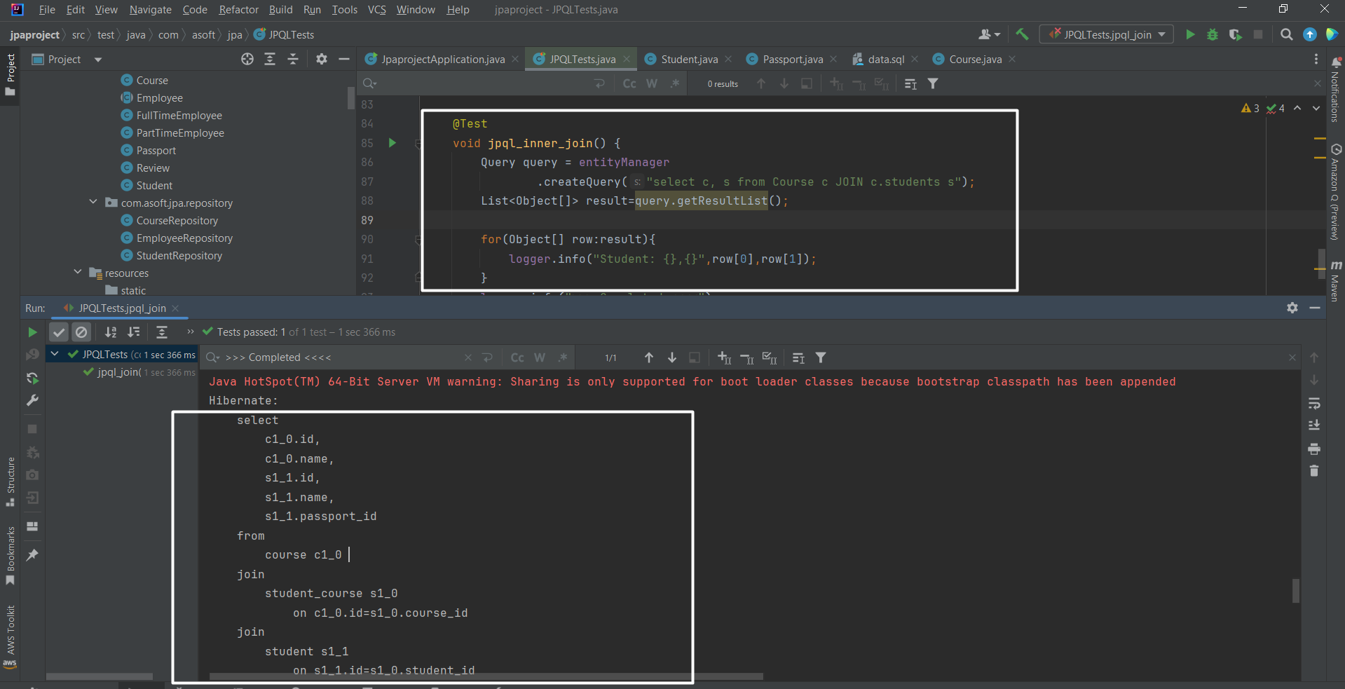

LEFT JOIN:

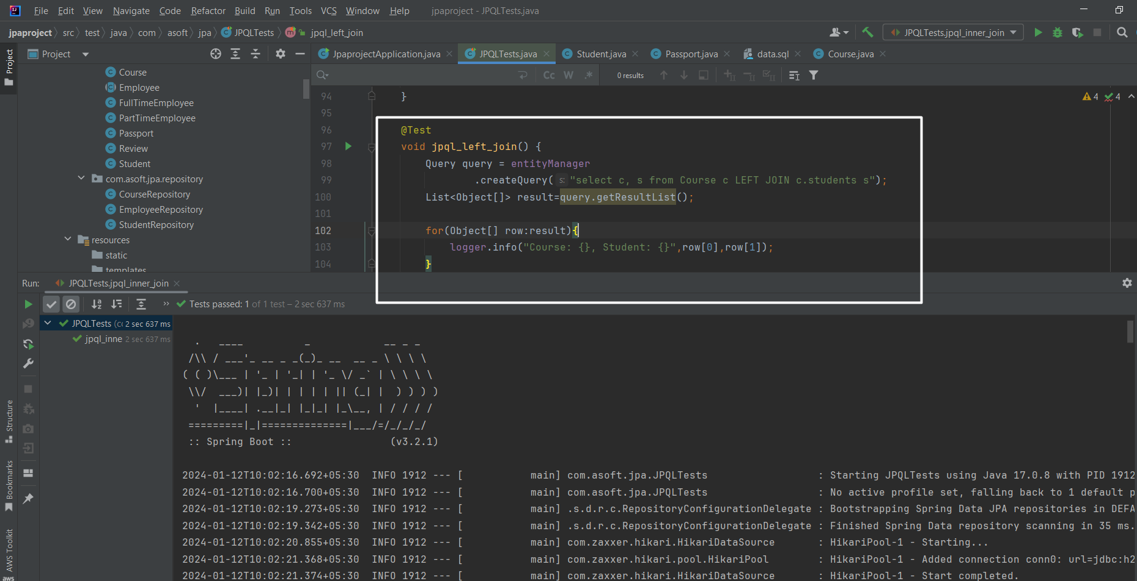

# Transaction Management

ACID

1. Atomicity
   1. All transaction should be successful, in case of failure all changes should revert.
   2. All or nothing rule

C-Consistency

* 1. In short It refers to the correctness of a database.
  2. Ex:
     1. In transaction T, we are transferring 100 out of 500 from account A to account B. The account B already has 200.
     2. So, when we transfer 100 then in account A 400 remain and Account will be 300.
     3. If we calculate:
        1. Total **before T occurs** = 500 + 200 = **700**.
        2. Total **after T occurs** = 400 + 300 = **700**.
     4. Both before and after are correct. That’s what consistency is means.

I-Isolation

* 1. Multiple transaction can occur indecently without interference

D-Durability

* 1. The changes of successful transaction occurs if the system failure.

Isolation in detail:

Dirty read:

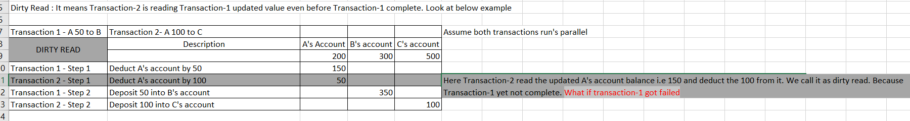

Non Repeatable Read

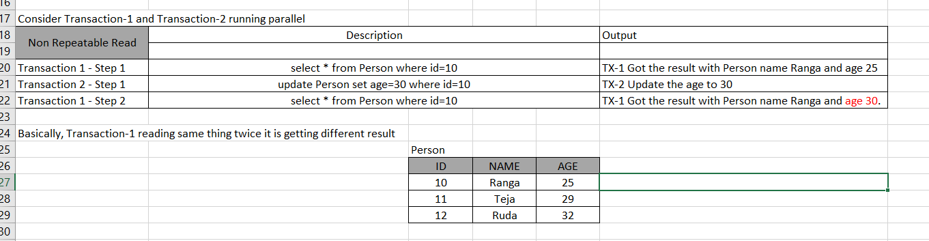

Phantom Read:

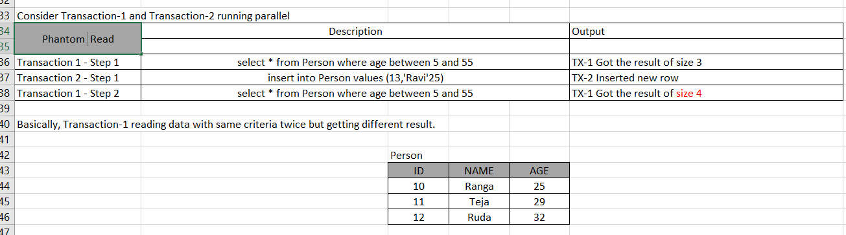

Using isolation level, we can solve this issue:

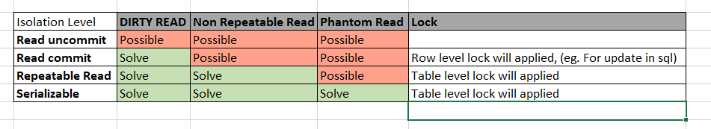

NOTE: We always use Read commit in our all application.

Difference between spring Transactional and JPA Transactional annotation



The spring transaction annotation is best choice if you have multiple database in single application.

Using spring transaction annotation provide you best isolation level. Ex:

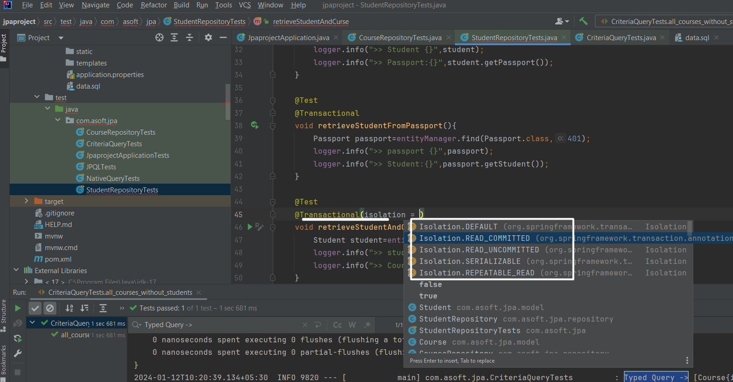

Cross with JPA @Transactinal annotation- No facility for insolation

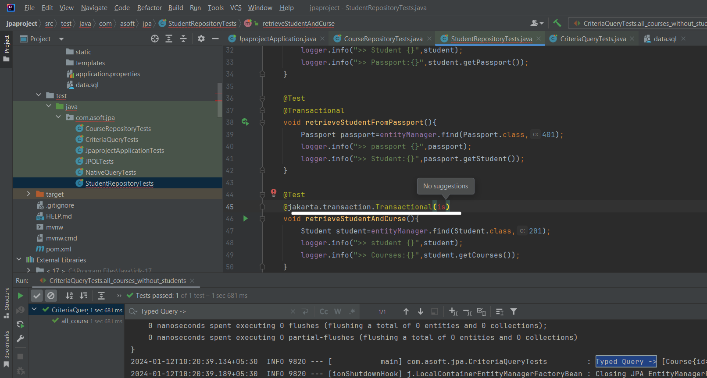

# Spring data JPA example:

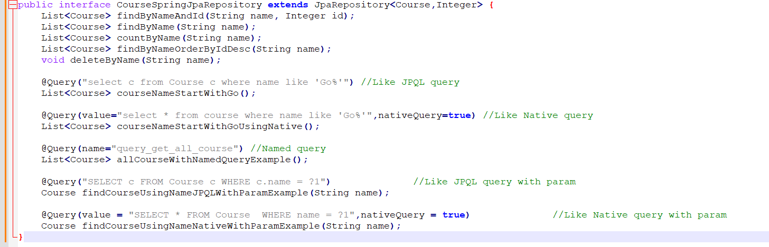

# Caching with JPA:

Ideally master data should be cache.

What does mean by master data?

* The data which is not changed frequently, for example Item in supply chain domain.

Yes, If some time master data is changed then we should have to re-cache the updated master data.

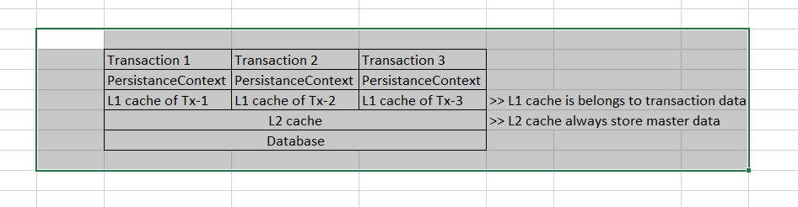

## First level cache demo:

Written test case that simply read same course id twice

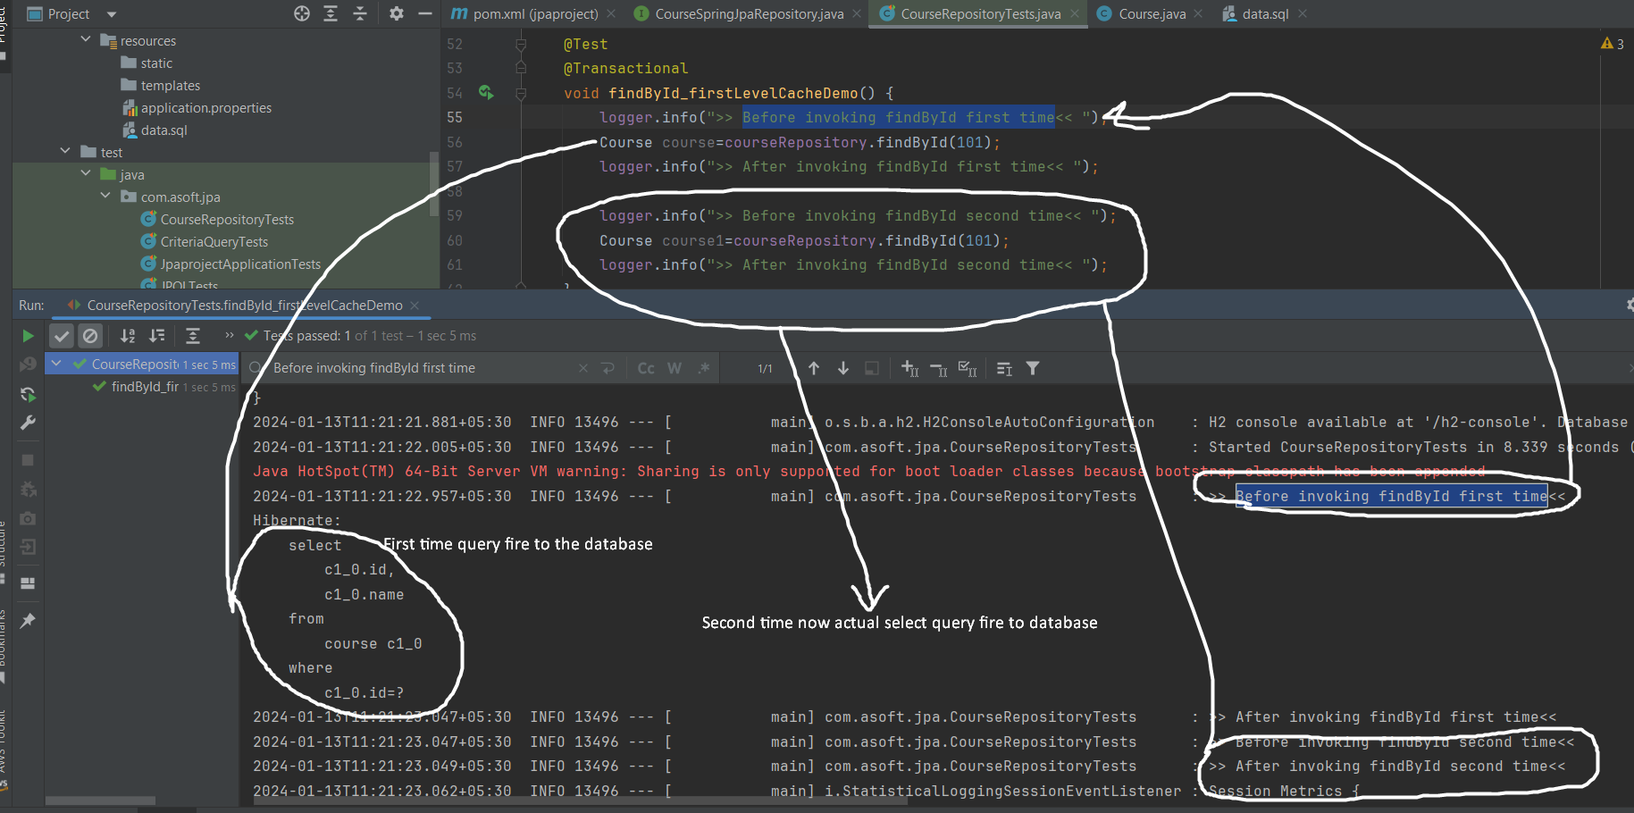**But note that @Transactional should be there**

## Second level cache demo:

Steps to follow if want to use second level cache in application

Add below dependencies:

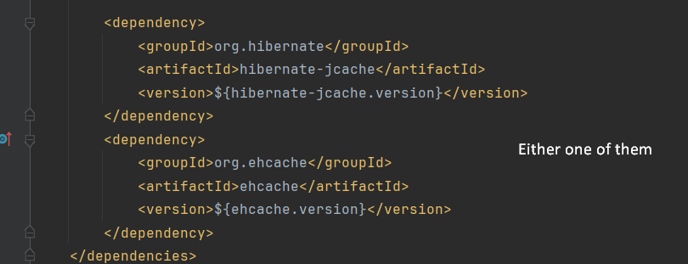

Using hibernate-jcache implementation here

Configuration in application.properties

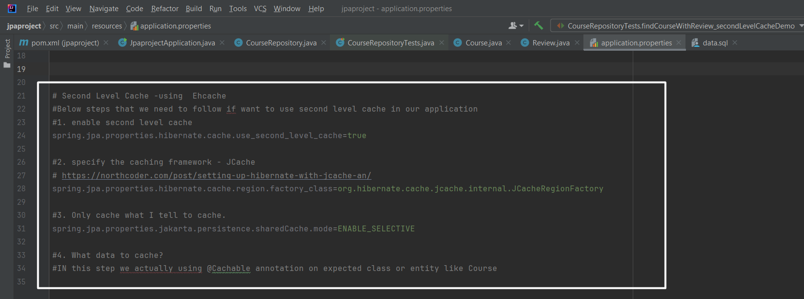

Ok, when you execute below test consecutively more than one time then two query got fire one for course and one for review, actually course gone not change most frequently but review can. So ideally every time we need not to make query to fetch Course detail. We can cache course and run only queries for review.

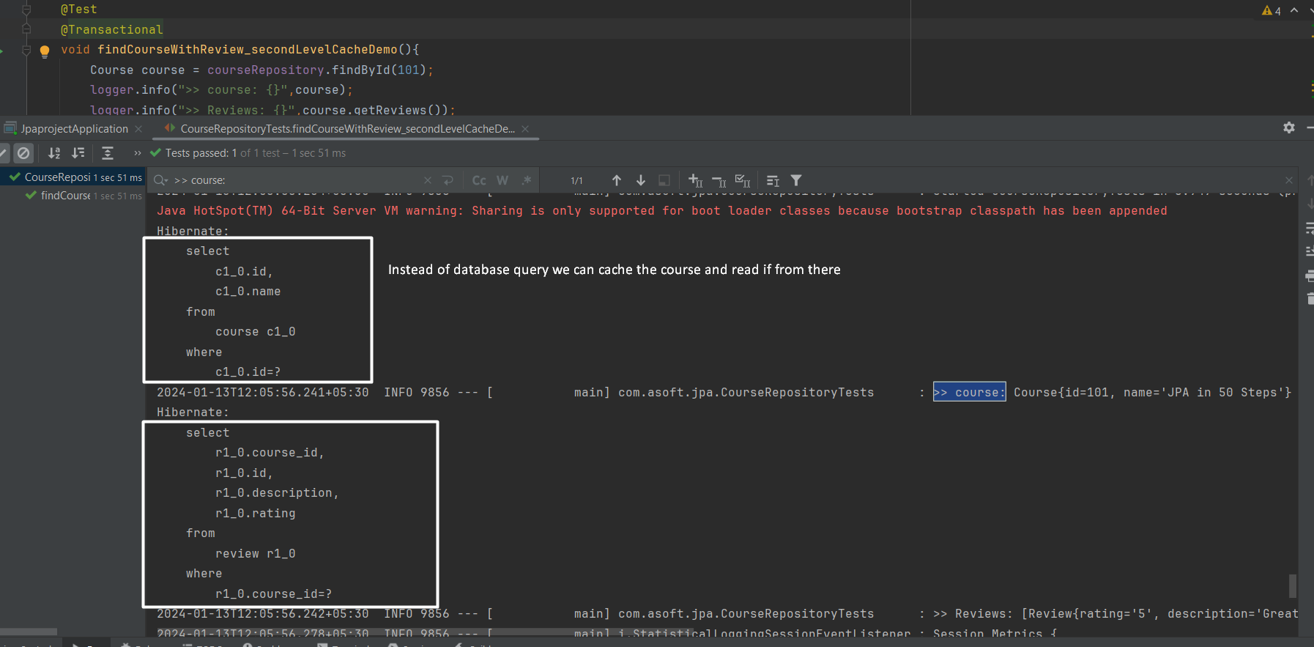

Ok, how to do that?

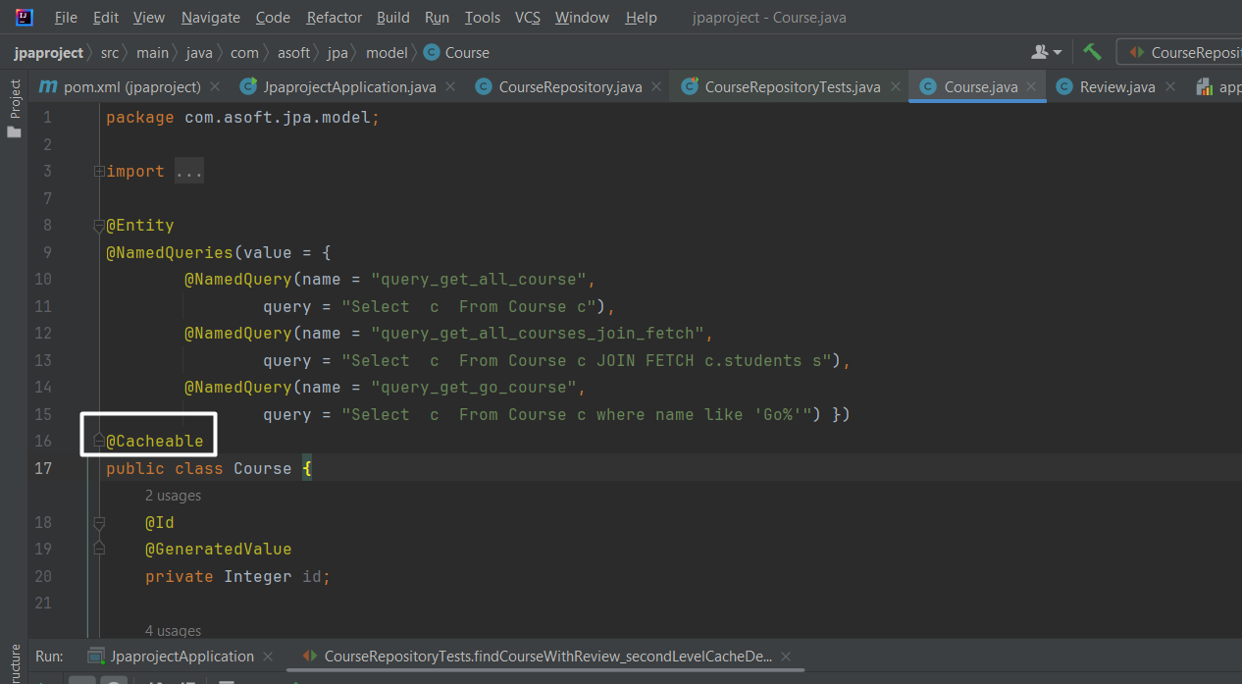

This is good enough

# Pending: How to handle update and delete of cache data

Follow: <https://medium.com/@himani.prasad016/caching-in-hibernate-3ad4f479fcc0>